

Introduction to

Static Analysis Using

SolidWorks Simulation

®

Radostina V. Petrova

***CHAPTER 7***

# STATIC ANALYSIS OF A SHELL BODY

## 7.1 WHEN CAN AN OBJECT BE TREATED AS A SHELL? THIN OR THICK SHELL FEs? DIFFERENT APPROACHES FOR FEA OF A SHELL IN SW SIMULATION

In general, a body is considered a shell/plate when the contribution of shear deformations becomes non-significant and can be neglected. This happens when the ratio between the span of plate-bending curvature/the projected span of curvature and the shell thickness is larger than 10:1. According to some authors, this formulation itself is adequate and can be applied for a ratio down to 5:1 (https://wiki.csiamerica.com).

When studying shells, there are two basic formulations, depending on the inclusion of transverse shear deformation in plate-bending behaviour. These are the thin and the thick shell formulations. Thin-plate formulation neglects the transverse shear deformation, whereas thick-plate formulation does account for it. Thick-plate formulation has no effect on membrane (in-plane) behaviour, but only on plate-bending (out-of-plane) behaviour.

Shearing may become significant in locations of bending-stress concentrations, which occur near sudden changes in thickness or support conditions and near openings or re-entrant corners. Thick-plate formulation is best for such applications.

Thick-plate formulation is also recommended in general because it tends to be more accurate, though slightly stiffer, even for thin-plate bending problems in which shear deformation is truly negligible. However, the accuracy of thick-plate formulation is sensitive to mesh distortion and large aspect ratios, and therefore should not be used in such cases when shear deformation is known to be small.

The statement that thick shells tend to be stiffer than thin shells applies only to the bending components of shells and to models in which meshing is too coarse. When meshing adequately captures bending deformation, thick-shell elements are more flexible because of the additional shear deformation that is not captured through thinshell formulation. Given pure-bending deformation, however, the thin-shell element is slightly more accurate; therefore, the thick-shell element may be stiffer for coarser meshes. This effect diminishes as the mesh is refined.

Stresses may be of greater concern than deflections. When shear deformation is expected to be important, the thick-shell FEs are recommended because they capture better the stress distribution. This is the case not only for thicker shells but also for regions near openings and other geometric discontinuities in which transverse shear deformation develops.

There are two ways to develop and study a shell body in SW Simulation and both will be discussed below.

* The first approach supposes the CAD model of the body to be developed using the **Surface** tool. During finite element analysis (FEA), the software automatically creates a shell uniting all surfaces. The type of the shell (thin or thick), its thickness and the off-set towards the surfaces are input by the user. This approach allows the use of composites and can generate shells with varying thickness. The input of contact constraint is necessary in this model.
* The second approach uses the **Sheet Metal** tool to develop the CAD model. While meshing the model, the software creates shell elements assuming that the thickness of the shell is equal to the thickness of the sheet metal. This approach is applicable for spatial forms with constant thickness.

This section discussed about when a body can be modelled and studied as a shell instead of studying it as a solid body. It briefly summarised and compared the two formulations of studying shells.

We obtained criteria to help us in deciding how to model and study the body – as a shell or as a solid body.

We learned about the advantages and disadvantages of the thin and the thick plate formulations. Therefore, we know how to justify our decision of which of the two formulations to use in the analysis.

## 7.2 DEVELOPMENT OF A CAD MODEL OF A SHELL USING SURFACE TOOL (Surface.sldprt)

The CAD model of the analysed object will be developed using the **Surface** tool. After starting a new part file (File→New→ Part→OK) and setting the used units to ‘**millimetre-gram-second**’ (Tools→Options→ Document Properties→Units→Unit system MMGS→OK), the model is saved as **Surface.sldprt**. The next stage is to start the **Surface** tool and afterwards to create the model. The following stages must be done:

1. Activating the **Surface** tool

After right clicking on the command bar, a pop-up menu appears (Figure 7.1b) and you must left click on **Surface** line (, Figure 7.1b). The tools at the **Surface** toolbar are shown in Figure 7.1a and are defined in Figure 7.1c.

(a)

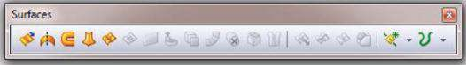

(b) (c)

Extend surface

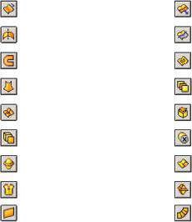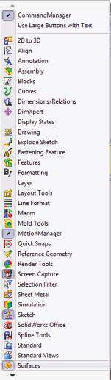

Extruded surface

Revolved surface

Swept surface

Lofted surface

Boundary surface

Offset surface

Radiate surface

Knit surface

Planar surface

Trim surface

Filled surface

Mid-surface

Replace face

Delete face

Untrim surface

Parting surface

Ruled surface

### Fig u r e 7.1

*Activating Surface tool. (a) Surface toolbar. (b) Pop-up m enu. (c) Tools for creating and providing surfaces.*

1. Drawing **Sketch1** in **Top Plane** (Figure 7.2a).
2. Transforming **Sketch1** in a planar surface:

Surface→Planar Surface()→OK

Select **Sketch1** by clicking on it at the **Graphics area** (Figure 7.2b). As a result, its signature appears in the blue window of the **Planar surface** property manager (Figure 7.2c). Then click OK.

1. Defining a plane perpendicular to the existing planar surface and coinciding with its side edge (Figure 7.2d, e and f).

Features→Reference Geometry() →Plane()→OK

1. Drawing **Sketch2** in **Plane1** (Figure 7.3a).

(a) (b) (c)

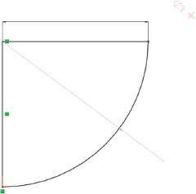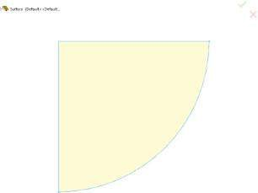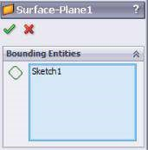

100

R100

(d)

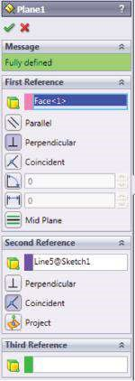 (e) (f)

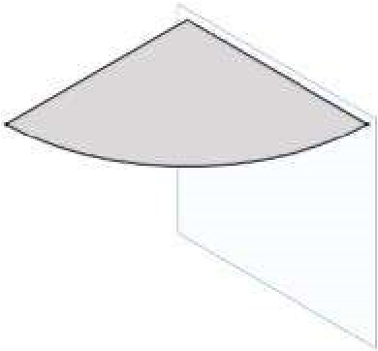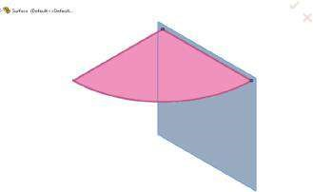

Pl

ane

1

### Fig u r e 7.2

*Creating a CAD m odel using Surface tool – stage from 2 to 4. (a) Sketch1. (b) Graphic area view while Planar surface property managed is active. (c) Planar surface property manager. (d) Plane property manager. (e) Graphic area view while Plane property managed is active.*

*(f) New Plane1.*

1. Transforming **Sketch2** into a planar surface (Figure 7.3b and c)

Surface→Planar Surface()→OK

1. Defining **Plane2** at the side edges of both planar surfaces (Figure 7.2d and e).
2. Drawing **Sketch3** in **Plane2** (Figure 7.3f).
3. Transforming **Sketch3** into a planar surface (Figure 7.3g)

Surface→Planar Surface()→OK

The ready CAD model is shown in Figure 7.3h.

(a) (b) (c)

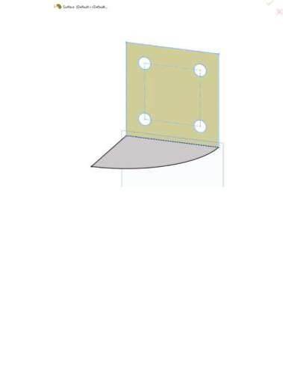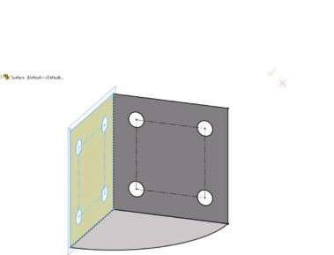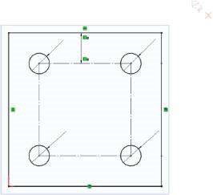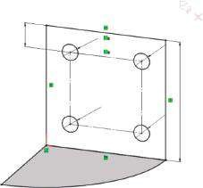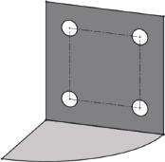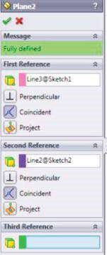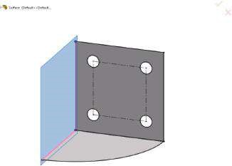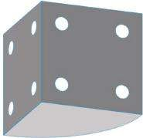

)

e

(

)

d

(

)

f

(

)

(

g

(

h

)

20

10

0

Ø13.50

Ø13.5

0

Ø13.50

Ø13.50

Ø13.50

Ø13.50

Ø13.5

0

Ø13.50

20

Plane2

Pl

ane

2

Pl

ane

1

### Fig u r e 7.3

*Creating the CAD model using Surface tool – stage from 5 to 9. (a) Sketch2 in Plane1. (b) Graphic area view while Planar surface property managed is active. (c) CAD model of two planar surfaces. (d) Plane2 property manager. (e) Graphic area view while Plane2 property managed is active. (f) Sketch3 in Plane2. (g) Transforming Sketch3 into planar surface. (h) The ready CAD model.*

In this section, we modelled the studied object as a shell using the **Surface** tool. Thus, the software will automatically recognise this body as a shell and will perform the FEA using 2D FEs.

|  |
| --- |
| We learned   * How to start the **Surface** tool * How to develop geometric models through it |

## 7.3 FEA OF A SHELL, CREATED USING SURFACE TOOL (Surface.sldprt)

### 7.3.1 Pre-Processor Modelling of the O bject

A new static analysis is started:

Simulations→New Study()→Static()→Study 1→OK

The model unites three surface bodies (Figure 7.4a), in which material and thickness will be defined. The selected material is Alloy Steel and the thickness of the shell is set to 4 mm.

Right click on the name of the model in the **Simulation analysis tree** to open the pop-up menu. Start the **Apply Material** command ().

Surface→Apply Material to All Bodies…(,Material library open)→

SolidWorks Material→Steel→Alloy Steel→Apply→Close

(a) (b)

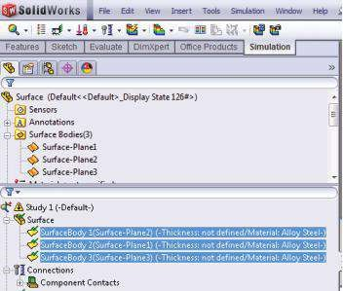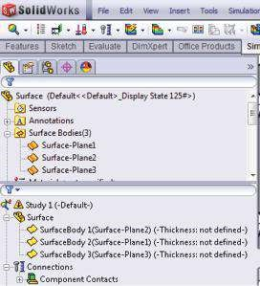

(c) (d)

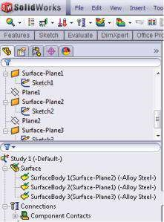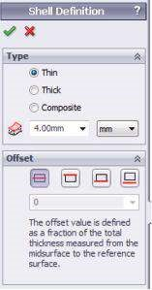

#### Fig u r e 7.4

*Introducing the shell properties. (a) The surface bodies included in static Study 1. (b) Selecting all surface bodies after applying the material. (c) Shell Definition property manager. (d) Defined shell properties.*

The quickest way to define the thickness of the shell bodies is to select all of them by clicking on their signatures in the **Simulation** analysis tree while the **Ctrl** button of the keyboard is pressed (Figure 7.4b). Then right click on them and pick **Edit Definition** from the pop-up menu. The **Shell Definition** property manager opens (Figure 7.4c).

The **Shell Definition** property manager is used to define the adopted calculation theory (thin-plate theory, where transverse shear deformations are neglected, or thickplate theory). This is done by checking the correct button. As a general guideline, thin shells can be used when the thickness-to-span ratio is less than 0.05.

The shell can also be defined as a composite laminate. This case will not be discussed in the book.

The **Shell Definition** property manager defines the thickness of the shell elements. By default, the software assigns zero thickness to the shell geometry, but it can be modified by introducing a new value in the shell thickness window (). In our case, this is 4 mm, which means that the thickness of the shell is 4 mm.

Based on the assumed shell thickness and the model geometry, the thickness-tospan ratio is less than 0.05. Thus, the thin plane theory can be adopted (Figure 7.4c).

Furthermore, there is the **Offset** option, which allows the user to control the position of the shell mesh relative to its surface. The option aligns the mesh to the top, the middle or the bottom faces of the shell. To align the mesh to a reference surface, an offset value is typed. By default, the mesh is always aligned to the middle face of the shell (). The **Top Surface** () aligns the mesh with the top surface of the shell. The **Bottom Surface** () aligns the mesh with the bottom surface of the shell. For example, to model adjacent shells with differing thicknesses such that their bottom faces coincide, you can create the two surfaces and align them using the **Bottom surface** option. The **Specify Ratio** ( ) aligns the mesh to a reference surface defined by an offset value that is a fraction of the total thickness. The offset value ranges between −0.5 and 0.5. The **Offset** option is not available for large displacement analysis of shells.

After the input of the material and the shell properties, the note ‘Thickness not defined’ disappears, and the chosen material is written for each surface body (Figure 7.4d).

The next stage is to define **Connections** (). The program considers the three designed shells as free surface bodies despite the added geometric relations. Therefore, the type of the connections between them must be input manually (Figure 7.5a). **Edge Weld** connections are defined.

When defining a weld connection, the user chooses among the following types: **Fillet, Double-Sided** (); **Fillet, Single-Sided** (); **Groove, Double-Sided** (); and **Groove, Single-Sided** (). Depending on the selected weld type, the **Weld Type** sub-windows differ a little fromeach other(Figure 7.5b). The common input options include selection of the connected faces. **Face Set 1** () selects either the face of the shell or the face of the sheet metal body, which belongs to the terminated part. **Face Set 2** () selects the other face, which can belong to a shell, to a sheet metal object or to a solid body.For fillet welds, the selected faces of Sets 1 and 2 are perpendicular to each other. For groove welds, the selected faces are parallel. After picking the faces on the graphic area, their signatures appear in the windows on the left and the faces are coloured in blue (Figure 7.5c)**.** The signatures of the **Intersecting Edges** () appear automatically. These edges are the touching edges between the selected **faces of Sets 1** and **2**, where the welding will be applied. Non-touching edges, which belong to the terminated part, can also be selected. The last option to be defined in that sub-window is **Weld Orientation** ( ,). It is available only for single-sided welds. It provides the location of the weld with respect to the shell surface



(a) (b)

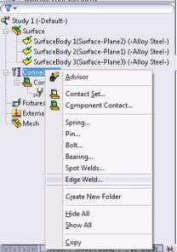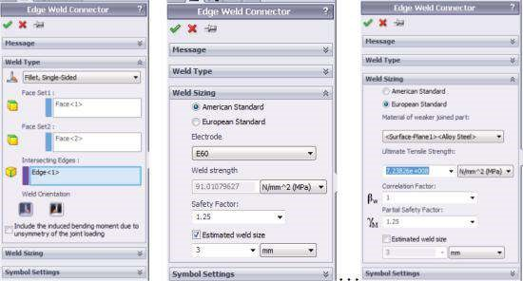

(c) (d)

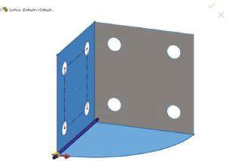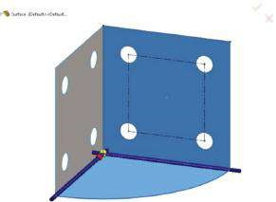

#### Fig u r e 7.5

*Defining the edge welds. (a) Connections pop-down menu. (b) Edge Weld Connector property m anager for the first welding. (c) Graphic area view while defining the first welding. (d) Graphic area view while defining the second welding.*

alignment. A red arrow in the graphics area shows the weld orientation (Figure 7.5c). When designing the weld parameters, the user must remember that due to asymmetry of the joint loading, the force, which is transmitted perpendicular to the longitudinal axis of the weld, can induce an additional bending moment at the weld throat. Considering or neglecting that moment is controlled through the **Include the induced bending moment due to asymmetry of the joint loading option** (not selected in the example,Figure 7.5b).

The next stage is determining the **Weld Sizing** (Figure 7.5b). The user can choose between **American Standard** (*Am eric an Weldin g Stan dard D1.1 an d D1.2*) or **European Standard** (*Eurocode 3: Design of steel structures, Part 1.8: Design of joints, Sec tion 4.5*).

The **American Standard** options include

* **Electrode** – to set the electrode’s material.
* **Weld strength** – displays the selected electrode’s material ultimate shear strength.
* **Safety factor** – reduces the allowable shear strength for the calculation of the weld strength. The allowable shear strength for the electrode’s material is calculated as (Ultimate shear strength/Safety factor).
* **Estimated weld size –** let the program calculate the appropriate size for the weld connector.

The **European Standard** options include

* **Material of weaker joined part** – defines the weaker part, which is connected by the edge weld. The weaker part has the lesser material tensile strength.
* **Ultimate Tensile Strength** – displays the selected material’s tensile strength.
* **Correlation factor** (ˆI*w*2 ) – its value is between 0.8 and 1.0 for the weld calculations. The values for the correlation factor embedded in the software are from Eurocode EN 1993-1-8: 2002, Table 4.1.
* **Partial Safety Factor** (ˆIˆI3*œ*) – the safety factor for joints is between 1.0 and

1.25. These values are from Eurocode EN 1993-1-8: 2002, Table 2.1.

* **Estimated weld size** – let the program calculate the appropriate size for the weld connector. It is determined according to Eurocode EN 1993-1-8: 2002, Paragraph 4.5.3.

European Standard is chosen for all defined edge welds in the case study, and the input options are given in Figure 7.5b. The **Graphics area** view, while the second edge weld is defined, is given in Figure 7.5d.

The next stage is the definition of the fixtures and loads. It is important to remember that the fixtures can be applied to the edges and vertexes of the shell. Since shell FEs have rotational degrees of freedom, there is difference between the **Immovable** (no translation) and the **Fixed Geometry** (no translation and no rotation) fixtures. **Immovable** fixtures at all edges around the holes are preferred over **Fixed Geometry** fixtures to replace the **Ground Bold** fixtures, assumed in the second example. The main reason for this choice is the relatively small pre-load tensile force in the bolds (Figure 7.6a).

(a) (b)

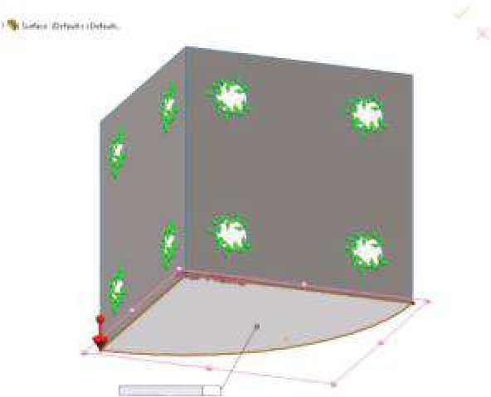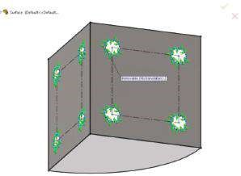

Normal to Plane (m/s

2

)

9.81

(c)

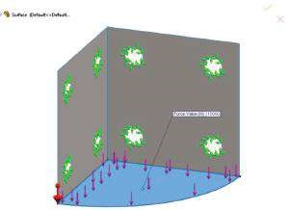

#### Fig u r e 7.6

*Defining the fixtures and the external loads. (a) Immovable fixtures at the edges of the holes.*

*(b) Applied Gravity load. (c) Applied Force load.*

The external loads at the analysed object are **Gravity** () and **Force** (). **Gravity** is calculated based on the density value of the material and the thickness of the shell (Figure 7.6b). **Force** is equal to 10 kN and is normal to the horizontal surface (Figure 7.6c). Regarding the load, you must remember that for shells, the concentrated moments and forces can be applied using the **Force/Torque** property manager at faces, edges or vertexes. The pressure can be applied only to faces or to shell edges. The software uses the thickness of the shell and the length of the edge to calculate the equivalent force applied to the edge.

### 7.3.2 Meshing the Shell

After defining the connections, the fixtures and the loads, the model should be meshed. The program automatically determines the mesh to be of shell FEs.

Of course, any geometric model depending on the used commands and the way of creating the CAD design can be defined and analysed as a solid body model as well. Then, the software automatically uses tetrahedral solid elements. However, meshing of thin models with solid elements results in generating a large number of elements, since FEs of small element size are used. Just the opposite, using a larger element size deteriorates the quality of the mesh and leads to inaccurate results.

Surface models can only be meshed with shell elements. The shell mesh is generated on the surface, located at the mid-surface of the shell, unless nothing else is defined through the offset option.

By definition, shell elements are 2D elements capable of resisting membrane and bending loads. They can be either linear triangular elements (or first-order elements; Figure 7.7a) or parabolic triangular elements (or second-order elements; Figure 7.7b). Three corner nodes, connected by three straight edges, define a linear triangular shell element. Three corner nodes, three mid-side nodes and three parabolic edges define a

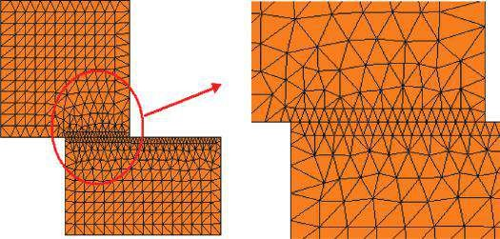

(

a

)

(

b

)

(

c

)

#### Fig u r e 7.7

*Shell finite elem ents (SW Simulation Help). (a) Linear triangular elem ent. (b) Parabolic triangular elem ent. (c) Com patible m esh along shells sharing edges.*

parabolic triangular element. For structural studies, each node in shell elements has six degrees of freedom: three translations and three rotations. The translational degrees of freedom are motions in the global X, Y and Z directions. The rotational degrees of freedom are rotations about the global X, Y and Z axes. When using shell elements, the software generates one of the following types of elements depending on the active meshing options for the study: **draft-quality mesh**, when the automatic mesher generates linear triangular shell elements; or **high-quality mesh**, when the automatic mesher generates parabolic triangular shell elements.

The software generates a continuous mesh on shells sharing edges. Meshing generates a compatible mesh along the interface and merges the nodes automatically regardless of mesh control and contact settings (Figure 7.7c). If a mesh control is applied to one of the shared edges, the software uses the smaller size of FEs for both edges. Mesh controls can be applied on the appropriate faces, edges and vertices. Remember that, by default, the software assigns a thin shell formulation to each surface body. The user can edit it before running the study. A reasonably fine draft-quality mesh gives results that are generally similar to the results obtained from a high-quality mesh with the same number of elements. The difference between the two results increases if the model includes curved geometry.

A mesh of the following options is generated: curvature-based mesh, Max FE size –

4 mm; Min FE size – 1 mm. Draft Quality option is checked (Figure 7.8a and b). The

(a) (b) Model name: Surface

Study name: Study

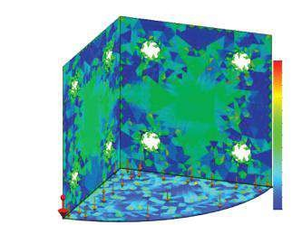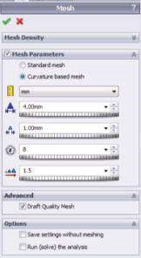

Plot type: Aspect ratio Mesh Quality1

Aspect Rati

o

2.88

2.72

2.57

2.41

2.25

2.1

1.94

1.79

1.63

1.48

1.32

1.17

1.01

(c) Model name: Surface (d) Model name: Surface Study name: Study Study name: Study

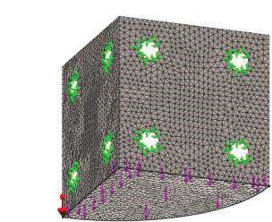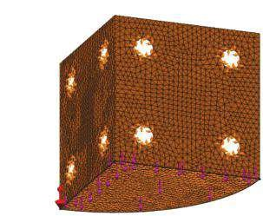

Mesh type: Shell mesh using surfaces

Mesh type: Shell mesh using surfaces

#### Fig u r e 7.8

*Meshing of the shell. (a) Mesh property m anager. (b) Aspect Ratio plot. (c) Inner surface of the shell is ‘bottom’. (d) Inner surface of the shell is ‘top’.*

bottom faces’ colour is defined to be orange. If you like, you can change it through the following path of commands (Figure 4.1b):

Simulation→Options→System Options→General→Mesh colors→Shell bottom face color→Orange→OK

Each surface can be flipped using the **Flip Shell Elements** command, which is accessible through

Mesh (right click)→Flip Shell Elements

Thus, you can define the inner surface of the shell to be ‘bottom’ (Figure 7.8c) or ‘top’ (Figure 7.8d).

### 7.3.3 Viewing the Results

There are no significant differences in viewing the results of the FEA of shells compared to those of solid bodies. The software generates data about displacements, strain and stresses. The new points that will be discussed in this chapter concern the different types of stresses, in relation to the deformations they are related to, and the displacement to the mid-plane of the shell. The following stresses can be viewed:

* **Top** – provides the total stresses (bending + membrane) at the top face of the shell
* **Bottom** – provides the total stresses (bending + membrane) on the bottom face of the shell
* **Membrane** – provides membrane stress component
* **Bending** – provides bending stress component

Before continuing with plotting the results, some additional explanation on the topic is provided. It is of great importance to choose the correct ‘top/bottom’ side while doing shell calculations. Usually the top side lies above the mid-plane of a horizontal plate, and its offset distance is one-half of the thickness of the plate (Figure 7.9a). The stresses that appear in the shell have two main components: membrane stresses and bending stresses. Membrane stresses are related to the in-plane deformations of the shell. They are due to the tensile/compressive forces and are constant along the thickness of the shell. Bending stresses are related to the out-of-plane deformations of the shell. Bending moments or forces perpendicular to the shell mid-plane cause them. It is assumed that these stresses distribute linearly along the thickness of the shell; their extreme values, that is, maximal tensile and maximal compressive stresses, are at the two layers most distant from the mid-plane. They are equal, while the mid-plane bending stress is zero. The total (normal) stresses are a sum of the membrane and of the bending stresses. Thus, their values at the top layer differ from the values at the bottom layer (Figure 7.9b).

It is important to notice that this is the simplest explanation of the nature of these stresses. It is true for linear objects and it is fundamental for the mechanics of materials, which studies 1D objects (bars, beams or frames). Therefore, when trying to find any similarity between the given explanation and the one generated by the software results, you have to remember that software calculates the stresses in a way based on the above explanation, but this time including more factors and the fact that the shells

Top face

Bottom

face

Shell thickness (t)

Top face

Bottom face

t

Membrane

Bending

Mid-surface

(

a

)

(

b

)

Total

#### Fig u r e 7.9

*Stresses in a shell (SW Simulation Help). (a) Shell view. (b) Vertical distribution of the stresses.*

are calculated as 2D objects. Additionally, not all maximal values rise in the same element (Figure 7.10c and d). Some of the obtained plots for a 4-mm shell and an assumed thin formulation are shown in Figure 7.10, where you can compare the membrane and the bending stress distributions across the shell.

The extreme values of some results are given in Table 7.1. The Yield Strength of the chosen material (Alloy Steel) is 620.4 MPa. It is seen that the minimal value of FoS is smaller than 1, which is unallowable in this case. More important is the fact that this low value is due to the calculation process. If you look at the given picture (Figure 7.10f, right), you will see that the vulnerable area involves a few FEs only. Even more, if you change the formulation and assume thick-plate formulation (which is considered to be more accurate but more complicated and which requires more computer resources and calculation time), you will see that the discrepancies between the stresses in the element and in the node mode almost disappear and the FoS rises to 1.06. Therefore, we can conclude that the FoS discrepancy is due to numerical calculations, including shell formulation and mesh definition. Even more, if the target value of FoS is 1, we can assume to keep the object design as it is.

We performed an FEA of a shell object, modelled through the **Surface** tool. The software automatically recognised the surfaces as shells and uses 2D FEs to mesh them.

The user inputs the thickness of each surface and assumes the formulation for calculations (a thin or a thick plate) and the displacement of the shell to the surface (the offset).

It is important to remember that despite the existing geometric mates between the surfaces, contacts must be applied. We chose edge welding and we define two welded edges.

The limitations concerning the application of the fixtures and of the loads are explained.

2D FEs and the meshing of shells are discussed. It is explained why it is better to use 2D elements for shells instead of 3D FEs, and why we do not model and prefer not to analyse the shells as solid objects.

The nature of the four stresses calculated by the software (top, bottom, membrane and bending) was explained and their plots were presented.

(a) Model name: SurfaceStudy name: Study 1 (b) Model name: SurfaceStudy name: Study 1

Plot type: Static element stress (Top) Stress1 Plot type: Static element stress (Bottom) Stress1

Deformation scale: 1 Deformation scale: 1

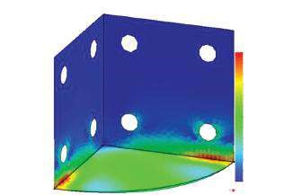

von Mises (N/mm

2

(MPa))

Yield strength: 620.4

529.0

485.0

440.9

395.8

352.8

308.7

264.7

220.6

178.5

132.5

88.4

44.4

0.3

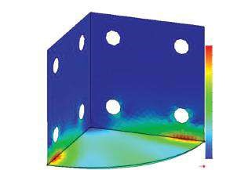

von Mises (N/mm

2

(MPa))

597.6

547.9

498.1

448.3

398.5

348.7

298.9

249.1

199.3

149.5

99.7

49.9

0.1

Yield strength: 620.4

(c) Model name: Surface (d) Model name: Surface

Study name: Study 1 Study name: Study 1

Plot type: Static element stress (Membrane) Stress1 Plot type: Static element stress (Bending) Stress1

Deformation scale: 1 Deformation scale: 1

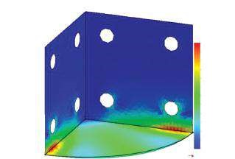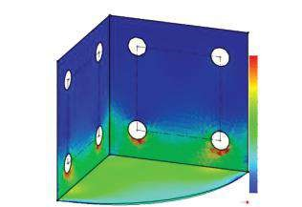

von Mises (N/mm

2

(MPa))

Yield strength: 620.4

64.3

59.0

53.6

48.3

42.9

37.5

32.2

26.6

21.5

16.1

10.7

5.4

0.0

von Mises (N/mm

2

Yield strength: 620.4

0.2

47.1

94.0

140.9

187.6

234.7

281.6

328.5

375.4

422.3

469.2

516.1

563.0

(MPa))

(e) Model name: Surface (f) Model name: Surface

Study name: Study 1 Study name: Study 1

Plot type: Static displacement Displacement1 Plot type: Factor of Safety Factor of Safety 1

Deformation scale: 1 Criterion: Automatic

Factor of safety distribution: Min FOS = 0.97

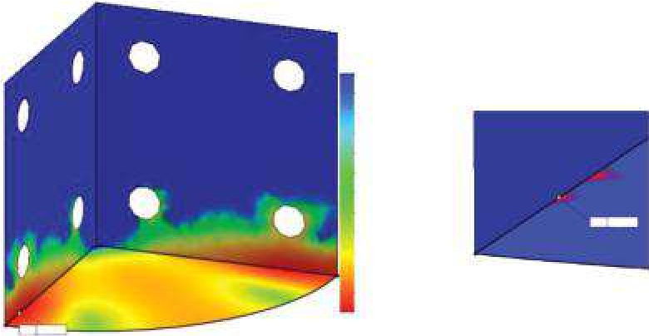

0.97

1.73

2.48

3.23

3.98

4.73

5.49

6.24

6.99

7.74

8.50

9.25

10.00

FOS

Min 0.97

Min 0.97

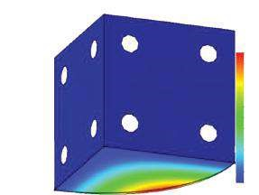

URES (mm)

0.000

0.118

0.237

0.355

0.473

0.591

0.710

0.828

0.946

1.064

1.183

1.301

1.419

#### Fig u r e 7.10

*Plots for a 4-mm shell, a thin formulation assumed, shell thickness – constant. (a) Top von Mises stresses, presented in element mode, t = 4 mm. (b) Bottom von Mises stresses, presented in element mode, t = 4 mm. (c) Membrane von Mises stresses, presented in element mode, t = 4 mm. (d) Bending von Mises stresses, presented in element mode, t = 4 mm. (e) Displacement plot, t = 4 mm. (f) FoS plot, t = 4 mm.*

***Table 7.1***

### Results for Analysed Shell for Thin and Thick Shell Formulations

**Maximal von Mises Stresses (MPa)**

**Surface Shell, with Displacement**

|  |  |  |  |  |  |  |
| --- | --- | --- | --- | --- | --- | --- |
| **Thickness of 4 mm Top** | | **Bottom** | **Membrane** | **Bending** | **(mm)** | **FoS** |
| **Thin-Plate Formulation**  Element mode 597.6 | | 529.0 | 64.3 | 563.0 | 1.419 | 0.97 |
| Node mode 637.4 | | 569.6 | 80.7 | 603.2 |  |  |
| **Thick-Plate Formulation**  Element mode 585.08 | | 520.0 | 62.8 | 550.5 | 1.462 | 1.06 |
| Node mode 583.3 | | 517.1 | 72.4 | 549.9 |  |  |
| We learned   * How to define shell properties through the **Shell Definition** property manager and how easy the shell thickness and the assumed calculating formulation can be changed * How to define a welding, what the different types of welding are and the standard definitions used by the program * How to apply fixtures and loads at shells and what the main differences are with solid body applications * How to define a mesh of 2D FEs and how to flip their sides * What is the nature of top, bottom, membrane and bending stresses and how to plot them | | | | | | |

## 7.4 DEVELOPMENT OF A CAD MODEL OF A SHELL USING SHEET METAL TOOL (Sheet_Metal.sldprt)

In this section, the CAD model of the same part will be developed by the Sheet Metal tool and following further instructions.

The stages to be fulfilled are as follows:

1. Starting **a new model**:

File→New→ Part→OK

Save file as **Sheet_Metal.sldprt**.

1. Setting the options:

Tools→Options→ Document Properties→Units→Unit system MMGS→OK

1. Drawing **Sketch1** in the **Top Plane** (Figure 7.11a).
2. Extruding **Sketch1** (Figure 7.11b and c):

Features→Extrude Boss/Base() →OK

Select the sketch. Let the feature be extended as **Blind** to 100 mm.

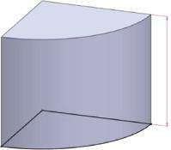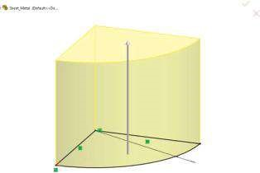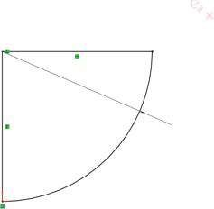

R100

R100

10

0

(

a

)

(

b

)

(

c

)

(d) (e) (f)

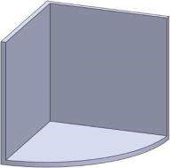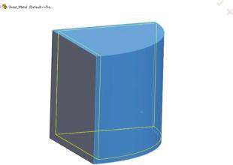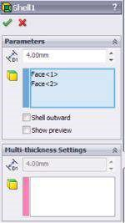

### Fig u r e 7.11

*Development of the CAD model of the Sheet_Metal part – stages 3 to 5. (a) Drawn Sketch1. (b) Extrusion of the sketch. (c) The m odelled solid body after the extrusion of Sketch1. (d) Shell property manager. (e) Preview of the hollowed part. (f) Created shell.*

1. Defining the shell geometry from the modelled solid body:

Features→Shell() →OK

The **Shell** tool hollows out a part, leaves open the selected faces and creates thin-walled features on the remaining ones.If no face on the model is selected, the software creates a closed, hollow model. The program can also create a shell model using multiple thicknesses. To create a shell feature of uniform thickness, we set the thickness of the kept faces () in the **Parameters** sub-window and select one or more faces in the **Graphics area** for **Faces to remove** (). The **Shell outward option** increases the outside dimensions of the part. The options of the **Shell** property manager include the introduced thickness of the shell, which is set to 4 mm, and the pointed faces, which are coloured in blue (the top face as **Face1** and the cylindrical face as **Face2**, Figure 7.11d and e). The user can see the preview of the hollowed part before confirming the execution of the command. The created shell is shown in Figure 7.11f.

1. Drawing **Sketch2** in the outer plane of the vertical side of the shell(Figure 7.12a).

To draw the sketch, the **Offset** command is used to set the construction lines and to locate the centres of the circles. The diameter of each circle is 13.5 mm(Figure 7.12b).

(a) (b) (c)

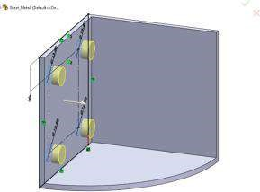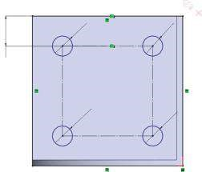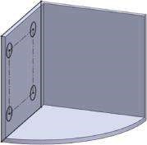

20

Ø13.50

Ø13.50

Ø13.50

Ø13.50

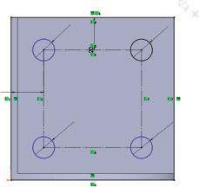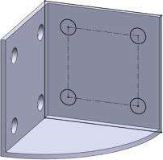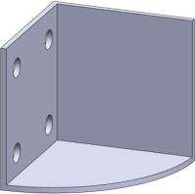

(

d

)

(

e

)

(

f

)

Ø13.5

0

Ø

13.50

Ø13.5

0

Ø13.50

20

(g) (h)

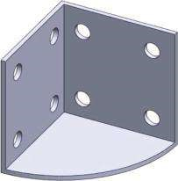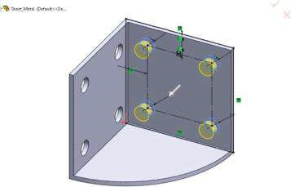

Ø13.50

Ø13.50

Ø13.50

Ø

13.50

20

### Fig u r e 7.12

*Development of the CAD model of the Sheet_Metal part – stages 6 to 9. (a) Displacement of Sketch2. (b) Sketch2. (c) Picked contours to be cut-extruded. (d) Cut-extruded holes. (e) Displacement of Sketch3. (f) Sketch3. (g) Selected to be cut contours. (h) The ready geometry of the shell.*

1. Cutting the holes in the side:

Features→Extruded Cut () →OK

Select the regions, outlined by the circles, as shown in Figure 7.12c. Pay attention totheir input in the **Selected Contour** sub-window by picking them in the **Graphic area**. The **distance** () of the extrusion is set to 10 mm as this is supposed to be the thickest studied sheet metal (Figure 7.12d).

1. Drawing **Sketch3** in the outer plane of the other vertical side of the shell (Figure 7.12e and f).
2. Cutting the holes in the second side (Figure 7.12g and f):

Features→Extruded Cut () →OK

If we stop modelling the part now and start performing FE analysis, despite the used **Shell** command and the created shell geometry, the software treats the part as a solid body and uses solid FE throughout the calculations.

Therefore, the part must be transformed to a shell. This will be done through the **Sheet Metal** tool.

1. Activating the **Sheet Metal** toolbar.

After right clicking on the command bar, a pop-up menu appears (Figure 7.13b). The user have to left click on the **Sheet Metal** (, Figure 7.13a) to start the tool. Among the most useful commands in the **Sheet Metal** toolbar are as follows:

* + **Sheet Metal** () – contains the default bend parameters. It edits the default bend radius, bend allowance, bend deduction or default relief type.
  + **Base-Flange** () – represents the first solid feature of the sheet metal part.



* + **Flat-Pattern** () – flattens the sheet metal part. By default, it is suppressed, as the part is in its bent state. Unsuppressing the feature will flatten the sheet metal part.

1. Converting the shell part to a sheet metal.

SolidWorks provides three ways to create a sheet metal part:

* + Convert a solid part to a sheet metal part – solid or surface bodies can be converted to sheet metal parts that have constant thickness and have no shells or fillets, have either a shell or fillets or have both a shell and fillets • Create the part as a sheet metal part using sheet metal-specific features
  + Build a part, shell it and then convert it to sheet metal.

To model the studied unit, the third way is selected.

A shell part of uniform thickness is already created (Figure 7.12h), and the **Sheet Metal** toolbar is activated (Figure 7.13a).

We start a **Convert to Sheet Metal** command (, Figure 7.13):

Sheet Metal toolbar→Convert To Sheet Metal

After creating the sheet metal part, all sheet metal features can be applied to it. Through the **Convert to Sheet Metal** property manager (Figure 7.13c), the user can specify the fixed face and thickness of the sheet metal part, the default bend radius and the edges or fillet faces on which to create bends. If an edge already has a fillet applied, the radius of the fillet is used as the bend radius for the new sheet metal part. The software automatically selects the edges on which rips are applied. However, this can also be done manually by selecting rip edges and using rip sketches.

The options of the eight sub-windows of the **Convert to Sheet Metal** property manager are given as follows (Figure 7.13d and e):

**• Sheet Metal Gauges** – This option is available only the first time the **Convert to Sheet Metal** tool is activated. It enables selecting a gauge table as the base of the sheet metal feature. The sheet metal parameters (material thickness, bend radius and bend calculation method) use the values stored in the gauge table unless something else is overridden. The table can be selected () through the browse option, which directly opens a file path to the software directory **Sheet Metal Gauge Tables** or through

Tools *>* Options *>* System Options *>* File Locations and selecting **Sheet Metal Gauge Table** in the **Show folders for** window.

(a) (b)

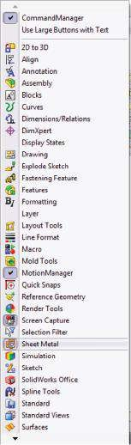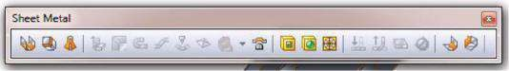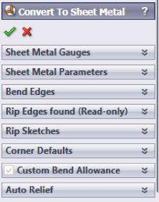

(

c

)

(d)

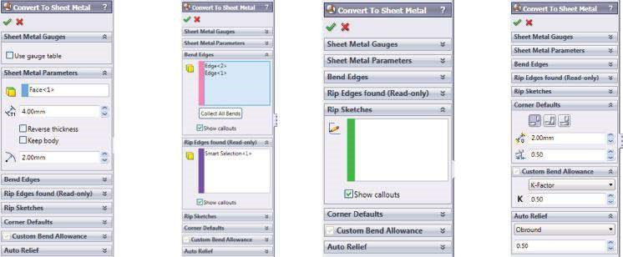

(e)

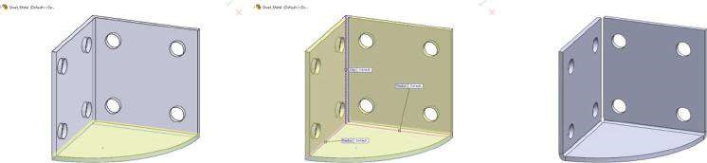

### Fig u r e 7.13

*Converting the solid part to a sheet m etal. (a) Sheet Metal toolbar. (b) Activating Sheet Metal menu. (c) Convert to Sheet Metal property manager. (d) Options of the tabs of Convert to Sheet Metal property manager. (e) Graphic area views when Convert to Sheet Metal property manager is open.*

* **Sheet Metal Parameters** – At first, we select a fixed entity (): this is the face that remains in place when the part is flattened – the bottom face in the horizontal plate (the green face in Figure 7.13e, the figure on the left). **Sheet thickness** () is 4 mm. **Reverse Thickness** changes the direction in which the sheet thickness is applied – *not checked*; **Keep body** keeps the solid body to use with multiple **Convert to Sheet Metal** features or designates that the entire body be consumed by the sheet metal feature – *not checked*; **Default radius for bends** () is set to 2 mm.
* **Bend Edges** – Through that option, the user selects edges/faces that represent bends (). It is enough to click on an edge in the **Graphics area** to add it to the list of bend edges in the pink window – *clic k on the pin k edges* (the pink lines in Figure 7.13e, the figure on the middle). **Collect All Bends** is pushed when there are pre-existing bends to find all of the appropriate bends in the part – *no pre-made bends*. When checked, **Show callouts** displays callouts in the **Graphics area** for all selected edges.
* **Rip Edges found (Read-only)** – When selecting a bend edge, the corresponding rip edge is automatically displayed in the violet window (Figure 7.13d). **Show callouts** displays callouts in the graphics area for all rip edges (Figure 7.13e, the figure on the middle).
* **Rip Sketches** – This option selects a sketch to add a rip (); a 2D or a 3D sketch is selected to define the required rip (its signature immediately appears in the green window). **Default gap for all rips** () should be introduced. No rip sketches are defined for our model.
* **Corner Defaults** – The settings apply to all rips in the **Graphics area** whose callouts say ‘Default’. These defaults can be overridden by setting new options for individual rips in the same callouts. At first, the user should define the **Rip Type** by clicking on one of the icons ( , ); then the user should define the **Rip Width** ( ) and finally the **Default overlap ratio for all rips** (). **Open butt** ( ) is selected and the **Default gap for all rips** () is 2 mm. **Default overlap ratio for all rips** () adjusts the material lengths and is taken into account only for **Overlap** ( ) and **Underlap** rips (). Because of that, its value is of no importance to our model.



,



* **Custom Bend Allowance** – It is active only the first time when the **Convert to Sheet Metal** tool is used. **Bend Allowance Type** – K-factor; **Bend Allowance Value** – 0.50.
* **Auto Relief** – The software automatically adds relief cuts where needed when inserting bends. The type of the relief cut could be **Rectangular, Obround** or **Tear**. If you select **Rectangular** or **Obround** options, a relief ratio needs to be introduced. The relief ratio is calculated as

Relief ratio = part thickness*d*

where the distance *d* represents the width of the auto relief cut and the depth by which it extends past the bend region. The value of the relief ratio must be between 0.05 and 2. The higher the value, the larger the size of the relief cut added during the insertion of bends. For our model, the inputs options are type: Obround and value: 0.50.

After closing the **Convert to Sheet Metal** tool, three new lines automatically appear in the **FeatureManager** design tree. They hold the properties of the designed sheet metal.

* **Sheet Metal1** (, Figure 7.14a): If we open it and click on the **Edit Feature** icon (), we will see the properties of the designed sheet metal:
* **Fixed Face or Edge** ( ), which can be modified through that window



* **Bending radius** ( ), which can also be modified through that property manager
* **Thickness of the sheet** (), which cannot be changed through the **Sheet Metal** property manager
* **Convert – Solid1** () – This line unites all properties introduced to the model through the **Convert to Sheet Metal** property manager. All input values and properties, including the sheet metal thickness, can be modified through that feature. As sub-directories of **Convert – Solid1,** two bending lines appear: **Sharp Bend1** and **Sharp Bend2** (). They represent both bended edges

(Figure 7.14b).

* **Flat-Pattern1** (), which is suppressed by default. If you unsuppress () it, you will see the flattened sheet (Figure 7.14c).

When creating a multibody sheet metal part, in the **FeatureManager** design tree, the main tree lists each body and its features in the order in which they are added. In addition, the cut list contains a separate representation for each body, with a flat pattern specific to the body. By default, the **Automatic** option of the cut list is active; correspondingly, the **Update** option is added to the right-click menu. There are two icons that show the update information about the generated cut list:  (indicates that the cut list needs to be updated) and



(indicates that the cut list is up-to-date).

This time, we built the unit from the previous section as a solid body, shelled it and then converted it to sheet metal using the **Sheet Metal** tool.

(a) (b) (c)

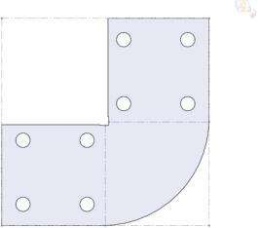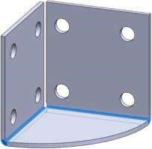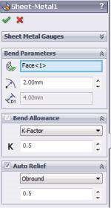

### Fig u r e 7.14

*Final data for the sheet metal shell. (a) Sheet metal property manager. (b) Both bended edges. (c) Flattened sheet.*

|  |
| --- |
| We learned   * How to use the **Shell** feature to hollow a solid body. * How to convert a solid part to a sheet metal using the Sheet Metal tool. * The properties of the **Sheet Metal** tool. * How to modify the model properties. * How to obtain the flattened sheet model, etc. |

## 7.5 FEA OF THE SHELL, CREATED USING SHEET METAL TOOL (Sheet_Metal.sldprt)

After the start of the new static study (Simulation→New Study→Static→OK), the software automatically recognises the sheet metal structure as a shell structure made of 2D FEs. Even more, it automatically extracts and assigns the thickness of the sheet metal to the shell. The thickness cannot be modified through the **Shell Definition** command. Only the calculating mode – thin or thick plate formulation – can be changed. The thickness of the shell is modified by the **Convert to Sheet Metal** tool at the geometric model. Another option is the transformation of the shell to a solid body. This can be done by right clicking on the **Sheet_Metal** () and selecting **Treat as Solid** from the pop-up menu. If so, the software will use 3D FEs when meshing the body. Right now, we want to avoid this procedure.

Compared to the shell model developed through the **Surface** tool, this time, the software automatically recognises existing connections, in compliance to the flattened sheet geometry (Figure 7.14c). There is no need to introduce additional connections as it was in the previous studied model.

To make it easier to compare the results of the two studied models, again, the applied material is Alloy Steel and equivalent loads. A vertical force of 10 kN is applied to the top horizontal surface (pink arrows). The gravity is also considered (the red arrow in Figure 7.15a).

Regarding the fixtures and the external loads acting at the body, you will notice that they can be applied to the cross faces of the sheet metal as well. The software automatically transfers them to the mid-surface. Thus, to apply a fixture or a load to a

(a) (b)

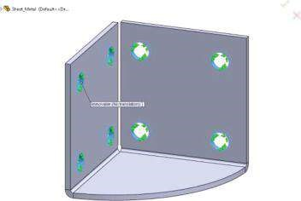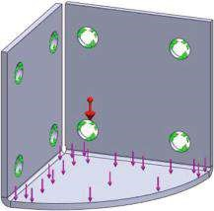

### Fig u r e 7.15

*Applied restraints at the model. (a) Applied loads. (b) Applied Immovable fixtures.*

(a) Model name: Sheet_Metal (b) Model name: Sheet_Metal Study name: Study 1 Study name: Study 1

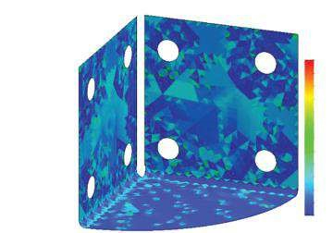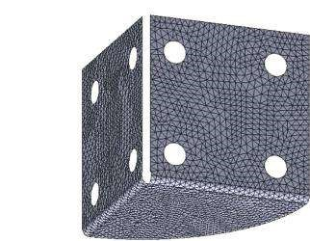

Mesh type: Shell mesh using mid-surfaces

Plot type: Aspect ratio Mesh Quality1

Aspect Rati

o

4.43

4.14

3.86

3.57

3.29

3

2.72

2.43

2.15

1.86

1.58

1.29

1.01

### Fig u r e 7.16

*Meshing the m odel. (a) Plot of the m esh. (b) Plot of the Aspect Ratio.*

shell edge, the associated face of the solid must be selected. To apply a fixture or load to the shell vertex, the associated edge of the solid must be selected. This enlarges the scope of applicable restraints. For example, **Grounded Bolt** fixtures can be applied at the hollows. We will do this and then will compare the results. **Grounded Bolds** with a diameter 13.5 mm and an axial force of 500 N suit quite well to that problem. The calculated results for the case of **Ground Bold** fixtures with the described properties are as follows: FoS = 1.09; max displacement 1.33 mm; maximal von Mises top stresses (element mode) = 560 MPa.

Further, we will continue with the case when **Immovable** fixtures at the cylindrical faces of the hollows are applied (Figure 7.15b).

When meshing the shell, the software automatically uses 2D FEs. It extracts the midsurfaces and generates shell mesh at the mid-surface. The **Flip Shell Elements** command is available. The program recognises the bended edges (Figure 7.14b) as separate shell components (Figure 7.16).

There are no tricky points in the solution. Some final plots and values are provided in Table 7.2. They compare the ‘sheet metal’ shell with **Immovable** fixtures to that with **Grounded Bold** fixtures. The plots of the stresses, of the resultant displacement and of FoS for both cases with equal ranges of the used charts are displayed in Figure 7.17.

Based on the provided values and plots, we can conclude that the use of **Immovable** fixtures makes the model steadier and causes larger stresses and displacements compared to the use of **Grounded Bold** fixtures. The **Grounded Bold** fixture ensures more accurate stress distribution and a FoS that is a little bit higher.

***Table 7.2***

### Comparison of the Results for the ‘Sheet Metal’ Part, Depending on the Applied Fixtures

**Max von Mises Stresses**

**(Element Mode) (MPa)**

**Max Displacement Min**

**Fixture Top Bottom Membrane Bending (mm) FoS**

Immovable 611.53 496.23 82.81 545.67 1.39 1.01

Grounded Bold 560.25 480.32 67.73 507.01 1.33 1.01

*Immovable fixtures*

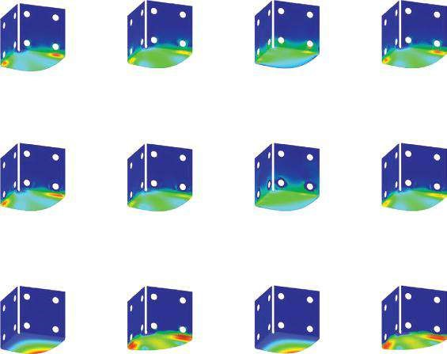

*Grounded bold fixtures*

*Grounded bold fixtures*

*Immovable fixtures*

Top stresses plot

Bottom stresses plot

Membrane stresses plot

Be

nding stresses plot

Top stresses plot

Bottom stresses plot

Membrane stresses plot

Be

nding stresses plot

Displacement plot Factor of safety plot Displacement plot Factor of safety plot

#### Fig u r e 7.17

*Results of both FEAs.*

In this section, we made an FEA of a shell, whose geometry is developed using the **Sheet Metal** tool. We compared the impact of the applied Immovable fixture to the applied Ground Bold fixture on extreme stresses and displacements.

|  |
| --- |
| We learned how to perform FEA of a shell, whose geometry is designed using the **Sheet Metal** tool. We compared   * **Shell Definition** options for shells of uniform thickness, whose geometry is developed in both different ways, and learned how to modify its thickness, offset disposition and bending radii * The processes of applying fixtures and loads and the limits imposed by different geometry modelling |

## 7.6 COMPARISON OF THE RESULTS FROM THE TWO CASE STUDIES

The results of the two previously discussed cases will be compared, and some comments and recommendations on the selection of the approach of geometry modelling – **Surface** tool versus **Sheet_Metal** tool – will be given.

To do so, the results of both previous case studies (material: Alloy steel; thickness of the sheet: 4 mm; fixtures: Immovable; loads: vertical force of 10 kN and gravity) are systematised and analysed.

The first questions to be answered are as follows: What will happen to the stresses and the displacements if we model the studied object as a solid body? What is the impact of the use of a different type of FEs? Based on the given data (Table 7.3), we can conclude that the use of solid FEs provides minimal FoS and maximal stresses. Thus, it ensures the highest level of safety, but its use is not recommended because of the great demand for computer resources and time. At that point, we do not discuss whether thin- or thick-plate formulation is used for the calculations given above.

The next set of questions to be answered is as follows: What is the impact of the choice of formulation – thin or thick plate? Can a wrong choice cause significant errors? The data provided in Table 7.4 compare the results of the FEA of the **Surface. sldprt** adopting both formulations. As the thickness increases, the discrepancies, calculated towards the ‘thick-plate’ values, also increase. Thin-plate formulation provides larger stresses, resultant displacements and smaller FoS. Thus, it is safer to use it.

The last item to be discussed is the comparison of the results of FEA of the two models – **Surface.sldprt** versus **Sheet_Metal.sldprt**. The data given in Table 7.5 are obtained according to thick-plate formulation. The most important conclusion, which can be done regarding the data, is that it is not correct to compare the results and to make any recommendations. More important is the nature of these results. Vulnerable zones are located along the bended edges of the sheet metal model. Thus, the radii of the bends influence strongly the maximal stresses, and their least modification can significantly reduce or increase the stresses. The given data are for a bending radius equal to 5 mm. The **Surface.sldprt** has adopted edge welding, which ensures less deformable edge connection, and the stresses distribute more uniformly. The only recommendation I can make, based on all the given data, is as follows: If I had to choose which of the two supporting elements to produce, I would choose to make the support made of three welded surfaces because of the higher level of safety reached. The manufacturing operations and their cost were not considered when I made my decision.

***Table 7.3***

### Comparison of Solid Body Results to Shell Model Results

**Shell Model, Developed by**

|  |  |  |  |
| --- | --- | --- | --- |
| **Cases to be Compared** | **Solid Body Model** | **Surface Tool** | **Sheet Metal Tool** |
| Max von Mises Top stresses (MPa) Bottom | 665.14 | 597.6  529.0 | 611.53  496.23 |
| Membrane |  | 64.3 | 82.81 |
| Bending |  | 563.0 | 545.67 |
| D isplacement (mm) | 1.37 | 1.42 | 1.39 |
| FoS | 0.69 | 0.97 | 1.01 |

***Table 7.4***

### Comparison of Thin-Plate versus Thick-Plate Results

**Maximal von Mises Stresses (MPa)**

**Displacement**

|  |  |  |  |  |
| --- | --- | --- | --- | --- |
| **Used Formulation Top Bottom** | **Membrane** | **Bending** | **(mm)** | **FoS** |
| **Shell Thickness *t* = 2.5 mm; *F* = 3 kN**  Thin plate 454.0 418.7 | 36.0 | 436.3 | 1.692 | 1.28 |
| Thick plate 447.6 414.3 | 35.4 | 429.4 | 1.717 | 1.39 |
| D iscrepancy 1.41 1.05 | 1.67 | 1.58 | −1.48 | −8.59 |
| **Shell Thickness *t* = 3 mm; *F* = 5 kN**  Thin plate 528.0 480.0 | 46.9 | 503.9 | 1.646 | 1.10 |
| Thick plate 519.6 473.9 | 46.0 | 494.8 | 1.679 | 1.20 |
| D iscrepancy 1.59 1.27 | 1.92 | 1.81 | −2.00 | −9.09 |
| **Shell Thickness *t* = 3.5 mm; *F* = 5 kN**  Thin plate 390.1 350.4 | 37.4 | 370.1 | 1.059 | 1.49 |
| Thick plate 383.4 345.2 | 36.5 | 362.8 | 1.086 | 1.63 |
| D iscrepancy 1.72 1.48 | 2.41 | 1.97 | −2.55 | −9.40 |
| **Shell Thickness *t* = 4 mm; *F* = 10 kN**  Thin plate 597.6 529.0 | 64.3 | 563.0 | 1.419 | 0.97 |
| Thick plate 585.08 520.0 | 62.8 | 550.5 | 1.462 | 1.06 |
| D iscrepancy 2.10 1.70 | 2.33 | 2.22 | −3.03 | −9.28 |
| **Shell Thickness *t* = 5 mm; *F* = 10 kN**  Thin plate 383.8 332.1 | 50.1 | 357.6 | 0.750 | 1.52 |
| Thick plate 375.0 325.2 | 49.1 | 348.5 | 0.781 | 1.66 |
| D iscrepancy 2.29 2.08 | 2.00 | 2.54 | −4.13 | −9.21 |
| **Shell Thickness *t* = 6 mm; *F* = 10 kN**  Thin plate 266.1 225.6 | 41.1 | 245.5 | 0.445 | 2.19 |
| Thick plate 259.4 220.2 | 40.4 | 238.7 | 0.469 | 2.40 |
| D iscrepancy 2.52 2.39 | 1.70 | 2.77 | −5.39 | −9.59 |
| **Shell Thickness *t* = 7 mm; *F* = 20 kN**  Thin plate 388.9 323.5 | 68.8 | 355.6 | 0.570 | 1.50 |
| Thick plate 378.4 314.9 | 67.7 | 345.1 | 0.609 | 1.65 |
| D iscrepancy 2.70 2.66 | 1.60 | 2.95 | −6.84 | −10.00 |
| **Shell Thickness *t* = 8 mm; *F* = 20 kN**  Thin plate 295.8 245.8 | 58.8 | 268.6 | 0.391 | 1.98 |
| Thick plate 287.8 237.8 | 58.1 | 260.6 | 0.423 | 2.16 |
| D iscrepancy 2.70 3.25 | 1.19 | 2.98 | −8.18 | −9.09 |

***Table 7.5***

### Comparison of the Results of Both Geometrical Models

**Maximal von Mises Stresses (MPa)**

**Displacement**

|  |  |  |  |  |
| --- | --- | --- | --- | --- |
| **Used Formulation Top Bottom** | **Membrane** | **Bending** | **(mm)** | **FoS** |
| **Shell Thickness *t* = 3 mm; *F* = 5 kN**  Surface.sldprt 519.6 473.9 | 46.0 | 494.8 | 1.679 | 1.20 |
| Sheet_Metal.sldprt 631.2 404.6 | 126.3 | 512.0 | 1.685 | 0.85 |
| **Shell Thickness *t* = 4 mm; *F* = 10 kN**  Surface.sldprt 585.08 520.0 | 62.8 | 550.5 | 1.462 | 1.06 |
| Sheet_Metal.sldprt 744.2 451.0 | 179.0 | 574.0 | 1.436 | 0.74 |
| **Shell Thickness *t* = 5 mm; *F* = 10 kN**  Surface.sldprt 375.0 325.2 | 49.1 | 348.5 | 0.781 | 1.66 |
| Sheet_Metal.sldprt 530.4 280.1 | 145.1 | 389.9 | 0.748 | 1.11 |
| **Shell Thickness *t* = 6 mm; *F* = 10 kN**  Surface.sldprt 259.4 220.2 | 40.4 | 238.7 | 0.469 | 2.40 |
| Sheet_Metal.sldprt 384.4 189.5 | 115.9 | 272.4 | 0.443 | 1.52 |

In this section, we compared 3D FEA to 2D FEA. We discussed the impact of the adopted calculating formulation by comparing thin-plate results to thick-plate results.

|  |
| --- |
| We learned the following:   * What the advantages are of 2D FEA, when shell objects are studied. * Will it be crucial to our analysis if we do not know which formulation (thin or thick shell) to adopt? * There is no general answer to the question: Which of the two tools (Surface or Sheet Metal) for development of shell geometry is better and should be preferred? The general answer depends on the analysed object and on the user experience. |

***CHAPTER 8***

# STATIC ANALYSIS OF A FRAME BODY

***8.1 BEAMS OR TRUSSES?***

There are many planar or spatial frames that are better modelled by 1D finite elements (FEs) instead of the known solid or shell elements.

There are two main groups of 1D FEs used by SW Simulation.

The structure in Figure 8.1a is built of 1D elements connected to each other through joints, which are designed in a way that no moments develop in them. We are not interested how these joints are implemented in the real structure – through welding, through bold connection or through another way. More important is that this structure is exposed only to forces applied at the joints. Thus, each member of the structure is either tensed or compressed. The only inner force that develops in the member is the axial force. This axial force is constant along its length and generates an axial stress that is uniform throughout the cross section. The used structural 1D members are known as **trusses**. Trusses are commonly used in structural applications such as bridges, roofs, etc.

In finite element analysis (FEA), truss members are modelled as truss elements. The truss is a special beam element that can resist only axial deformation. It is defined by two nodes at its ends. Each node has 3 orthogonal translational degrees of freedom (DoFs).

A particular case of a planar truss FE is given in Figure 8.2a. It is pinned at the left node, and an axial force *P* is applied at the right node. Axial direction is along the length of the truss. The axial stress is σ*X*=*P A*/ , and the axial displacement of the right node is *u X* = *PL EA*/ , where *P* is the axial force along the length of the truss element, *A* is the cross-sectional area of the truss, *L* is the length of the truss and *E* is the modulus of elasticity. If we write this equation as *u X* = *P*.1/(*EA*/ )*L* = *P*/*K*, *K* = *EA L*/ is called the axial stiffness of the element and describes its ability to resist axial loads. Thus, the truss is considered analogous to an axial spring.

Entirely different is the structure in Figure 8.1b. It is exposed to a horizontal force applied at the upper left corner of the frame. If all frame members are trusses, there

(a) (b)

## Fig u r e 8.1

*Frame structures (SW Simulation on-line help). (a) Frame structure of trusses; (b) frame structure of beams.*

is no way to transfer the force to the ground, and the frame will fall aside. This does not happen because the top horizontal member is fixed to the two vertical ones, that is, the connection between them is not a joint. It can be either a fixed connection, which is to be calculated as a rigid connection, or an elastic connection, and the real stiffness of the connected members is to be considered throughout the calculation. To achieve this, 1D FEs of another type are used. These FEs are known as **beams**. Beams resist bending, shear and torsional loads. To calculate the displacements, deformations and stresses inside beams, FE software requires defining the exact cross section. The stresses vary within the plane of the cross section and along the beam. In a general case, each node of the beam element has 3 orthogonal translational DOFs and 3 rotational DOFs. Therefore, not only forces but also moments can be acting on the beam.

Figure 8.2b shows a small segment along a beam element subjected to simplified 2D inner forces – axial force *P*, shearing force *V* and bending moment *M*. The stresses throughout the cross section of the beam are equal to

*P*

)

a

(

b

(

)

*V*

*M*

*M*

*y*

*V*

*Y*

*X*

*P*

/

*A*

*M*

/

*I*

*P*

/

*A*

+

*M*

/

*I*

*P*

*P*

## Figure 8.2

*1D FEs used by SW Simulation (SW Simulation on-line help). (a) Truss FE; (b) beam FE.*

* τ*X* =*V A*/ – uniform shearing stress.
* σ′*X* = *P A*/ – uniform axial stress, similar to those of the truss elements.
* σ′′*X* =( *M I*/ )\**y* – non-uniform bending stress. It is caused by the bending moment *M* and varies linearly with the vertical distance *y* from the neutral axis. The bending stress is the largest at the extreme fibres. *I* is the crosssectional moment of inertia about the neutral axis in the given equation.

Each frame problem can be simplified if the frame members are modelled with 1D FEs. This significantly reduces the required system resources. The beam formulation is acceptable if the length of the beam is at least 10 times larger than the largest dimension of its cross section. Then the software starts a procedure allowing the user to choose how to model the component – as a solid body (using 3D FEs) or as a beam (using 1D FEs). Further, the user chooses the type of the 1D FEs – a beam or a truss, in relation to the characteristics of fixtures and the connections at each member end, etc.

Beam members can be straight or curved. Each straight structural member is defined by a straight line connecting two joints at its ends. Straight beam members can have a constant cross section (Figure 8.3a) or a varying cross-sectional size along their lengths (tapered beams, Figure 8.3b). Curved structural members are modelled with a number of straight beams. The cross section of each beam is assumed to be constant throughout its length.

The program meshes each member by creating a number of beam FEs. Each beam FE is defined by two end nodes and a cross section. When viewing the mesh and the results, the beam elements are represented by cylinders regardless of their actual cross section. Each structural member can be defined as a beam (first stage) and then subdivided into a number of beam FEs represented by cylinders (second stage, Figure 8.4).

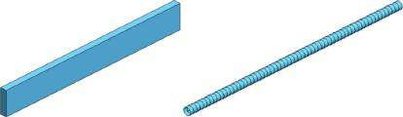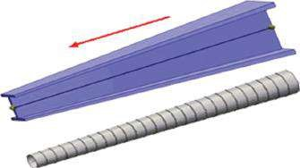

(

a

)

(

b

)

## Figure 8.3

*Beam members with constant or variable cross section (SW Simulation on-line help). (a) Beam member with constant cross section; (b) tapered beam member.*

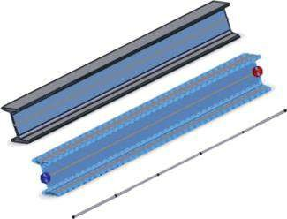

## Figure 8.4

*Modelling a structural member by beam FEs (SW Simulation on-line help).*

The section discussed the difference between the truss and the beam members of the frame structures; answered the question when the simplification of the structure by adopting 1D FEs provides acceptable results; compared both types of beam members, beams with constant cross section and tapered beams; and explained how the software models them using FEs.

We outlined the difference between the truss and the beam. We obtained a criterion for the accuracy of the results when the beam model is adopted. We studied how to calculate the stresses, adopting a truss or a beam formulation. We defined the axial stiffness of a truss. We learned how the software meshes straight and curved beams, beams with a constant cross section and tapered beams.

## 8.2 DEVELOPMENT OF A CAD MODEL OF A 3D FRAME

The CAD model will be developed using the **Weldments** tool. After starting a new part file (File→New→Part→OK) and setting the used units “**millimeter-gramsecond**” (Tools→Options→ Document Properties→Units→Unit system MMGS→OK), the model will be saved as **Frame_1. sldprt**. The next stages include

1. Drawing **Sketch1** in **Front Plane** (Figure 8.5a).
2. Drawing **Sketch2** in **Right Plane** (Figure 8.5b). The sketch is perpendicular to **Sketch1**.

The isometric view of both sketches is shown in Figure 8.5c. These sketches form the frame of the created spatial ‘structural member’ structure. The sketch segments define the path of the structural members. The sketched frame of the structure can be a planar sketch, a spatial one or a combination of a few sketches. It can include linear or curved entities. The sketch in the studied case is a combination of two perpendicular planar sketches.

The next stage is defining the structural members.

The easiest way to define a structural member is to use the **Weldments** tool.

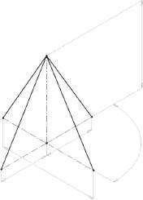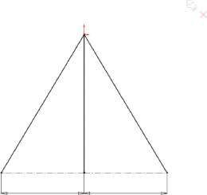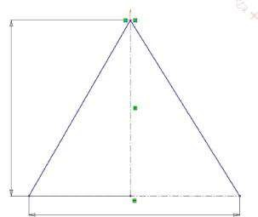

)

a

(

(

)

b

c

)

(

50

0

600

300

300

(500)

(600)

(

9

0

°

)

### Fig u r e 8.5

*CAD m odel of the spatial fram e sketch. (a) Sketch1; (b) Sketch2; (c) isom etric view of both sketches.*

1. Starting the **Weldments** tool.

To do so, right click on the **SW toolbar** and select the **Weldments** command from the pop-down menu (Figure 8.6a). The icons of some of the **Weldment** commands, being used further, are given in Figure 8.6b.

1. Adding and defining the structural members along the sketch segments of **Sketch1**.

Weldments→Structural Member()→OK

There are two sub-windows, which have options that help us in defining the properties of each structural member.

The first sub-window is **Selections**, where we select the type of the profile. The software has a rich database of different profiles in ISO, ANSI INCH or custom standard. The experienced users can add self-defined cross sections of the profiles to that library. In the pop-down **Type** menu, we can select the type of the profile: rectangular, pipe, etc. (Figure 8.7c) and to continue with selecting the size of the profile in the **Size** window. There is an option **Merge arc segment bodies**, which is available only for curved entities and adjusts the arc segment to the bodies in the structural member. We have selected an ISO 30 × 30 × 2.6 square tubeprofile (Figure 8.7d). This means that an ISO

(a) (b)

Weldment

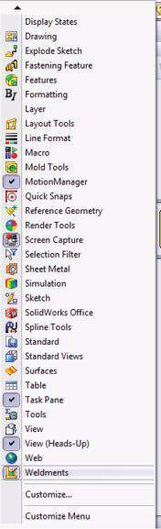

Structural member

Gusset

End cap

Weld bead

Fillet bead

Trim/extend

### Figure 8.6

*Starting Weldments tool. (a) Pop-down menu where you can start Weldments tool; (b) commands in Weldm ents toolbar.*

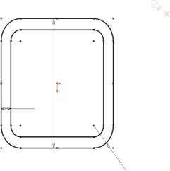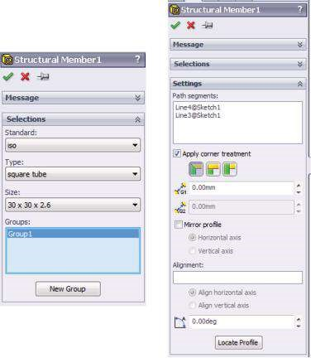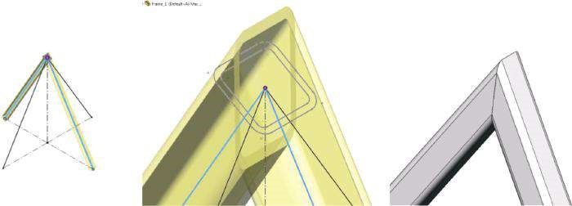

(

a

)

(

b

)

(

d

)

30

2.60

5.20

(c)

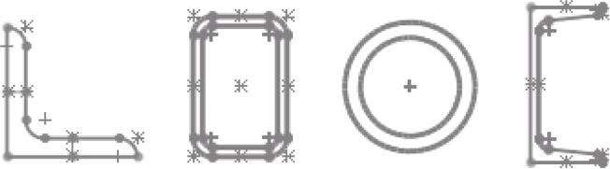

Angle iron Rectangular tube Pipe C-channel

### Fig u r e 8.7

*Definition of the structural members from Group1. (a) Structural member property manager – Group1; (b) selected sketch segments, cross section of the chosen profile and outer view of the defined group of structural members; (c) samples of the different profiles in the software library (SW Simulation on-line help); (d) sketch of the selected profile sam ple – square tube 30 × 30 × 2.6.*

standard, square tube profile with outer dimension of 30 mm and a thickness of 2.6 mm, is applied to the frame. This structural profile is attached to **Group1**, whose members are selected by picking at the **Graphics area** and whose signatures are in **Path segments** in the **Settings** sub-window (Figure 8.7a). **Group1** unites the structural members, whose paths correspond to the segments of **Sketch1** (Figure 8.7b).

The second sub-window is titled **Settings** and defines the properties of the defined group of structural members (Figure 8.7a). By either clicking directly on the model components in the **Graphics area** or by picking the sketches from the **Design manager** tree, we define the segments in the group, whose signatures are listed directly in the **Path segments** window (see blue lines in Figure 8.7b). The next choice concerns either applying or not applying corner treatment. The **Apply corner treatment** option is available only for contiguous groups and defines how to trim group segments at corner intersections. This option can be modified within the study. As the **Apply corner treatment** is selected, we can choose among **End Miter** (), **End Butt1** () or **End Butt2** (). The weld gap at the corners of the segments is input in the **Gap between Connected Segments in Same Group** window (). The weld gap between the end segments of the defined group and the segments of other groups is introduced in the **Gap between Different Group Segments** window (). The next few options can also be selected:

* **Mirror Profile**, which flips the profile of the group about its **Horizontal Axis** or **Vertical Axis**
* **Alignment**, which aligns the axis of the group profile to any selected edge, construction line, etc. picked at the **Graphics area**
* **Rotation Angle** (), which rotates the structural member by a set number of degrees
* **Locate Profile** option, which zooms to the profile, so that the user can change its **pierce point**

The pierce point defines the location of the profile, relative to the sketch segment used to create the structural member. The default pierce point is the sketch origin in the profile library feature part. However, any vertex or sketch point specified in the profile can also used as a **pierce point** (Figure 8.8).

For this case study, the following options of the **Settings** are selected: the lines*,* which form the group; End Miter corner treatment; **Gap between Connected Segments in Same Group** is zero;No**Gap between Different Group Segments** is defined for there is only one group of structural members; no need to flip the profile for it is symmetrical – **Mirror profile** unchecked;

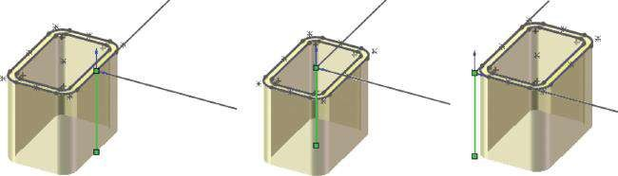

### Figure 8.8

*Profile sample, with three different pierce points (SW Simulation on-line help).*

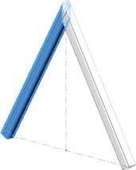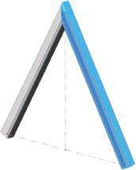

(

a

)

(

b

)

### Fig u r e 8.9

*Structural m embers attached to Sketch1. (a) Structural Member1 [1]; (b) Structural Member1 [2].*

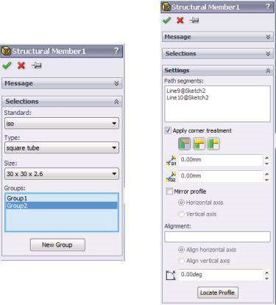

(

a

)

(b)

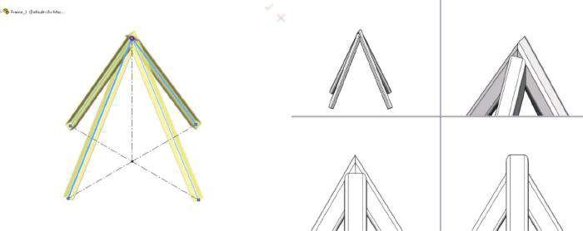

### Fig u r e 8.10

*Definition of the structural members of Group2. (a) Structural member property manager – Group2; (b) selected sketch segments and outer view of both defined groups of structural members.*

**Rotation** angle is zero and the pierce point of the profile coincides with its axis (Figure 8.7b).

After clicking **OK** and closing the **Structural member** property manager, some new lines appear in the **Design manager tree**. They include **Structural Member1** [1] (Figure 8.9a) and **Structural Member1** [2] (Figure 8.9b).

5. Adding and defining the structural members along the sketch segments of **Sketch2**.

Without closing the **Structural member** property manager, we continue with the definition of the second group of structural members. It unites the structural members, whose paths correspond to the line segments of **Sketch2**. To start this operation, we click on the **New Group** button in the **Selections** sub-window and pick the lines at the **Graphics area** (Figure 8.10). The user can see how the software forms the upper connection of the structure and, if necessary, how to modify it through **Apply corner treatment** options.

In this section, the user develops a CAD model of a 3D frame using the **Weldments** tool and by defining structural members along the line segments of two perpendicular sketches.

We learned how to create a CAD model of a 3D frame using a combination of two perpendicular sketches. The path of each structural element corresponds to the line segments of these sketches. We defined the cross section of the elements using an existing library of structural elements. We explained the different ways of corner treatment and the required input data.

## 8.3 CALCULATION OF A 3D FRAME OF TRUSSES

### 8.3.1 Pre-Processor and Processor Stages

Our next task is to perform a static analysis of the developed 3D frame using truss elements. Therefore, we have to define immovable fixtures at the end of each structural member and to ‘tell’ the software that the connection at the top of the structure is a joint. Consequently, the external loads are limited to forces at the joints.

We start a static analysis. Its title is **Static_Truss** to remind us that we will use truss elements. The material of all bodies is **Aluminum Alloy 1060**, with the following properties: elastic modulus – 69 GPa; Poisson’s ratio – 0.33; shear modulus – 27 GPa; mass density – 2700 kg/m3; tensile strength – 68.94 MPa; yield strength – 27.57 MPa. As we intend to use truss elements, only elastic modulus and yield strength are required for performing the calculations. As gravitational loads will be considered, the density is also required.

After right click on the name of each body (Structural Member), a pop-up menu appears (Figure 8.11a), where we can select one of the two options – either **Treat as Solid** or **Edit definition**. The icon in front of the name of the body () prompts that the structural member is modelled as 1D body, that is, either truss or beam FEs will be

(a) (b)

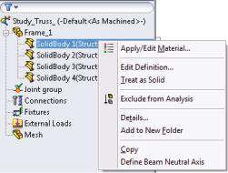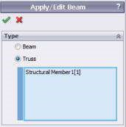

#### Fig u r e 8.11

*Definition of the truss structural members. (a) Simulation analysis pop-down menu; (b) apply/ edit Beam property manager – Truss checked.*

used throughout the structural analysis. If we pick the **Treat as Solid** command, the software automatically starts to consider the body as a solid one and the icon in front of its name changes (). Further, this body will be meshed with 3D solid FEs. Truss FEs are preferred for this example. Thus, we pick the **Edit definition** command, and the **Apply/Edit Beam** property manager appears. This property manager allows the user to define a beam or a truss. Our choice directly influences the transfer of forces and deformations. We pick **Truss** (Figure 8.11b) and then **OK**. The icon in front of the body’s name automatically changes to .

When defining beams or trusses, the software automatically generates a new group in the **Simulation Analysis** tree. This new group is titled **Joint group** () and calculates the joints in the analysed structure. The software identifies a joint at the free end of a structural member or at the intersection of two or more structural members. The joint coincides with the pierce point of the weldment profile. Hence, it is recommended to locate the **pierce point** (Figure 8.8) at the centre of gravity of the weldment profile (Figure 8.12). If so, the axial loads generate axial stresses only.

After right clicking on **Joint group** and selecting **Edit** from the pop-down menu, the **Edit Joints** property manager opens (Figure 8.13a). It combines three sub-windows: **Selected Beams**, **Results** and **Criteria**. There are two options in the **Selected Beams** sub-window: **All** – when the software considers all structural members when calculating the joints; and **Select** – when the software considers only the selected structural members () when calculating joints. Clicking the button **Calculate** calculates the joints in the structure. As a result, the software colours in pink ( ) the joints where two or more structural members intersect and colours in green ( ) the joints at the ends of the structural members, as well as their mid-points (Figure 8.13b).

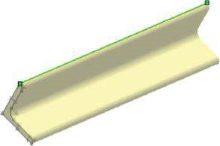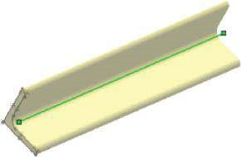

(

a

)

(

b

)

#### Fig u r e 8.12

*Definition of the joints for truss structural members (SW Simulation on-line help). (a) A pierce point at the vertex of the angle profile; (b) a pierce point at the centre of gravity of the angle profile.*

(a) (b)

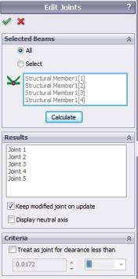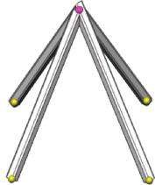

#### Fig u r e 8.13

*Calculation of the joints. (a) Edit Joints property manager; (b) calculated joints.*

The list of all calculated joints is automatically displayed in the **Results** sub-window. By clicking on a joint from the list, the software highlights it, and we can edit its properties or even delete it. Selecting the **Keep modified joint on update** allows the user to save the modifications in the model.

The **Criteria** sub-window enables definition of joints between non-touching structural members within a certain distance (tolerance). The software suggests an optimal tolerance value, but the user can overwrite it by selecting **Treat as joint for clearance less than**.

Restraints can be applied to joints only. Only translational restraints can be applied to truss joints. There are 3 translational degrees of freedom at each node (joint). Consequently, **Fixed Geometry** () and **Immovable (No translations)** ( ) restraints act similarly at truss joints as no rotations are considered. Zero or non-zero prescribed translations can also be applied. The joints at which restraints are applied are selected by picking at the **Graphics area** and are listed in the joint window (, Figure 8.14).

(a) (b)

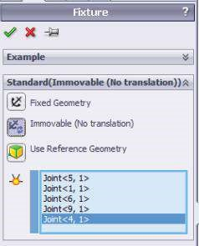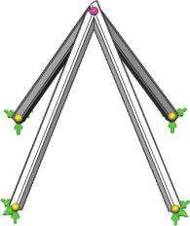

#### Fig u r e 8.14

*Application of the fixtures. (a) Fixture property manager for structures of 1D members; (b) 3D structure with applied fixtures.*

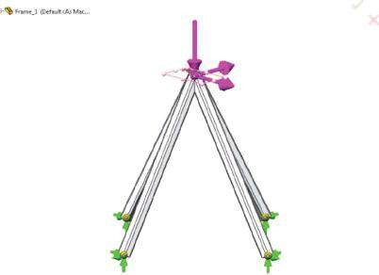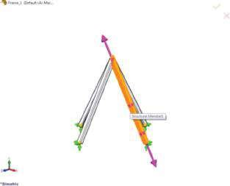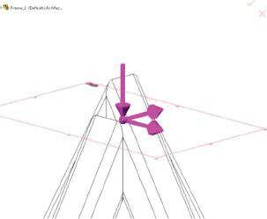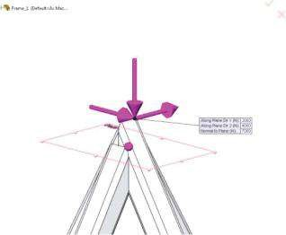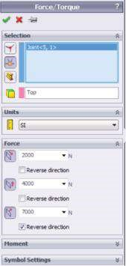

(

)

a

(

b

)

(

e

)

(

d

)

(

)

c

***Figure 8.15***

*Applying the forces. (a) Applying forces at a vertex; (b) applying forces at a joint; (c) applying forces at a structural member; (d) Force property manager;*

*(*

*e) applied forces.*

The software applies only concentrated forces at joints or at reference points. The software automatically ignores any forces applied normally to the truss. Only axial forces generated in the elements are considered. After activation of the **Force/Torque** property manager, only force options are accessible. Forces can be applied at **Vertices** or **Points** (, Figure 8.15a), at **Joints** (, Figure 8.15b) or at **Structural members** ( ). When applying a force at a structural member, it can be either a tensile or a compressive force along the axis of the member (Figure 8.15c). We apply the force at the top joint (Figure 8.15d and e). When applying the force at a vertex or a point, or at a joint, a reference entity **Face, Edge or Plane for direction** () must be selected. The values of the force components are related to that selection. We have selected Top Plane as a reference plane (Figure 8.15d and e). The selected unit for force components is newton (N). The values of the components are as follows: **Along Plane Dir 1** ( ) – 2000 N; **Along Plane Dir 2** () – 4000 N; and **Normal to Plane** () – 7000 N with **Reverse direction** selected (Figure 8.15d).

Regarding the meshing, there are no options in meshing trusses. A straight truss is represented by one truss element. The axial stress is constant throughout the cross section and along the truss. The variation of the axial deformation is linear. Meshed truss members are displayed as solid cylinders regardless of their actual cross-sectional shape. The meshed structure consists of four FEs and five nodes, which coincide with the joints (Figure 8.16).

### 8.3.2 Viewing the Results

The use of truss FEs provides results for axial stresses and forces, displacements and deformed shape plots. Forces and stresses of a truss member are constant throughout the cross section and along the truss. In the stress plot, each truss element appears in one colour (Figure 8.17a).

Inner forces are displayed by activating the **Beam Diagrams** property manager after right clicking the **Results** menu. We can pick some or all trusses (). Automatically the software suggests all structural members to be selected. We select the **component** () and the **units** () of the displayed inner force – axial force, measured in newtons. The **Beam Diagram Width** option controls the width of beam plots for better visibility and is set to 30 (Figure 8.17c). The force in a truss member equals the axial stress multiplied by its cross-sectional area (Figure 8.17b).

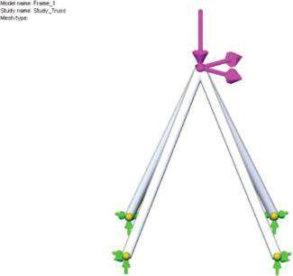

Model name: Frame_1

Study name: Study_Truss

Mesh type:

#### Fig u r e 8.16

*Meshed structure.*

(a) (b)

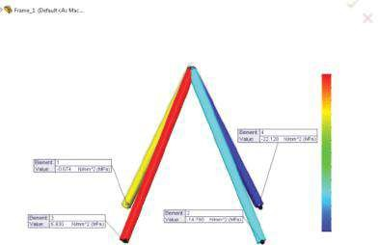

Model name: Frame_1

Study name: Study_Truss

Plot type: Axial stress (P/A) Stress1

Model name: Frame_1

Study name: Study_Truss

Plot type: Shear-Moment Plot1

Axial P/A (N/mm

2

(MPa))

Axial Force (N

)

6.930

4.509

2.087

–0.334

–2.756

–5.178

–7.599

–10.021

–12.442

–14.884

–17.205

–19.707

–22.128

–5920

–5273

–4625

–3977

–3329

–2681

–2033

–1385

–737

–89

558

1205

1854

(c) (d)

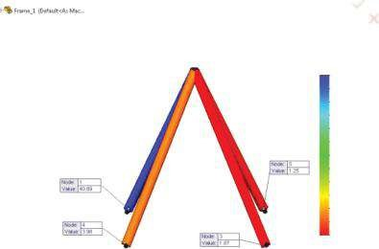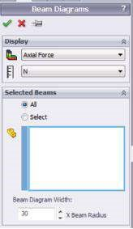

Model name: Frame_1

Study name: Study_Truss

Plot type: Factor of Safety Factor of Safety1

Criterion: Automatic

Factor of Safety ditribution: Min FOS = 1.2

FOS

1.25

4.55

7.85

11.16

14.46

17.76

21.07

24.37

27.68

30.98

34.28

37.59

40.69

(e) (f)

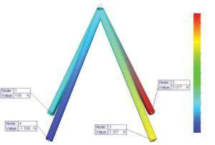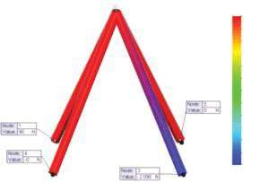

RFX (N)

RFY (N)

–2090

–1909

–1727

–1545

–1363

–1182

–1000

–818

–637

–455

–273

–91

90

–1590

–1004

–479

77

632

1188

1743

2299

2655

3410

3966

4521

5077

(g)

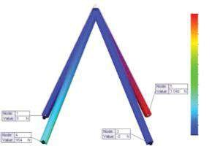

RFZ (N)

–0

254

508

762

1015

1266

1523

1777

2031

2265

2538

2792

3045

#### Fig u r e 8.17

*Results of truss structure calculation. (a) Axial stresses; (b) axial force diagram; (c) Beam Diagrams property manager; (d) FoS plot; (e) RX reaction in each truss; (f) RY reaction in each truss; (g) RZ reaction in each truss.*

***Table 8.1***

### Results of Truss Structure Analysis

|  |  |  |  |  |
| --- | --- | --- | --- | --- |
| **Results** | **Structural**  **Member 1** | **Structural**  **Member 2** | **Structural**  **Member 3** | **Structural**  **Member 4** |
| Stresses (MPa) | −0.675 | −14.780 | 6.930 | −22.128 |
| Axial forces (N) | −180 | −3955 | 1854 | −5920 |
| FoS | 40.89 | 1.87 | 3.98 | 1.25 |
| **Reactions** RX (N) | 90 | −2090 | 0 | 0 |
| RY (N) | 156 | 3357 | −1590 | 5077 |
| RZ (N) | 0 | 0 | 954 | 3046 |
| Resultant reaction force (N) | 180 | 3955 | 1854 | 5920 |

The displacements vary linearly between the ends. The displacements at the top node are UX = 0.118 mm; UY = −0.075 mm; UZ = −0.238 mm; and UREZ = 0.277 mm.

The reactions are plotted in Figure 8.17e–g. The values are listed in Table 8.1. Axial forces and stresses at each truss can be listed and saved as a *.csv or *.txt file.

In this section, we made a FE analysis of a spatial frame using truss FEs.

|  |
| --- |
| We learned   * How to transform structural members in trusses * What the restrictions are regarding the application of external loads and fixtures * How the software visualizes truss members after meshing the frame • The main results provided by the program |

## 8.4 CALCULATION OF A 3D FRAME OF BEAMS

### 8.4.1 Pre-Processor and Processor Stages

When the ratio of a body’s length over the largest orthogonal cross-sectional distance from the centroid is larger than 3.0, the software offers the option **Treat as Beam** in the pop-up menu that is displayed after right clicking on the name of the part. If this option is selected, the icon in front of the name of the part changes to **Beam** (). By default, the software chooses this option for all structural members. The beams can have a constant cross section or a varying cross-sectional size along their lengths. The second group of beams is known as tapered beams ().

Before defining the beam properties, the material of the structure is set. This is Aluminum Alloy1060. When beam FEs are used, **the modulus of elasticity** and **Poisson’s ratio** of the material are always required. **Density** is required only if gravitational loads are considered. Modulus of elasticity and Poisson’s ratio are 69,000 MPa and 0.3, respectively.

The properties of the beam are introduced through the **Apply/Edit Beam** property manager. At first, the user defines whether the member will be treated as a truss or as a beam. Differing from the truss, the beam resists axial, bending and torsional loads. If the beam option is picked, the user controls the transfer of forces and moments at each end. Thus, any of the force or moment components at the member’s ends can be set to zero. The input restraints apply to joints and hence to all beams’ ends that meet at those joints also. The options specified by the **Apply/Edit** **Beam** property manager override restraints. For example, if you define a beam end as a **Hinge** and apply a **Fixed** restraint to the associated joint, the specified beam end acts as a **Hinge** and does not carry any moment.

The **Apply/Edit Beam** property manager combines four sub-windows (Figure 8.18a).

The first sub-window is **Type** and it enables the user to select the type of the picked member – a truss or a beam (Figure 8.18b). The picked member is visualized at the **Graphics area** (Figure 8.18e).

The next two sub-windows introduce the restraints at each end of the beam. End 1 is coloured in red (), while End 2 is coloured in blue (, Figure 8.18e).

The sub-window **End1 Connection** sets the forces and the moments at the first end of the beam. The **End2 Connection** sub-window has the same set of options (Figure 8.18c). The user chooses among the following options:

* **Rigid** – No forces or moments are released at this end. If restraints are applied to the associated joint, the restraint condition fully defines the transfer of forces and moments. If no restraints are applied, continuity is assumed at the associated joint. This option is used unless there is a reason to release (set to zero) force or moment components at the end.
* **Hinge** – The end can rotate freely and does not transfer any moments to the joint. This condition is applied to all beam ends meeting at the joint to define the joint as an intermediate hinge.
* **Slide** – The end can translate freely and does not transfer any forces to the joint.
* **Manual** – If this option is checked, the user must manually specify for each force or moment component whether it is known to be zero. To do so, the user either checks or not the following options:
* Hinge, first direction – sets the moment about the first direction of the cross section to zero. The end can rotate about this direction.
* Hinge, second direction – if checked, the moment about the second direction of the cross section is zero. The end rotates about this direction.
* Hinge, along beam – the options must be checked if the moment about the axial direction of the beam is known to be zero. The end can rotate about this direction; hence, this beam end is not exposed to torsion.
* Slide, first direction – if the force in the first direction of the cross section is known to be zero, the user must check this option. The end can translate freely along this direction.
* Slide, second direction – select this option if the force in the second direction of the cross section is known to be zero. The end translates along that direction.
* Slide, along beam – this option sets the force in the axial direction of the beam to zero. The end can translate along this direction.

The directions of the beam are shown in Figure 8.18f. The red arrow on the right picture shows the positive axial direction, the green arrow shows the positive direction 1 and the blue arrow shows the positive direction2 for each beam member.

For this case study, Rigid option at both ends of each beam member is checked (Figure 8.18c).

(a) (b) (c) (d)

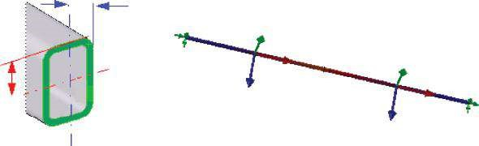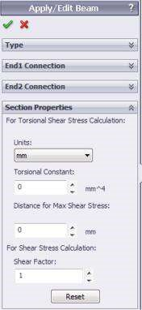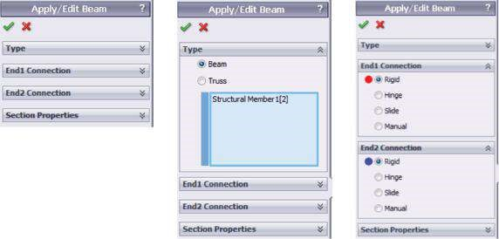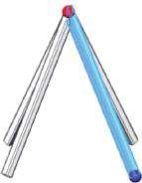

(

e

)

(

f

)

y1

dir 1

y2

dir 2

#### Fig u r e 8.18

*Definition of the constraints at the beam ends. (a) Apply/Edit Beam property manager; (b) Type sub-window; (c) End Connection sub-windows; (d) Section Properties sub-window; (e) view of the selected structural member; (f) directions of the beam (SW Simulation on-line help).*

The fourth sub-window of the **Apply/Edit Beam** property manager is **Section Properties**.

It allows the user to select the unit of length for the calculation of torsional constant and distance for maximum torsional shear (mm in the example). Further, the user can introduce the calculated **Torsional Constant** (K). Torsional stiffness constant has a dimension of the length to the fourth power and is a function of the cross section. To calculate the torsional constant, the user can utilise the special tables (Formulas for torsional deformation and stress, Formulas for Stress and Strain of Roark and Young, for example). The next window defines the **Distance for Max Shear** (CTOR). This is the distance from the centre of the section to the point of maximum torsional shear. The distance for maximum shear depends on the cross section. The maximum torsional shear stress is then calculated from τMAX =(*T K*/ ) *CTOR, where *T* is the applied torque. The software requires a **shear factor** (**SF**) for the shear stress calculation. This factor is the ratio of (effective area under shear/beam’s cross-section area). It depends on the cross-section’s shape and is less than 1. For example, for a rectangular section, *SF* = ⅔, and for a solid circular section, *SF* = ¾. The maximum shear stresses in the two local directions are *V A*1 / \**SF* and *V A*2 / \**SF*, where *V*1 and *V*2 are the two shear forces, *A* is the cross-sectional area and *SF* is the shear factor, as input by the user. The **Reset** button resets the variables to their default values.

After setting the type of each beam member, we have to recalculate the joints. We will do this according to the instructions in Section 8.3. It is important to remember that the program creates a node at the centre of the cross section of each joint member. Sometimes, due to trimming and the use of different cross sections for different members, the nodes of members associated with the joint may not coincide. Then, the program creates special elements near the joint to simulate a rigid connection based on geometric and material properties. Further, the **Display of neutral axis** button can also be checked (Figure 8.13a). The neutral axis is that fibre of the beam member, whose length remains constant during the deformation.

The software allows the user to identify a new neutral axis and thus to override the neutral axes of beams automatically selected by the program. To do this, the user must start the **Identify Neutral Axis** property manager by right clicking on the name of the structural member and then clicking the **Define Beam Neutral Axis** command (Figure 8.19). The user selects an edge of the beam’s body that is parallel to the desired orientation of the new neutral axis (). The use of that tool is worthy in cases where the identification of neutral axes by the software may not be accurate, and there is a need to modify the direction of the beam’s neutral axis, for example, for short structural members with a length-to-width ratio < 3. If the edge selection is invalid, a message appears to inform that the beam’s section properties are incorrect and prompts selecting a valid edge.

Performing FE analysis with beam FEs, the user can apply restraints to joints only. There are 6 degrees of freedom at each joint. Thus, zero or non-zero prescribed translations and rotations can be applied. **Fixed Geometry** fixtures will be applied at the free end of each structural member (Figure 8.20a).

Afterwards, the external loads are applied. There are no restrictions that these loads be forces and be applied only at joints, as is the case when truss FEs are used. The applied loads are as follows:

* **Gravity** (the red arrow, Figure 8.20b).
* **Torque** applied to the top joint () and equal to 100 Nm (the violet arrow, Figure 8.20c).
* **Non-uniform load**, distributed according to parabolic () law. The total value of the load is 500 N (the orange arrows, Figure 8.20d). This load is applied at the beam () picked in the **Selection** sub-window. When non- uniform load is input, the software does not allow selection of multiple members. Thus, the introduction of the linear non-uniform loads is done in two consequent operations – for every structural member separately.

(a) (b)

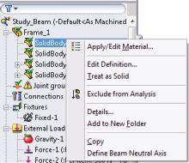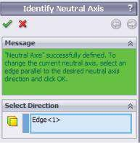

#### Fig u r e 8.19

*Definition of a new beam neutral axis. (a) Start of the procedure; (b) Identify Neutral Axis property m anager.*

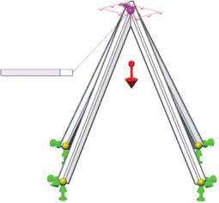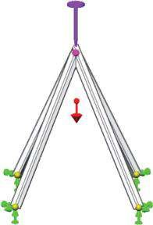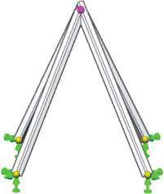

(

c

)

(

b

)

(

a

)

Normal to Plane (m/s

2

):

9.81

(d) 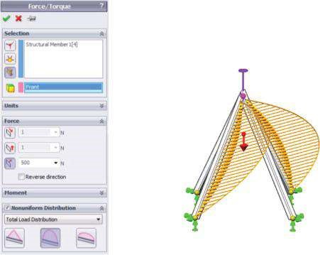

#### Figure 8.20

*Defined the boundary conditions. (a) Fixed Geometry fixtures; (b) gravity is applied; (c) torque is applied; (d) applied non-uniform distributed loads.*

Further, some additional explanations about the input of non-uniform loads are given. When a uniform load along the beam is applied, the units are set to newtons per meter and the total applied force is calculated by the software as a product of the load value and the length of the beam. For non-uniform loads, this option is not available. When a non-uniform distribution is selected, the user must choose one of the following options:

* **Total Load Distribution** – It distributes the total force/moment along the length of the beam. No loads are applied at the ends of the beam. The shape of the distribution can be triangular, parabolic or elliptical. The total value of the load equals the value introduced in the property manager (Figure 8.20d).
* **Centred Load Distribution** – Applies the force/moment at the centre of the beam. Loads decrease on either side of the centre according to the selected triangular, parabolic or elliptical distribution and are defined per unit length. No loads are applied at the ends of the beam. The value introduced in the property manager equals the centre/maximal value of the load. The total applied load is a function of the beam’s length.

(a) (b)

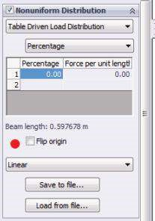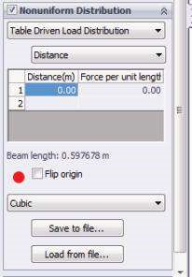

#### Fig u r e 8.21

*Definition of table-driven loads. (a) Table-driven percent load, using linear law interpolation for intermediate values; (b) table-driven distant load, using cubic law interpolation for intermediate values.*

When **Total Load Distribution** or **Centred Load Distribution** is picked, the user selects among the following:

* **Triangular distribution** (), which distributes the total or the centred load along the length of the beam in a triangular distribution.
* **Parabolic distribution** (), which distributes the total or the centred load along the length of the beam in a parabolic distribution.
* **Elliptical distribution** (), which distributes the total or the centred load along the length of the beam in an elliptical distribution.

The last existing option for the description of the law distribution is the **Table Driven Load Distribution** (Figure 8.21). It distributes the force values at specific locations along the length of the beam. The locations can be specified either as percentages or as distances from one end of the beam. If **Percentage** is selected, it lets entering the locations of the specified force values along the length of the beam as percentage values of the total beam length. For each percentage entry in the table, the associated force per unit length must be typed. If **Distance** is picked, the distances from the origin of the intermediate beam locations must be entered. For each distance entry in the table, the associated force per unit length must be typed. Checking the **Flip origin** reverses the tarting point of the force distribution to the opposite joint of the beam. The starting point is highlighted with an icon of a red sphere. An arrow indicates the direction of the force distribution in the **Graphics area**. The tab below guides the user in defining the interpolation scheme for intermediate beam locations not specified in the table. The user can choose between **Linear** or **Cubic** functions. The defined table-driven load distribution data can be saved to a *.csv or *.txt file by clicking **Save to file**. This file includes commaseparated values, which can be edited or viewed by a text editor or by Microsoft Excel package. The opposite command is **Load from file** (Figure 8.21).

Regardless of their actual cross-sectional shape, meshed beam members are displayed as hollow cylinders, which is the same way the truss members are displayed. The number of uniform elements is defined automatically, so the user can view the variation of deformation and stresses along the length of the member (Figure 8.22a). Differing the truss FEs, beam FEs enable the **Apply Mesh Control** (, Figure 8.22b).

(a)

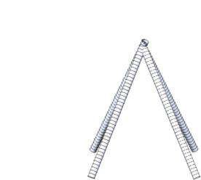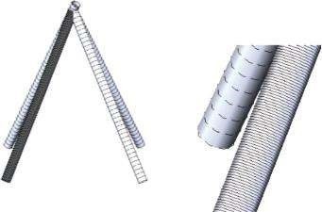

(

b

)

Model name: Frame_1

Study name: Study_Beam

Mesh type:

(c) (d)

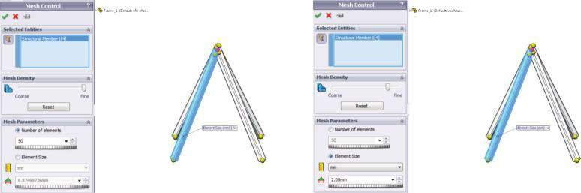

#### Figure 8.22

*Meshing the beam structure. (a) Meshed beam structure; (b) meshed beam structure with applied mesh control at one of the members; (c) controlling the number of FEs; (d) controlling the size of FEs.*

There are two ways to apply mesh control: by defining the number of FEs along the picked structural member (Figure 8.22c) or by defining their size (Figure 8.22d). Mesh control can be applied to each member separately or to a group of members.

### 8.4.2 Viewing the Results

Results for each element are presented in its local directions (Figures 8.18f and 8.23). There is no averaging of stresses for beam elements. The user can view uniform axial stresses, torsional and bending stresses in the two orthogonal directions (dir 1 and dir 2) and the worst stresses on extreme fibres generated by combining axial and bending stresses.

Starting the **Settings** property manager (), the user can select the option **Show beam direction** and thus see the local directions for every plot (Figure 8.23b). The green arrow always shows the positive **direction 1**, and the blue arrow shows the positive **direction 2**. Generally, the beam section is subjected to an axial force *P* and two moments *M1* and *M2* (Figure 8.23a). The moment *M1* is about the axis along direction 1, and the moment *M2* is about the axis parallel to direction 2.

The software provides the following options for viewing stresses (Figure 8.24):

* **Axial:** Uniform axial stress = *P*/*A* (Figure 8.24a).
* **Bending in local direction 1:** Bending stresses due to *M2*. This is referred to as **Bending Ms/Ss** in the plot name, title and legend (Figure 8.24c).
* **Bending in local direction 2:** Bending stress due to *M1*. This is referred to as **Bending Mt/St** in the plot name, title and legend (Figure 8.24d).

(a) (b)

y1

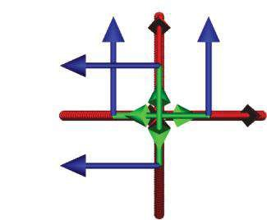

Model name: Frame_1

Study name: Study_Beam

Plot type: Factor of Safety Factor of Safety2

Criterion: Automatic

Factor of safety distribution: Min FOS = 1.1

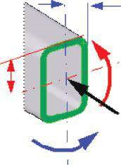

M2

M1

dir 2

y2

P

#### Figure 8.23

*Positive directions of inner forces. (a) Positive inner forces for a beam FE (SW Simulation on-line help); (b) positive directions for the studied structure – top view.*

(a) (b)

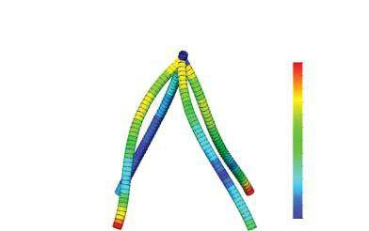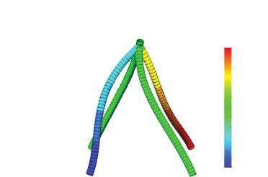

Mo

del name: Frame_1

Study name: Study_

Beam

Plot ty

pe: Axial stress (P/A) Stress1

De

formation scale: 230.653

Model name: Frame_1

Study name: Study_Beam

Plot type: Highest axial bending stress Stress1

Deformation scale: 230.653

Axial P/A (N/mm

2

(MPa))

Highest axial and bending (N/mm

2

(MPa))

2

1

1

1

1

0

–0

–0

–1

–1

–1

–1

–2

0

2

4

6

8

10

12

14

16

19

21

23

25

(c) (d)

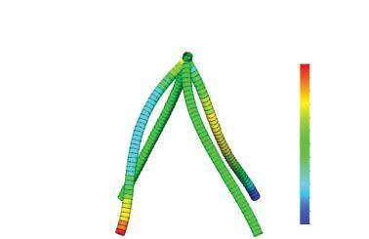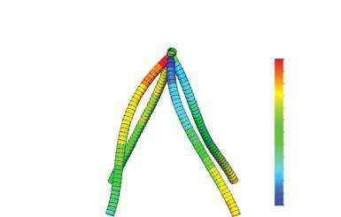

Bending Ms/Ss (N/mm

2

(MPa))

Bending Mt/St (N/mm

2

(MPa))

Mo

del name: Frame_1

Study name: Study_

Beam

Plot ty

pe: Bending stress (Ms/Ss) Stress1

De

formation scale: 230.653

Model name: Frame_1

Study name: Study_Beam

Plot type: Bending stress (Ms/Ss) Stress1

Deformation scale: 230.653

–20

–17

–14

–11

–8

–6

–3

0

3

6

9

12

15

–15

–13

–10

–7

–5

–2

0

3

5

8

10

13

15

#### Figure 8.24

*Plots of normal to the cross section of the beam member stresses. (a) Axial stresses; (b) highest axial and bending stresses; (c) bending in local direction 1 (Ms/Ss); (d) bending in local direction 2 (Mt/St).*

The software automatically calculates the highest stresses at the critical point on the cross section by combining axial and bending stresses due to *M1* and *M2*. This is the worst case and the recommended stress to view (Figure 8.24b). In general, the software calculates four stress values at the extreme fibres at each end. When viewing the worst case stresses, the software shows one value for each beam segment. This value is the largest in magnitude out of the eight values calculated for the beam segment. These values are accurate for beam with cross sections that are symmetric in two directions. These values are also conservative for all other cases.

The software plots the displacements of each node, parallel to the global coordinate axes as well as the resultant displacement (Figure 8.25).

While using other types of FEs, the FoS plot is also available. Its minimal value is

1.11 (Figure 8.26).

(a) (b)

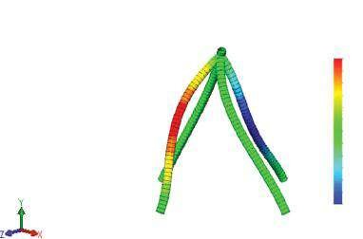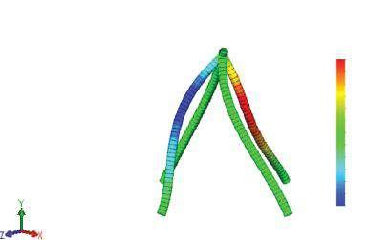

Model name: Frame_1

Study name: Study_Beam

Plot type: Static displacement Displacement1

Deformation scale: 230.653

Model name: Frame_1

Study name: Study_Beam

Plot type: Static displacement Displacement1

Deformation scale: 230.653

UX (mm)

UY (mm)

0.193

0.161

0.13

0.099

0.0678

0.0366

0.00546

–0.0257

–0.0569

–0.0881

–0.119

–0.15

–0.182

–0.101

–0.0841

–0.067

–0.0499

–0.0326

–0.0157

0.00143

0.0185

0.0356

0.0526

0.0699

0.087

0.104

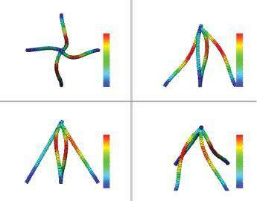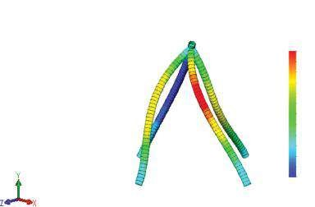

(

c

)

(

d

)

Model name: Frame_1

Study name: Study_Beam

Plot type: Static displacement Displacement1

Deformation scale: 230.653

UZ (mm)

–0.0852

–0.0554

–0.0276

0.00114

0.0299

0.0587

0.0875

0.116

0.145

0.174

0.203

0.231

0.26

URES (mm)

URES (mm)

URES (mm)

URES (mm)

0.278

0.255

0.231

0.208

0.185

0.152

0.139

0.115

0.0926

0.0604

0.0453

0.0231

1e-030

0.278

0.255

0.231

0.208

0.185

0.152

0.139

0.115

0.0926

0.0604

0.0453

0.0231

1e-030

0.278

0.255

0.231

0.208

0.185

0.152

0.139

0.115

0.0926

0.0604

0.0453

0.0231

1e-030

0.278

0.255

0.231

0.208

0.185

0.152

0.139

0.115

0.0926

0.0604

0.0453

0.0231

1e-030

#### Fig u r e 8.25

*Plots of normal to the cross section of the beam member stresses. (a) Displacement of nodes parallel to X; (b) displacement of nodes parallel to Y; (c) displacement of nodes parallel to Z; (d) resultant displacement from different points of view.*

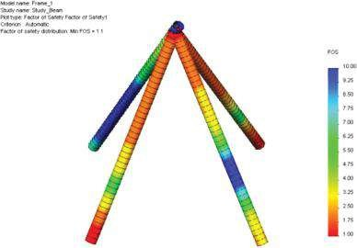

FOS

10.00

9.25

8.50

7.75

7.00

6.25

5.50

4.75

4.00

3.25

2.50

1.75

1.00

Model name: Frame_1

Study name: Study_Beam

Plot type: Factor of Safety Factor of Safety1

Criterion: Automatic

Factor of safety distribution: Min FOS = 1.1

#### Figure 8.26

*Factor of safety plot of the analysed structure.*

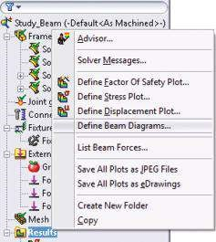

#### Figure 8.27

*Starting Define Beam Diagrams procedure.*

Clicking **Define Beam Diagrams** from the right-click pop-up **Results** menu (Figure 8.27) allows the user to plot the inner force diagrams for structural members (Figure 8.28).

Some of the inner force values are given in Table 8.2.

The graphs of some of the inner force functions along the member axes are given in Figures 8.29 and 8.30.

### 8.4.3 FE Analysis, When There Are Hinge Connections at Both Ends of All Beam Members

Further, the results of the structure, when there are hinges at both ends of each beam member, are provided. To transform the model, all rigid constraints are replaced by hinge ones (Figure 8.18c) through the **Apply/Edit Beam** property manager.

The minimum FoS strongly reduces to 0.586. This is a very good example to show one of the easiest ways to make the structure more reliable by simple change of the type of the connections between structural members. If the structure with rigid constraints is safe enough, the structure with hinges at both ends is not recommended.

The inner force diagrams of the newly studied structure are shown in Figure 8.31. There is no torsion at the beams because of the newly defined beam constraints. Even more, all moments at the fixtures are zero, that is, the applied **Fixed Geometry** () fixtures act as **Immovable** (), which means that when hinges replace the rigid constraints, the software automatically ignores the fixing moments and replaces the **Fixed Geometry** fixtures with **Immovable** fixtures.

Table 8.3 provides the values of the inner forces as well as the reaction forces at each fixture.

The graphs of the polynomial inner force functions are shown in Figure 8.32. As you can see, there is zero bending moment in direction 2 at both ends of each beam.

In this section, we made a FE analysis of a spatial frame using beam FEs. We applied different external loads at the analysed structure: gravity, torque and nonuniform parabolic linear load. We varied the restraints at the ends of beam members and compared the results.

|  |
| --- |
| We learned how   * To transform 1D members of the structure in beam members and how to define the restraints at beam ends * To apply non-uniform linear loads at beam members * To view inner force diagram and stresses as well as the reaction components * Different end constraints influence the final results   We showed how a simple modification of a structural members’ connection can increase the reliability and the safety of the structure, without adding new components or significant cost increase. |

(a) (b)

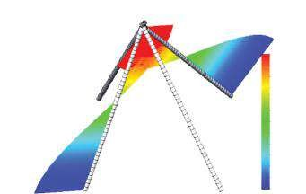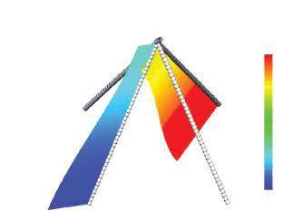

Mo

del name: Frame_1

Study name: Study_

Beam_hinge

plot ty

pe: Shear-Moment Plot1

Model name: Frame_1

Study name: Study_Beam_hinge

plot type: Shear-Moment Plot1

Axial Force (N)

Shear Force in Dir1 (N)

466

388

309

231

153

74.2

–4.2

–82.5

–161

–239

–318

–396

–475

–263

–226

–190

–154

–118

–81.3

–45

–8.67

27.6

63.9

100

137

173

(c) (d) (e) (f)

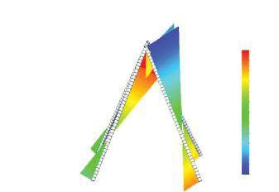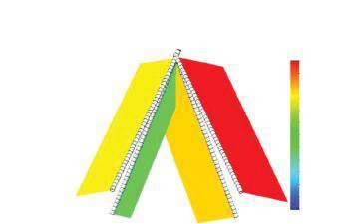

Mo

del name: Frame_1

Study name: Study_

Beam_hinge

plot ty

pe: Shear-Moment Plot1

Model name: Frame_1

Study name: Study_Beam_hinge

plot type: Shear-Moment Plot1

Moment in Dir1 (N-m)

Shear Force in Dir2 (N)

–4.55e-012

9.17

18.3

27.5

36.7

45.8

55

64.2

73.4

82.5

91.7

101

110

–43.1

–36.8

–30.6

–24.4

–16.2

–11.9

–5.7

0.521

6.75

13

19.2

25.4

31.6

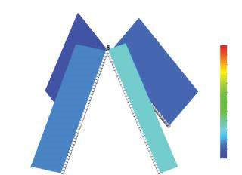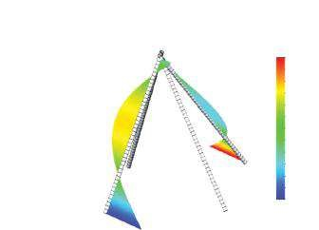

Mo

del name: Frame_1

Study name: Study_

Beam_hinge

plot ty

pe: Shear-Moment Plot1

Model name: Frame_1

Study name: Study_Beam_hinge

plot type: Shear-Moment Plot1

Torque (N-m)

Moment in Dir2 (N-m)

–33.4

–27.9

–22.4

–16.9

–11.4

–5.85

–0.354

5.15

10.7

16.2

21.7

27.2

32.7

–11.5

–10.6

–9.61

–8.65

–7.69

–6.73

–5.77

–4.81

–3.64

–2.88

–1.92

–0.961

0

#### Figure 8.28

*Inner force diagram s. (a) Axial force diagram ; (b) diagram of shear force in Dir 1; (c) diagram of shear force in Dir 2; (d) diagram of moment in Dir 1; (e) diagram of moment in Dir 2; (f) diagram of torque.*

***Table 8.2***

### Results for the Analysed Frame

|  |  |  |  |  |
| --- | --- | --- | --- | --- |
| **Structural**  **Member** |  | **Inner Force** | |  |
| **Shear Force in Dir 2 (N)** | **Minimum**  **Moment in Dir 1 (N m)** | **Maximum**  **Moment in Dir 1 (N m)** | **Torque (N m)** |
| 1 | 43.76 | −8.1 | 16.6 | −11.5 |
| 2 | 110.03 | −43.05 | 21.8 | −8.4 |
| 3 | 87.61 | −32.4 | 16.9 | −10.4 |
| 4 | 82.06 | −15.86 | 31.65 | −10.0 |
| **Reactions** | **RX (N)** | **RY (N)** | **RZ (N)** | **Total Reaction (N)** |
| 1 | 5.08 | 6.51 | 43.8 | 44.5 |
| 2 | 0.473 | 5.31 | −110 | 110 |
| 3 | 82.1 | 272 | −469 | 548 |
| 4 | −87.6 | −267 | −461 | 540 |
|  | **MX (N m)** | **MY (N m)** | **MZ (N m)** | **Total Moment (N m)** |
| 1 | 12.8 | 5.94 | 0.316 | 14.1 |
| 2 | −22.9 | −4.37 | 0.522 | 23.3 |
| 3 | −33.4 | 0.391 | −18.7 | 38.3 |
| 4 | −32.7 | 0.256 | 19.9 | 38.2 |

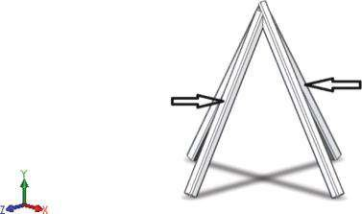

Structural

member 4

Struct

ural

member

3

#### Figure 8.29

*Structural members 3 and 4 of the analysed frame.*

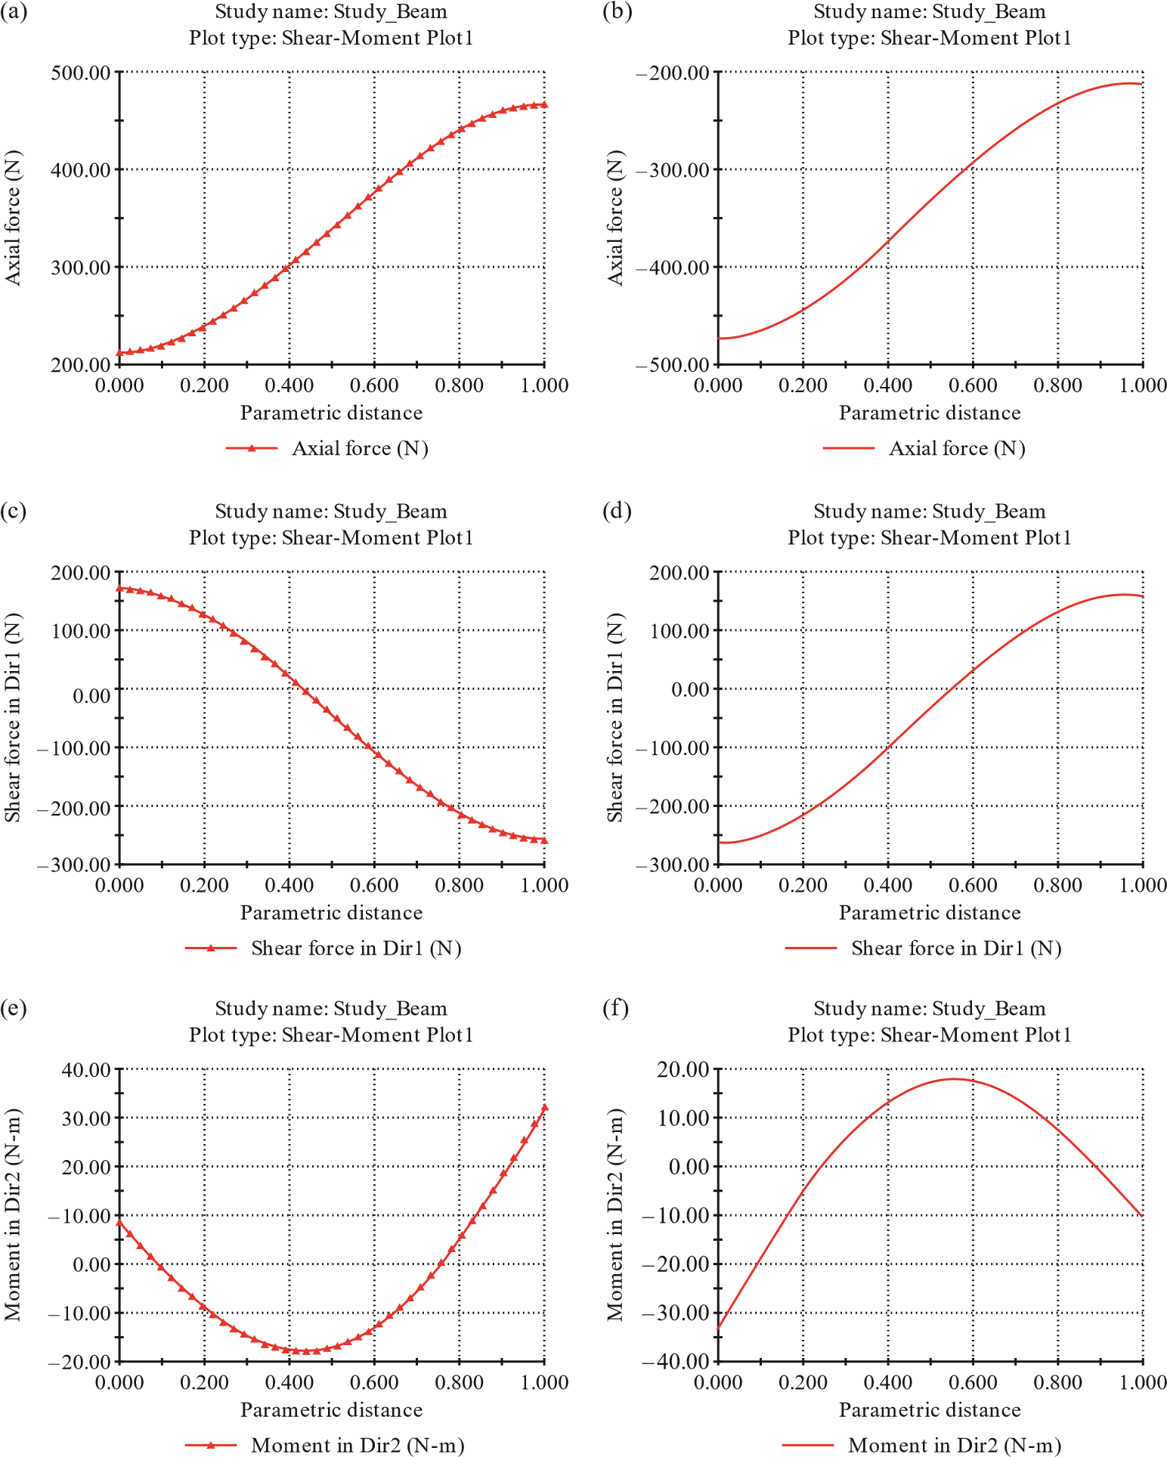

#### Figure 8.30

*Inner force graphs of structural members 3 and 4. (a) N force for structural member 3; (b) N force for structural m ember 4; (c) shear force in Dir 1 for structural m ember 3; (d) shear force in Dir 1 for structural member 4; (e) moment in Dir 2 for structural member 3; (f) moment in Dir 2 for structural member 4.*

(a) (b)

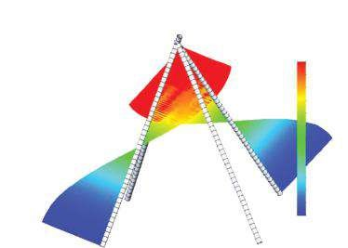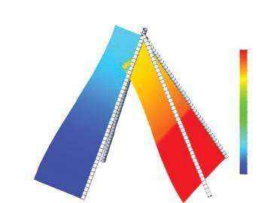

Mo

del name: Frame_1

Study name: Study_

Beam_hinge

plot ty

pe: Shear-Moment Plot1

Model name: Frame_1

Study name: Study_Beam_hinge

plot type: Shear-Moment Plot1

Axial Force (N)

Shear Force in Dir1 (N

)

590

491

392

293

194

95.2

–3.78

–103

–202

–301

–400

–498

–597

–223

–186

–150

–113

–76.6

–40.8

–3.57

32.9

69.4

106

142

179

215

(c) (d)

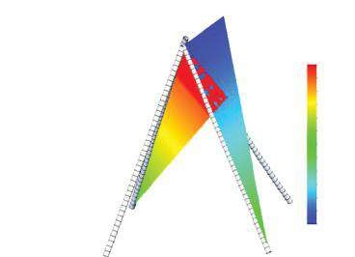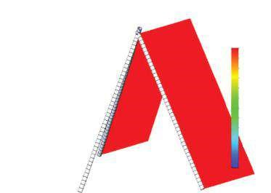

Mo

del name: Frame_1

Study name: Study_

Beam_hinge

plot ty

pe: Shear-Moment Plot1

Model name: Frame_1

Study name: Study_Beam_hinge

plot type: Shear-Moment Plot1

Moment in Dir1 (N-m

)

Shear Force in Dir2 (N)

–1.16e-017

–101

–86

–69.8

–52.6

–36.4

–20.2

–4.03

12.2

28.3

44.5

60.7

76.9

93.1

14.3

28.6

42.9

57.2

71.5

85.9

100

114

129

143

157

172

(e)

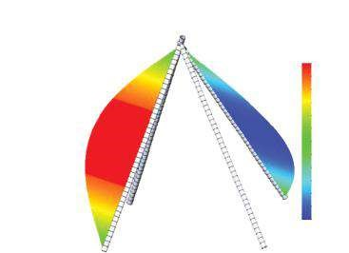

Model name: Frame_1

Study name: Study_Beam_hinge

plot type: Shear-Moment Plot1

Moment in Dir2 (N-m)

–37.8

–31.4

–24.9

–18.5

–12

–5.58

0.87

7.32

13.8

20.2

26.7

33.1

39.5

#### Fig u r e 8.31

*Inner force diagram s of the structure with hinged m embers. (a) Axial force diagram; (b) diagram of shear force in Dir 1; (c) diagram of shear force in Dir 2; (d) diagram of m om ent in Dir 1; (e) diagram of m om ent in Dir 2.*

***Table 8.3***

### Results for Analysed Frame while Rigid Restraints Are Replaced by Hinges

|  |  |  |  |  |
| --- | --- | --- | --- | --- |
| **Structural**  **Member** |  | **Inner Force** | |  |
| **Shear Force in Dir 2 (N)** | **Minimum**  **Moment in Dir 1 (N m)** | **Maximum**  **Moment in Dir 1 (N m)** | **Torque (N m)** |
| 1 | 161.22 | 0 | 90.9 | 0 |
| 2 | 171.7 | −101.1 | 0 | 0 |
| 3 | 0 | 0 | 0 | 0 |
| 4 | 0 | 0 | 0 | 0 |
| **Reactions** | **RX (N)** | **RY (N)** | **RZ (N)** | **Total Reaction (N)** |
| 1 | 3.2 | 7.05 | 161 | 161 |
| 2 | −3.2 | 6.73 | −172 | 172 |
| 3 | 0 | 398 | −498 | 637 |
| 4 | 0 | −395 | −488 | 628 |

#### Figure 8.32

0.000

300.00

400.00

500.00

600.00

0.200

0.400

0.600

Parametric distance

Axial force (N)

Study name: Study_Beam_hinge

Plot type: Shear-Moment Plot1

(

a

)

Axial force (N

)

0.800

1.000

0.000

–600.00

–500.00

–400.00

–300.00

0.200

0.400

0.600

Parametric distance

Axial force (N)

Study name: Study_Beam_hinge

Plot type: Shear-Moment Plot1

)

b

(

Axial force (N

)

0.800

1.000

Study name: Study_Beam_hinge

Plot type: Shear-Moment Plot1

)

(

c

Study name: Study_Beam_hinge

Plot type: Shear-Moment Plot1

)

d

(

*Inner force graphs of structural members 3 and 4, when there are hinge constraints at beam ends. (a) N force for structural m ember 3; (b) N force for structural m ember 4; (c) shear force in Dir 1 for structural member 3; (d) shear force in Dir 1 for structural member 4; (e) moment in Dir 2 for structural member 3; (f) moment in Dir 2 for structural member 4.*

## CHAPTER 9

***STATIC ANALYSIS OF A COMPLEX STRUCTURE***

### 9.1 CAD MODEL OF THE STUDIED STRUCTURE

The analysed structure unites beams, shell and a solid body (Figure 9.1).

The type of the model is ‘part’ (File→ New→ Part→OK), yet some additional contact conditions will be added to the FE model. The used unit is ‘**millimetre-gramsecond**’ (Tools→Options→ Document Properties→Units→Unit system MMGS→OK). The model is saved as **Frame_2. sldprt**.

To develop the structure, the sketches and the structural members from the previous frame are updated. To ease the development of the CAD model, some of the instructions are repeated and the differences in establishment of the components are emphasised. We will start with the following:

1. Drawing the **Sketch1** in the **Top** plane (Figure 9.2a).

Sketch→Sketch1→OK

1. Establishment of the two horizontal structural members

Weldments→Structural Member() →OK

We have chosen to use ISO angle iron profiles 35 × 35 × 5, mirrored and aligned as shown in Figure 9.2b–d.

1. Definition of **Plane2**, which is perpendicular and symmetric to the drawn sketch:

Features→Reference Geometry→Plane()→OK

To define the plane, both edges, where the two angle iron profiles connect each other, are picked (Figure 9.3a and b).

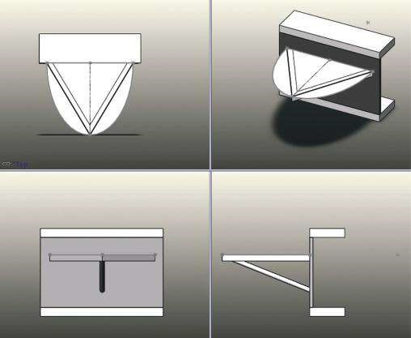

#### Fig u r e 9.1

*Different 3D views of the designed structure.*

(a) (b)

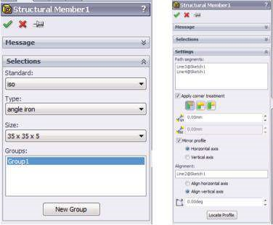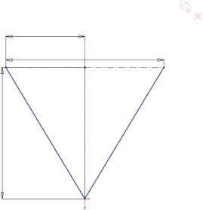

300

500

600

(c) (d)

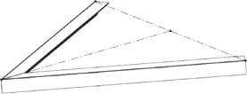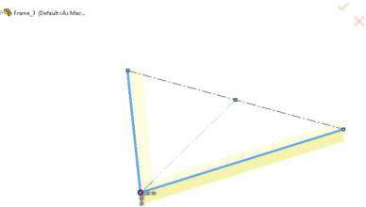

#### Figure 9.2

*Development of CAD model of the structure – stages 1 and 2. (a) Sketch1 in Top plane. (b) Selecting the members and disposing the selected profiles of Group1. (c) Graphic area view when Group1 is introduced. (d) Establishment of both structural members.*

(a) (b) (c)

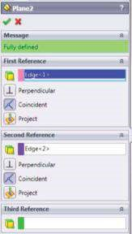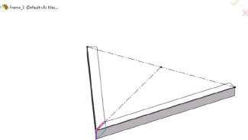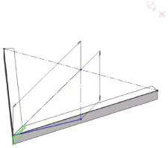

50

0

200

(d)

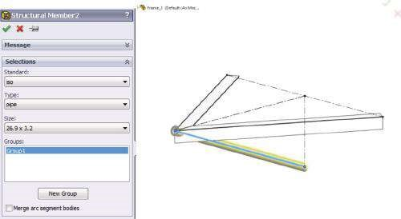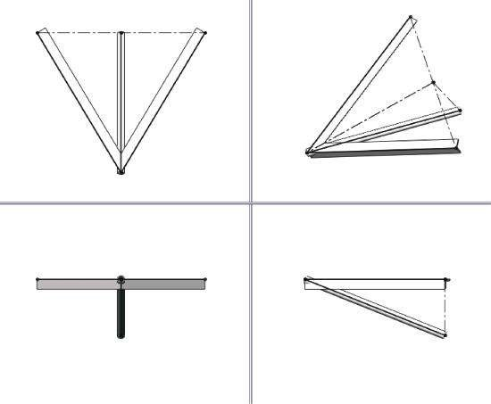

(

e

)

#### Figure 9.3

*Development of CAD model of the structure – stages 3, 4 and 5. (a) Plane property manager. (b) Graphic area view when Plane2 property manager is open. (c) Sketch2. (d) Definition of Structural Member2. (e) Structural members of the two groups.*

1. Drawing of **Sketch2** in the newly created plane. This is a triangle, whose dimensions are given in Figure 9.3c.
2. Definition of the third structural member (Figure 9.3d and e):

Weldments→Structural Member() →OK

We have chosen to use ISO pipe profile 26.9 × 3.2. This means that the outer diameter of the pipe is equal to 26.9 mm and the thickness of its walls is 3.2 mm.

1. Trimming the interfering parts of the pipe at its connection to the angle iron profiles:

Weldments →Trim/Extend ()→OK

We will cut the upper end of the pipe profile (coloured in yellow, Figure

9.4b and c) by picking it in the **Bodies to be Trimmed** sub-window (Figure 9.4a), selecting the **Bodies** option in the **Trimming boundary** sub-window (Figure 9.4a) and picking the two angle iron profiles (coloured in pink, Figure 9.4b and c). The ready structural members’ connection is shown in Figure 9.4d.

1. Definition of **Plane3**.

Features→Reference Geometry→Plane()→OK

This plane is defined by two crossing constructive lines of **Sketch1** and **Sketch2**. We can see them, coloured in pink and violet, in Figure 9.4f. The colours correspond to the colours of the windows of the **First Reference** and **Second Reference** sub-windows (Figure 9.4e). The newly defined vertical blue plane is shown in Figure 9.4f.

1. Drawing of **Sketch3** in **Plane3** (Figure 9.4g). This sketch outlines the supporting plate.
2. Establishment of the supporting C-channel part.

The first stage includes the extrusion to 18 mm of the middle area of **Sketch3** (Figure 9.5a and b).

Features→Boss/Extrude()→OK

The second stage includes the extrusion to 200 mm of the side areas of **Sketch3** (Figure 9.5c and d). Thus, the C-channel form is made (Figure 9.5e).

1. Trimming the profiles.

As you see, parts of the profiles interfere with the supporting plate (Figure 9.6a). Therefore, it is necessary to trim and discard these segments of the profiles. To do so, we use

Weldments→Trim/Extend()→OK

All **Bodies to be Trimmed** (the structural members) are picked and coloured in yellow, whereas the **Trimming Boundary** (trimming face) is

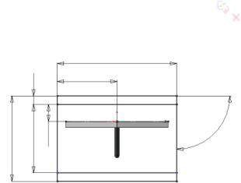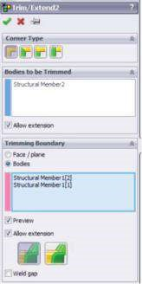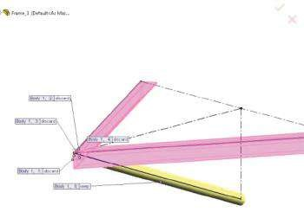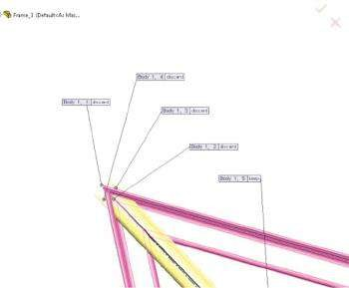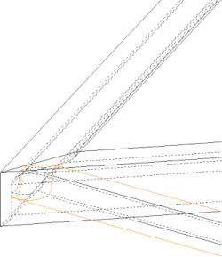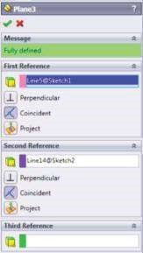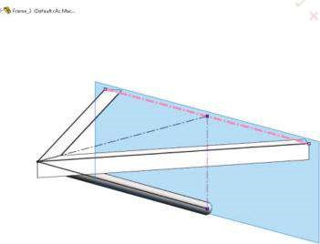

)

a

(

(

b

)

(

)

c

(

d

)

(

e

)(

f)

(

g

)

700

350

90

°

50

400

100

500

***Figure 9.4***

*Development of CAD model of the structure – stages 6, 7 and 8. (a) Trim/Extend property manager. (b) Graphic area view. (c) Graphic area view – detail.*

*(*

*3.*

*d) The upper pipe connection. (e) Plane3 property manager. (f) Defined Plane3. (g) Sketch3 in Plane*

(a) (b) (c)

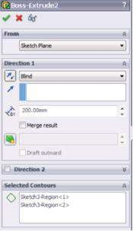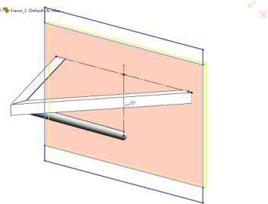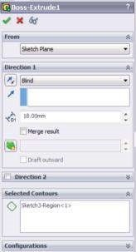

(d) (e)

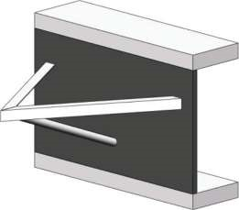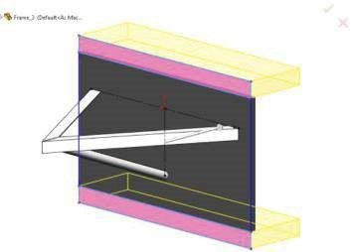

#### Fig u r e 9.5

*Development of CAD model of the structure – stage 9. (a) Boss/Extrude property manager – middle area extrusion. (b) Extrusion to 18 mm of the picked area. (c) Boss/Extrude property manager – side areas extrusion. (d) Extrusion to 200 mm of the side areas to form the C-channel outline. (e) The ready supporting plate.*

coloured in pink in Figure 9.6b and c. The software automatically suggests which segments of the structural members to discard and which to keep.

Further, we have to model the horizontal surface plate. To do so, we have to build the plane of that plate.

1. Development of the horizontal **Plane4**.

Features→Reference Geometry→Plane()→OK

The plane is developed to coincide with the upper side of the angle iron profiles. It is fully defined by picking the upper face of one of the horizontal profiles and pushing the coincide button (Figure 9.6d). A view of **Plane4** is shown in Figure 9.6e.

1. Drawing of **Sketch4** in **Plane4** (Figure 9.6f). The sketch outlines the horizontal surface plate. It is a half segment of an ellipse, with half-axes that coincide with the constructive lines of the spatial frame. You can see the dimensions in the figure.
2. Defining the plate.

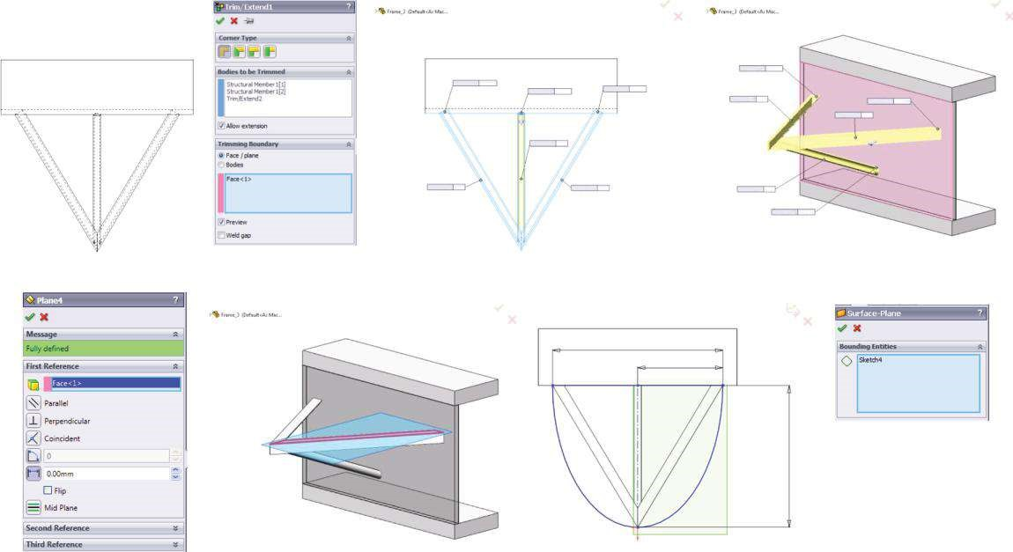

b

(

)

a

)

(

(

)

c

e

(

)

d

(

)

f

(

)

Bo

dy 2, 2:

ke

ep

Bo

dy 1, 1:

ke

ep

Bo

dy 3, 2:

ke

ep

Bo

dy 2, 1:

Bo

dy 2, 2:

ke

ep

Bo

dy 2, 2:

ke

ep

Bo

dy 3, 1:

ke

ep

discar

d

Bo

dy 3, 2:

discar

d

Bo

dy 2, 1:

discar

d

Bo

dy 1, 2:

discar

d

Bo

dy 3, 2:

discar

d

Bo

dy 2, 1:

discar

d

600

300

500

Pl

ane4

(

g

)

***Figure 9.6***

*Development of CAD model of the structure – stages 10, 11, 12 and 13. (a) Interferences between the profiles and the supporting plate. (b) Trim/Extend*

*property manager. (c) Trimetric view and top view of the discarded and kept body parts. (d) Plane4 property manager. (e) Plane4 view. (f) Sketch4.*

*g) Surface-Plane property manager.*

*(*

At first, we activate the **Surface** tool () and then pick the **Planar Surface** ()command:

Surface→Planar Surface()→OK

As **Sketch4** is still selected, its signature is automatically displayed in the window of the **Surface-Plane** property manager (Figure 9.6e). Thus, the area of **Sketch4** is transformed into a horizontal plate.

The CAD model of this complex structure is ready.

Regarding our intention to perform a static FEA of this model, we admit that it unites

* A body that will be treated as a solid body and which is the supporting C-channel form
* Three structural members made of two different types of ISO profiles, which will be modelled using beam FEs
* A horizontal plate, which is to be treated as a shell

Therefore, all types of structural components that the software adopts and analyses are included in this model.

This section helped us to exercise the modelling techniques using Weldments and Surface tools. We developed a complex structure, which combines 1D, 2D and 3D bodies. Despite its complexity, the structure is graded and saved as a part file (*.sldprt).

|  |
| --- |
| We exercised once more the modelling techniques using specific tools such as   * Weldments tool, which is used to model 1D parts (structural members as components of the complex spatial frame) * Surface tool, which is used to model a 2D shell (the horizontal plate in the analysed structure) * Features tool, which is used to model the complex 3D body, consisting of three extruded objects (C-channel supporting plate) |

### 9.2 STATIC FINITE ELEMENT ANALYSIS OF THE STRUCTURE

A static finite element analysis (FEA) of the created structure will be made.

The developed CAD model () combines three different types of bodies (Figure

9.7a). The materials of all components are selected from the library of **SW Materials**.

We have modelled a 3D frame consisting of three beam members (, Figure 9.7b). It is assumed that they are made of aluminium profiles. 1060 Alloy is an aluminium alloy with modulus of elasticity equal to 69 GPa, Poisson’s ratio of 0.33, mass density of 2700 kg/m3 and tensile strength of 68.94 MPa. The aluminium alloy is a ductile material, that is, its tensile and compressive strengths are assumed to be equal. The factor of safety of the 1D components is calculated regarding the yield strength of the alloy, which is 27.57 MPa. Rigid connections at both ends of each structural member are set through the **Apply/Edit Beam** property manager.

(a)

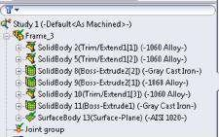

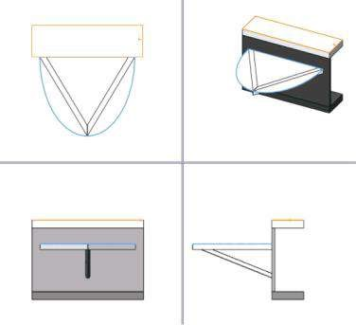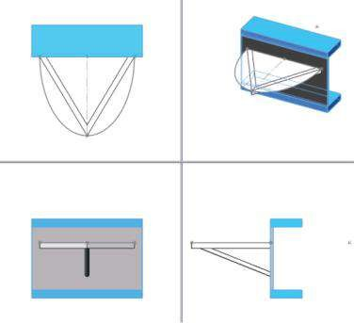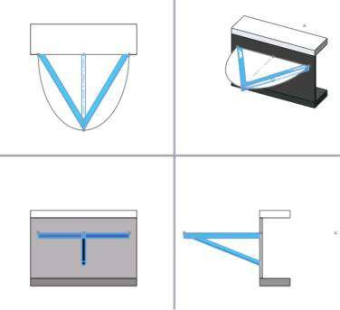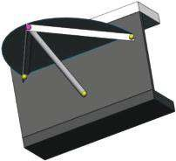

(

b

)

(

c

)

(

d

)

(

e)

#### Fig u r e 9.7

*Different types of components in the analysed structure. (a) Different types of structural components. (b) Views of all beam members. (c) View of all solid bodies. (d) View of surface plane. (e) Calculated joints.*

The second group of bodies consists of three solid bodies, which form the C-channel support (, Figure 9.7c). They are made of Gray Cast Iron, which is a brittle material. Its modulus of elasticity is 66.178 GPa and its Poisson’s ratio is 0.27. The mass density is equal to 7200 kg/m3. The compressive strength of the material (equal to 572 MPa) is a few times larger than its tensile strength (equal to 152 MPa). The factor of safety of these structural members is calculated according to Mohr failure criteria.

The material of the horizontal surface shell (, Figure 9.7d) is assumed to be AISI 1020 steel. Its material properties are modulus of elasticity equal to 200 GPa, Poison’s ratio of 0.29, mass density equal to 7900 kg/m3 and tensile strength of 420 MPa. The thickness of the plate is 4 mm. When the static analysis is performed, thick-plate formulation is used. The last two shell properties are introduced through the **Shell Definition** property manager.

All joints (, Figure 9.7e) are automatically calculated by the program. There are three end joints, coloured in green, which mark the boundary between the beams and the solid body, and one joint, connecting all beams, which is coloured in pink.

While performing an FEA of a structure uniting different types of components, the correct input of contact settings is crucial for obtaining the accurate results. Unfortunately, the software cannot assess the accuracy of the boundary conditions; thus, the user’s experience is significant at that stage.

Contact settings describe the interaction between part boundaries that are initially contacting or that come into contact during loading. The contact functionality is available in assembly and **multi-body part documents**, which is the studied case. Discussing the introduction of contact settings in a multi-body part analysis, we direct our progress to the static analysis of an assembled structure (*.sldasm).

The **Connections** icon () appears above the **Fixtures** icon () in the **Simulation study tree**. After defining the contact settings, any further change in contact conditions requires re-meshing of the model. If the study is run after the modification of contact settings, the software re-meshes the model automatically.

The right-mouse menu for the **Connections** icon provides different contact options, some of which will be discussed in the following.

At first, it is important to know that multiple contact conditions can be specified for an entity. The software enforces them as follows:

* **Global contact condition** is to be used for all touching entities for which no component or local contact condition has been specified. To apply **Global contact condition**, we select the top level assembly or multi-body part. By default, the software automatically applies automatic bonding between all touching entities of the model. Even more, the software automatically defines interaction between solids, shells and beams in a mixed mesh. Bonding beams to shells or solid faces is done automatically for touching components, and the algorithms imbedded in the software automatically bond them for the following cases:
* A face or edge of a shell with another shell (Figure 9.8a–d)
* A face or edge of a shell with a solid (Figure 9.8e and f)
* A face of a shell with a structural member (Figure 9.8g and h)

Shells refer to both sheet metals and surfaces. All bonding contacts get transferred to the mid-surface of the shell automatically. The user needs to manually define bonding for touching non-planar faces that are meshed with shell elements. Bonding between touching structural members with a sheet metal face is also automatically created and transferred to mid-surface shells.

SW Simulation applies the following types of global contacts:

* **No Penetration** – This contact type is available for static analysis. It prevents interference between **Set 1** and **Set 2** entities but allows gaps to develop (Figure 9.9a). This is the most time-consuming option to solve.

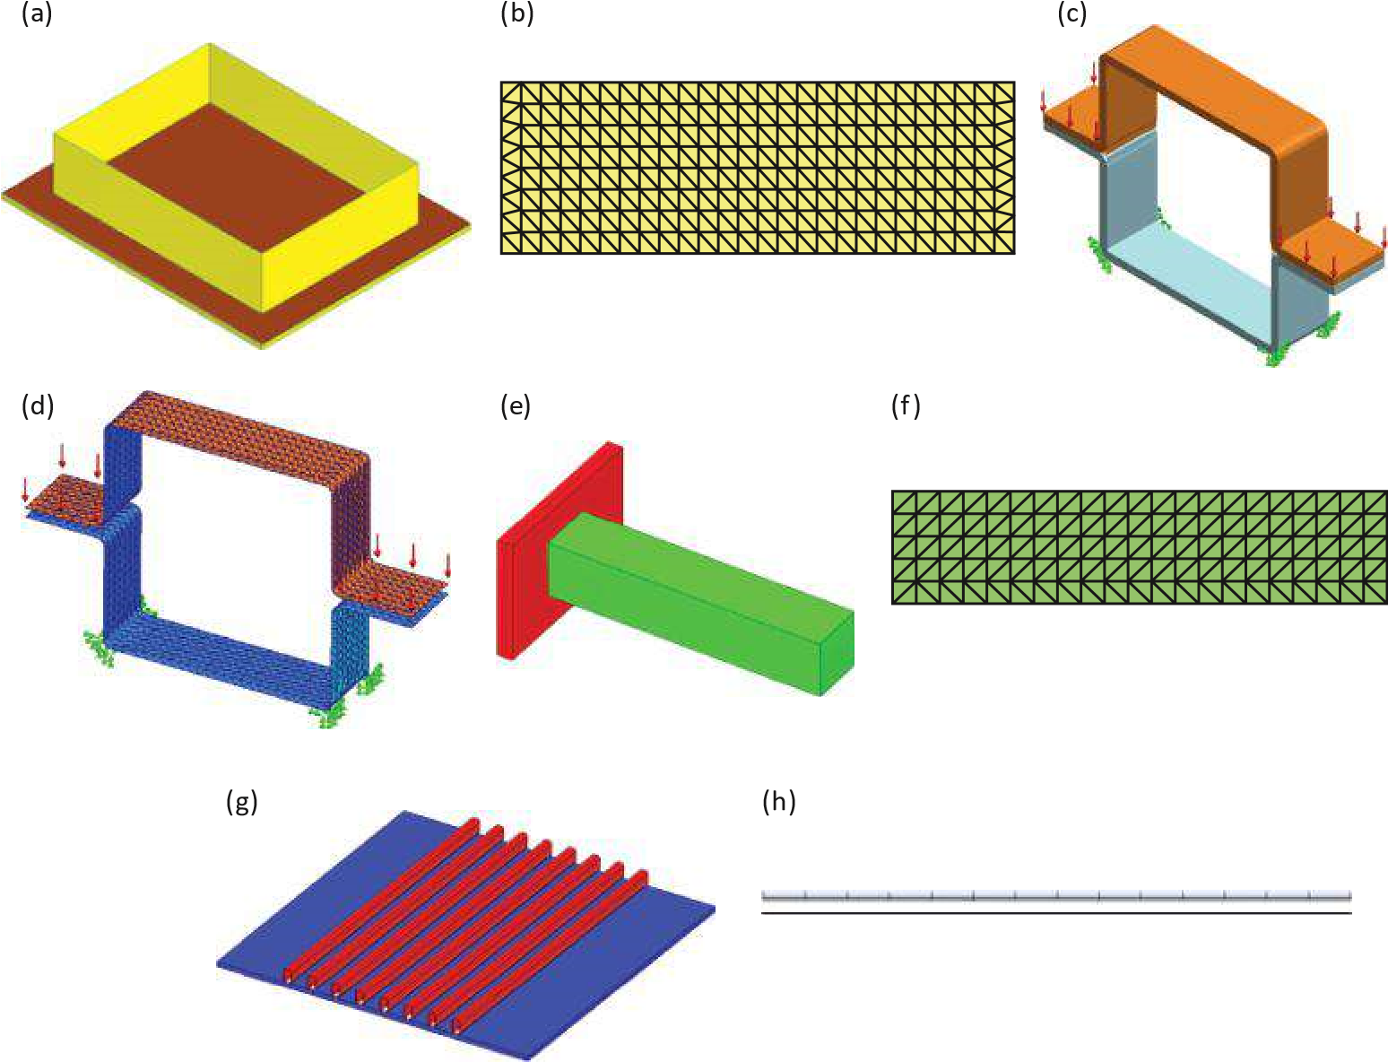

#### Figure 9.8

*Different types of bonded contact between different touching entities (SW Simulation help). (a) Surface edge touching a sheet m etal face. (b) Side view of m esh (zoom ed). (c) Sheet m etal faces touching each other. (d) View of Mesh at Mid-Surfaces. (e) Solid face touching a sheet m etal face. (f) Side view of mesh (zoomed). (g) Structural members touching a sheet metal face. (h) Side view of m esh (zoom ed).*

**• Bonded** – This type of contact is available for all types of studies that require meshing. The program bonds the **Set 1** and **Set 2** entities (source and target), which may be touching or within a small distance from each other (Figure 9.9b). Bonded entities behave as if they were welded. The mesh does not have to be compatible. If the mesh is compatible, the program merges coincident nodes along the interface (Figure 9.9c); otherwise, it applies constraint equations internally to simulate bonding. For a study with a mixed mesh (used automatically by program), as is the discussed example, the user can bond **Set 1** entities (vertices, edges, faces, beam joints and beams) to **Set 2** (faces). Vertices, edges and faces can belong to shells or solids. The behaviour of the bond depends on whether the source entity belongs to a solid or a shell. If the source entity belongs to a shell or a beam, the bond acts like a rigid connection where the original angle between the shell or the beam and the solid is maintained during deformation. If the source entity belongs to a solid, the bond acts like a hinge, where the original angle between the shell and the solid is not necessarily maintained.

(a)

(b)

(c) (d) Common nodes

Component A

(

e

)

Component B

Interference between components can occur during loading

Component A

Component B

(

f

)

#### Fig u r e 9.9

*Different types of contact between parts (SW Simulation help). (a) No penetration contact. (b) Bonded contact. (c) Bonded contact. (d) Bonded contact with com patible m esh. (e) Allow penetration contact. (f) Allow penetration contact with incompatible mesh.*

* **Allow Penetration** – This type of contact is available for static and other analysis. The program treats **Set 1** and **Set 2** faces as disjointed. For static studies, the loads are allowed to cause interference between parts. Using this option can save solution time if the user is convinced that the applied loads do not cause interference. The program meshes the common areas with an incompatible mesh.
* **Component contact** () conditions override **global contact** conditions. Modifying or adding a contact condition requires re-meshing the model. The component contacts are specified between the selected components () of the assembly. The components can be picked from the fly-out **Feature Manager** design tree or from the **Graphics area** directly. The available options for the **Component contact** depend on the study type. The component contact can be
* **No Penetration** – Selected components or bodies do not penetrate each other during simulation, regardless of their initial contact condition. **Surface to surface** contact formulation is applied for **No Penetration** contact.

If **No Penetration component contact** option is selected, we can introduce friction between touching entities. To obtain accurate results, it is recommended that the friction coefficient () be smaller than 0.5. If you do not know the exact value of the friction coefficient, you can set it to 0.2.

* **Bonded (No clearance)** – Selected components or bodies behave as if they were welded during simulation.

If the **Bonded component contact** option is selected, we can choose either the **Compatible Mesh** or the **Incompatible Mesh** at the areas of contact. The program creates a compatible mesh on initially contacting areas. If the mesh is compatible, the program merges coincident nodes along the common interface. If the mesh is incompatible, the program meshes each component independently. If meshing fails with the compatible mesh option, the incompatible mesh option can help the meshing process to succeed. In general, the compatible mesh option produces more accurate results in the bonded regions.

* **Allow Penetration** – Selected components or bodies can penetrate each other during the simulation. The **Allow Penetration** option overrides other existing component contacts.
* **Local contact conditions** () override global and component contact conditions. They can easily be defined using the **Contact Sets** property manager. The contact sets can be identified manually through the **Manually select contact sets** check button by further selecting pairs of faces and creating contact sets or automatically through the **Automatically find contact sets** check button. Using the automatic option urges us to be more careful because sometimes the automatic detection tool may not find all the contact sets that we want or it may find extra contact sets that we do not want.

The type of the local contact is visible only when the **Manually select contact sets option** is picked. We can choose among **No Penetration**, **Bonded**, **Allow Penetration**, **Shrink Fit** and **Virtual Wall**. As **No Penetration**, **Bonded** and **Allow Penetration** have already been discussed, we will focus on the remaining two options:

* **Shrink Fit** – This type of contact is available for static and nonlinear studies only. **Shrink Fit** refers to fitting an object into a slightly smaller cavity. Due to normal forces that develop at the interface, the inner object shrinks while the outer object expands. The amount of shrinkage or expansion is determined by the material properties as well as the geometry of the components. This is a local contact condition.
* **Virtual Wall** – This type of contact is available for static studies only. It defines the contact between the **Set 1** entities and a virtual wall defined by a target plane. The target plane may be rigid or flexible. If the virtual wall is chosen to be flexible, we can define the wall axial stiffness () and the wall shear stiffness (). Further, the user can define friction between the **Set 1** entities and the target plane by assigning a non-zero value for the friction coefficient.

The **Local Contact** conditions can be applied to different entities, combined in two sets.

**Set 1** () entities can be **Faces**, **Edges** and **Vertices**. For complex structures, a mixed mesh is applied, and if bonded type of contact is selected, we can pick **beam joints** () or **beams** ( ). The last option is suitable for connecting beams to shell or to solid faces.

For **Set 2** ( ),faces must be selected. If we define a **Virtual Wall** contact, then we select the **Target Plane** () as **Set 2**.



Entities of **Set 1** and **Set 2** must belong to different components, bodies, etc.

If the local contact sets are to be found automatically by pushing the **Automatically find contact sets** check button, we can select between two options: **Touching faces**, which sets contacts between selected touching faces, and **Non-touching faces**, which sets contacts between faces within the specified minimum () and maximum () distances for selected components. Further, we have to select the touching components and the software itself:

* Evaluates the possible contact sets among selected bodies or even the entire assembly
* Finds contacts of a single component or body with the neighbouring components • Finds face pairs between the selected components that meet the specified criteria

As a result, the software displaces the possible contact sets, depending on the previously selected options.

Despite our choice of how to input the local contact sets, automatically or manually, if **No penetration** contact is preferred, we have to choose the type of contact at an FE level. It can be the following:

* **Node to Node** (Figure 9.10a): This contact type prevents interference between the source and target faces but allows them to move away from each other to form gaps. The program selects the candidates for source and target faces internally between **Set 1** and **Set 2** and creates coincident nodes on them. It requires compatible meshes for **Set 1** and **Set 2** entities and allows faces only for **Set 1**. This contact is available for initially touching contact faces only. **Node to Node** formulation supposes faster calculations than **Node to Surface** and **Surface to Surface**, but it is the least accurate for general structural problems with sliding or large rotations. The accuracy of the results depends on the loading, being best if the two faces are pressed against each other without much sliding or relative rotations. The accuracy reduces as the loading causes large sliding or rotations. For such problems, we use the **Node to Surface** or **Surface to Surface** options and activate large displacements.
* **Node to Surface** (Figure 9.10b and c): This contact type prevents interference between the source and target faces but allows them to move away from each other to form gaps. This contact type does not require that the faces be initially touching. **Node to Surface** formulation does not require a compatible mesh between source and target faces, that is, compatible meshes for **Set 1** and **Set 2** entities. For each node on the source, the software assigns one or more element faces on the target. We can pick vertices, edges and faces as **Set 1** entities. Although **Surface to Surface** contact is more accurate in general, the **Node to Surface** option gives better results if the contact area between the two faces becomes very small or reduces to a line or point.
* **Surface to Surface**: This contact prevents interference between the source and target faces during loading but allows them to move away from each other to form gaps. It is more general than **Node to Node** and **Node to**

Coincident

nodes

Component A

Component B

Component B

Component A

Node on

the source

Component 1

)

Source

(

Component 2

(

Target

)

Contact entities

do not have to

be

initially touching

Small area on the target

as

sociated with the source

a

)

(

(

b

)

)

c

(

node

#### Fig u r e 9.10

*Different types of contact at finite element level (SW Simulation help). (a) A possible deformation of two faces that were initially touching by Node to Node contact. (b) A possible deformation of two faces with incom patible m esh. (c) A possible deform ation of two faces that were not initially touching and use incom patible m esh.*

**Surface** contacts. It is suitable for complex contacts with general loading. It does not require a compatible mesh between source and target faces, that is, between **Set 1** and **Set 2** entities. The program selects the candidates for source and target faces internally. The contact allows only faces as source and target entities. In most cases, **Surface to Surface** gives more accurate results but requires more time and resources. It is not recommended when the area of contact between the source face and the target face becomes too small or reduces to a line or a point during deformation. In such cases, we rather use the **Node to Surface** option.

After making a detailed review of the types, commands and options and the ways to input contact sets on the model, we can summarise the following general guidelines for specifying contact conditions:

* Check the interference between components before meshing. To detect interference in an assembly, you must click **Tools**, **Interference Detection**. The **Treat coincidence as interference** option allows you to detect touching areas, which are the only areas affected by the global and component contact () settings.
* For defining a local contact, use the **Contact Set** () to define the connection between solids, shells and beams.
* If no contact conditions are specified, the software assumes that all parts are bonded at their initially **touching entities**. All other entities are free.
* Specify global, component and local contact conditions efficiently to define the problem. For global and component contact, there is no need to select specific entities since they apply only to initially touching areas. The global contact is used to define the most commonly desired condition and then to override it by specifying component and local contact wherever needed.
* The **Find contact sets** property manager helps in finding and defining contact pairs between solids without having to select faces manually.
* After editing or defining contact conditions, the model must be re-meshed.

The most common contact condition is **bonding**. Bonding ensures the continuity of the model and transfers loads between two entities. The user can bond a face or an edge to any other face or edge. The meshes of the bonded entities do not have to be compatible. **Contact Set** () defines bonding conditions between solids, shells and beams. Bonding with a compatible mesh gives better results, but it can cause meshing to fail for some assemblies. Using the **incompatible mesh** can help in meshing such models. The entities do not have to be touching. The program bonds entities that are not too far apart or slightly interfering entities. Bonding is achieved by merging nodes when the mesh is compatible or by using multi-point restraints internally when the mesh is not compatible. Bonding incompatible meshes can generate local stress concentrations in the bonded areas. When bonding solid faces through the global contact condition, the program generates a compatible mesh on the touching areas and merges the nodes (Figure 9.11a). For example, meshing the model in Figure 9.11b with the default global contact setting (**Bonded**) bonds the whole circular face cylinder to the plate. If the cylinder is connected to the plate by welding its edge only, then set the **Global Contact** to **Free** and then bond the face of the plate to the edge of the cylinder by defining a local contact set. If a small clearance exists, the global contact settings are irrelevant, but local contact sets can bond the cylinder’s face or edges to the plate (Figure 9.11c).

Regarding our new knowledge, we will discuss the contact sets in the structure.

We activate the menu by right clicking on the **Connections** icon ( , Figure 9.12a). The second and third lines in that menu include the **Component contact** ( ) and **Contact set** () commands that we will use in defining contact conditions.



(a) (b) (c)

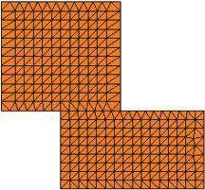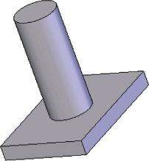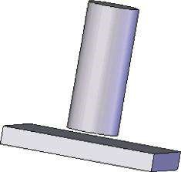

#### Fig u r e 9.11

*Different types of contact between two solid bodies (SW Simulation help). (a) Compatible mesh between two contacting solid bodies. (b) Bonded global contact between the cylinder and the face. (c) Use of a local contact set to bond the bodies while keeping the clearance between them.*

(a) (b)

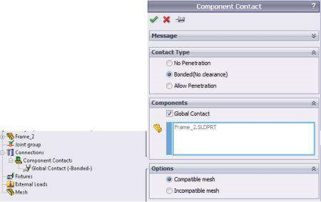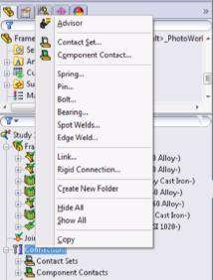

(c) (d)

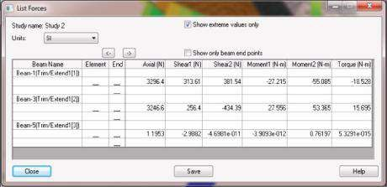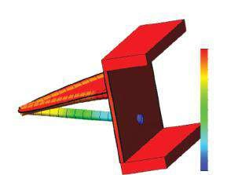

Model name: Frame_2

Study name: Study 2

Plot type: Static displacement Displacement1

Deformtion scale: 26.8151

UZ (mm)

0.000698

–0.102

–0.204

–0.306

–0.408

–0.511

–0.613

–0.715

–0.818

–0.92

–1.02

–1.12

–1.23

#### Fig u r e 9.12

*Calculation of the model at a global contact level. (a) Right click on Connections menu. (b) Global contact and Global Contact property manager. (c) Extreme values of beam forces. (d) Horizontal displacement plot (UZ).*

As previously mentioned, the structure combines three types of components: solid bodies, shells and beams. Therefore, we have to consider all types of contacts allowed by the software.

The first type of contact to be discussed is the **Global** contact. This is the top-level contact, and it is applied to the entire model (**Frame_2**) by default. The software automatically chooses this contact to be **Bonded** (Figure 9.12b).

If we mesh and run the study at that stage, considering the input fixtures and loads, the program will provide us some results. Extreme values of the beam forces are given in Figure 9.12c, yet their accuracy is questionable. According to the list, there are almost no forces transferred to the pipe. Even more, if we plot the horizontal displacements of the frame components (UZ plot, Figure 9.12d), we will see that the pipe penetrates the plate, which cannot be true in the real structure.

As a result, we can conclude that it is obligatory to add component and local contacts.

The first to be introduced is a **component contact** (, Figure 9.13a) at the joint common to all structural members (the pink joint in Figure 9.13b). After clicking on the **Component Contact** () on the **Connections** () right click menu (Figure 9.12a), the **Component Contact** property manager opens (Figure 9.13a). We select the type of the contact to be bonded, but instead of checking the **Global Contact**, we pick the three structural members by clicking on them in the **Graphics area** (Figure 9.13b). As a result, their signatures automatically appear in the blue **Components** window. We select to use

(b)

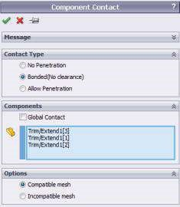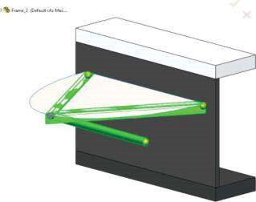

#### Fig u r e 9.13

*Calculation of the model while only global contacts are set. (a) Component contact property manager. (b) Graphic area view.*

the compatible mesh and click on the **OK** green mark to confirm our choice. Thus, a connection at a component level between the three structural members is defined.

Yet, this is not enough to obtain correct results from the analysis. While the defined component contact is optional, as the software has already established a bonded contact at the joint, it is obligatory to input a local contact between the vertical plate of the C-channel and the pipe.

This time, we pick the **Contact Set** () from the right click **Connections** menu (Figure 9.12a), and our choice opens the **Contact Sets** property manager (Figure 9.14a). The selected contact type is **Bonded**, and **Set 1** (set in the blue window) consists of the three end (green) joints. In order to select them, we pick the **Joint** icon (). **Set 2** (set in the pink window) includes the front face of the vertical solid plate (Figure 9.14b). The software introduced this local contact on a separate line in the **Connections – Contact Sets** group of the **SW Simulation analysis tree** (Figure 9.14e). The program uses an icon, drawing the contact as a vertical solid body and a horizontal beam attached to it (), to describe the contact in the **SW Simulation analysis tree**.

The last optional local contact, which duplicates the initial bonded settings of the global contact defined by the software, is the contact between the angle iron profiles and the bottom side of the horizontal shell. Of course, we can omit it, but when it comes to the fact that the correct identification of different contacts in complex structures is crucial, it is recommended to consider it. The software will overwrite the new boundary conditions over the existing global contacts. Sometimes it is better to duplicate some of the contact sets instead of omitting them, which has been proved by our initial calculations. We introduce this local contact () through the **Contact Sets** property manager (Figure 9.14a).

The selected contact type is **Bonded**.To enable selection of the structural members, we click the **Beam** () icon. **Set 1** (set in the blue window) consists of the two angle structural members (blue profiles in Figure 9.14d), whereas **Set 2** (set in the pink window) includes the horizontal shell (Figure 9.14d). The program sets a new line in the group of **Contact Sets** to describe the new contact. It uses an icon, drawing a horizontal plate supported by beams (), to describe it.

By setting these additional local contact sets, the software provides correct results.

Before starting the analysis, it is better to clarify our choice of boundary conditions once more. Regarding the input through the **Apply/Edit Beam** property manager

(a) (b) (c)

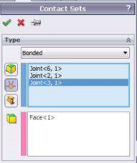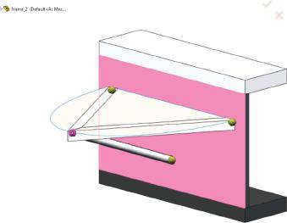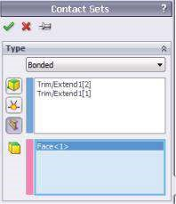

(d) (e)

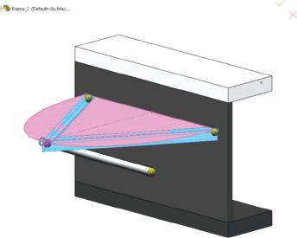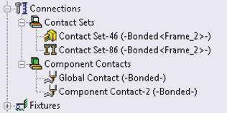

#### Fig u r e 9.14

*Calculation of the model at a local contact level. (a) Contact Sets property manager – joints’ local contact. (b) Picked contacted face of the solid plate. (c) Contact Sets property manager – structural members’ local contact. (d) Picked components of Set 1 and Set 2 of the local contact between the beams and the horizontal plate. (e) All input contacts as they are signified in SW Simulation analysis tree.*

rigid boundary conditions at the ends of the structural members, the static scheme of each structural member is assumed rigidly fixed at both ends of the beam.

The next stage of the development of the static FE model is the identification of the fixtures. Different cables, located inside the channel support, do not focus our attention and are not discussed here. The C-form is fixed to a rigid vertical wall. Therefore, we assume **Fixed Geometry** fixtures at the back faces of the C-form (Figure 9.15) and introduce them through the path

Fixtures(, rick click of the mouse)→ Fixed Geometry ()

The structure will be studied under the following static loads:

**• Gravity** – it is inevitable for every structure. For the successful input of gravity, the density of each material must be defined. Figure 9.16a shows the options and values in the **Gravity** property manager, and the path through, which to

start is

External Loads (right click) →Gravity () → OK ()

(b)

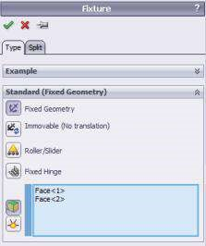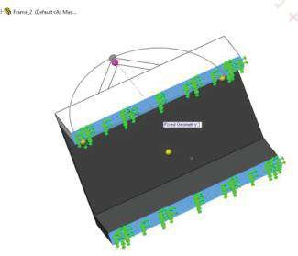

#### Fig u r e 9.15

*Applying fixtures to the model. (a) Fixture property manager. (b) Back faces of the solid body, where Fixed Geometry boundary conditions are applied.*

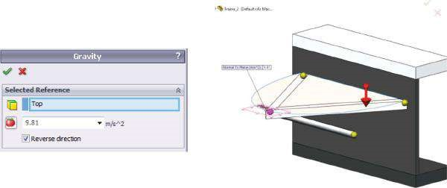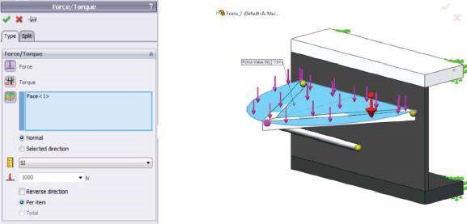

(

a

)

(

b

)

#### Fig u r e 9.16

*Applying the loads at the model – scenario 1. (a) Input of Gravity load. (b) Input of Force load, as a uniform load on the top side of the plate – scenario 1.*

**• Force** – let us suppose that this force is the impact of a load of an object whose mass is approximately 100 kg disposed at the upper side of the horizontal plate. The total value of the force is about 1000 N. We assume that it is uniformly spread across the entire area of the plate – scenario 1 (Figure 9.16b).

External Loads (right click) →Force () →OK ()

If we want to be more precise in the input of the force load, we must consider the geometry of the bottom face of the object put above. It is supposed to be a cylinder with a diameter of 300 mm. We will study this option under scenario 2. To start scenario 2, we duplicate **Study 1** by

Study 1(the tab at bottom of the SW area, right click) →Duplicate →Study 2

Then we re-define the options of **Force** load by splitting the loaded area. To do so, we click the **Split** tab on the **Force** property manager and click the **Create Sketch** button (Figure 9.17a). The program automatically recognises the plane of the plate as a drawing plane. We sketch a circle of a diameter of 300 mm and coordinates of the centre (0, 200 mm), according to Figure 9.17b. Then we split the face of the plate to a circle and a surrounding area (Figure 9.17c and d). Finally, we input the force properties, including the circle area, where the force is applied (Figure 9.17e). As a result, the force is spread only across the outlined segment of the plate.

The next stage is meshing the structure. The software automatically recognises the type of the appropriate FEs for each structural member. For this case study, the FE model is a combination of solid FEs, shell elements and beam elements. Everything we have learned up to now, including the impact of the order of the used FEs, of the aspect ratio, of the size of the FEs, of the mesh control, etc. is applicable.

We start the solution of the case study by meshing and running scenario 1. We activate **Study 1** by clicking the corresponding tab at the bottom of the working area.

We see that after picking the **Study 1** tab, the software marks some of the contact sets between the angle profiles and the plate and the input **Force** as incorrect (, Figure 9.18a). The reason is the splitting of the plate into two separated areas. The easiest way to overcome that problem is as follows:

* Either to suppress the **Split Line 1** () in the **SW Design tree** (Figure 9.18b) by right clicking on the feature and picking the **Suppress** icon () on the pop-down menu.
* Or by rolling the **End Line** to the previous and turning off the **Split Line 1** (). Its visualisation below the **End Line** informs the user that in spite of its inclusion in the **SW Design tree**, this item is not active (Figure 9.18c).

The view of the result of each of the two options is shown in Figure 9.18d.

After deactivation of the **Split** feature, the program automatically applies the new features to **Study 1**, and as a result, the FE model is correct. We will not apply mesh control options at this stage. Curvature-based mesh is chosen. The density of the mesh is at the middle of the scale – minimal size of FE is set to 10 mm and maximal size to 30 mm (Figure 9.19a). The largest values of the **Aspect ratio** are below 4 (Figure 9.19b) and are calculated for FEs at the ends of the vertical support. Thus, we can assume that the meshing of the structure suits to our expected level of accuracy and precision of the results.

Finally, the **Run** command is started.

Some of the obtained results are systematised later when comparison among all studied scenarios is done.

To run correctly **Study 2** (scenario 2), we unsuppress the **Split Line** feature.

The mesh used in **Study 2** keeps the properties of the mesh in **Study 1**, in relation to the type, density and mesh control. The only difference is due to the existence of

(b)

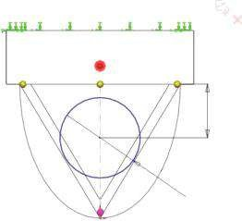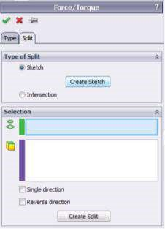

200

Ø300

(c) (d)

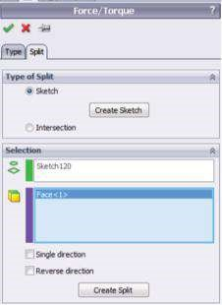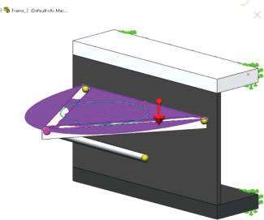

(e)

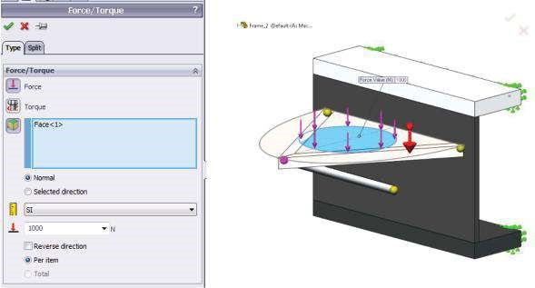

#### Fig u r e 9.17

*Applying the force to the model – scenario 2. (a) Force/Torque property manager – Split tab. (b) Sketch of the circle. (c) The input of the sketch line to split the violet face. (d) Graphic area view of the face to be split. (e) Input of the force at the split circle area.*

(a) (b)

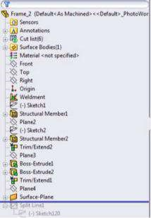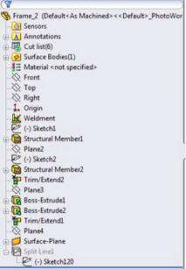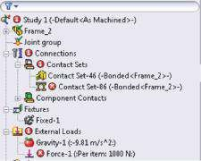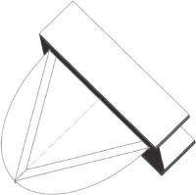

(

c

)

(

d

)

#### Fig u r e 9.18

*Deactivation of Split feature. (a) The incorrect SW Simulation analysis tree, including software massages. (b) The suppressed Split Line 1 in the SW Design tree. (c) Exclusion of Split Line 1 feature from the list of active commands. (d) Graphic area view after deactivation of the Split command.*

a split area in the middle of the shell. The software automatically considers the circle outline (Figure 9.20).

To continue exploring the structure, we duplicate **Study 1** and **Study 2** to **Study 3** and **Study 4**, respectively. The last two scenarios differ from the previous ones in the static scheme of the pipe. We assume a hinge connection at **End 2** (, blue end) and a rigid connection at End 1 (, red end, Figure 9.21). The **Hinge** connection ensures

(a) (b)

Aspect ratio

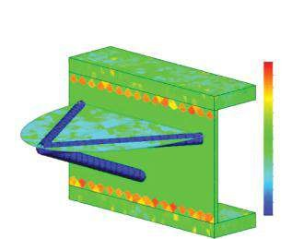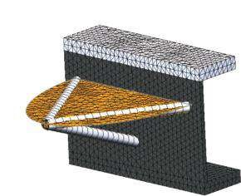

Mo

del name: Frame_2

Study name: Study

1

Plot ty

pe: Mesh Quality1

Model name: Frame_2

Study name: Study 1

Plot type: Aspect ratio Mesh Quality1

3.91

3.58

3.26

2.93

2.6

2.28

1.95

1.63

1.3

0.977

0.651

0.326

0

#### Fig u r e 9.19

*Meshing the structure – scenario 1. (a) Plot of the m esh. (b) Plot of the aspect ratio.*

(a) (b)

Model name: Frame_2 Model name: Frame_2

Study name: Study 2 Study name: Study 2

Mesh type: Mixed mesh

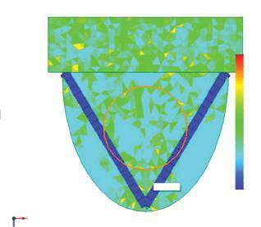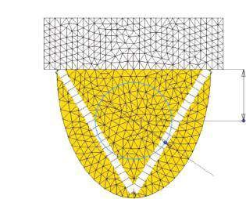

Ø300

200

Plot type: Aspect ratio Mesh Quality1

Aspect rati

o

3.91

3.58

3.26

2.93

2.6

2.28

1.95

1.63

1.3

0.977

0.651

0.326

0

Split Line1

#### Figure 9.20

*Meshing the structure – scenario 2. (a) Plot of the mesh – top view. (b) Plot of the aspect ratio – top view.*

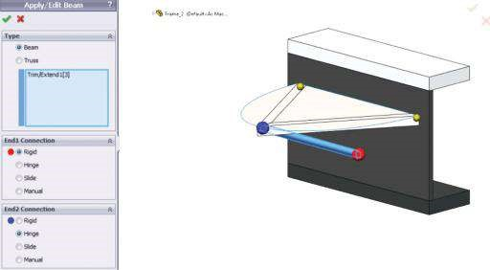

#### Fig u r e 9.21

*Definition of the new restraints of the pipe – scenarios 3 and 4.*

that **End 2** can rotate freely and does not transfer any moments to the joint. The **Rigid** connection ensures continuity and fully defines the transfer of forces and moments. In the real structure, these connections can be interpreted as edge welding along the connection to the plate edge (End 1) and as a spot welding at a few points at the edge of End 2, for example.

Considering the previous remarks about the **Split Line** feature and its activation, we are ready to run these two scenarios and compare the final results.

Our last attempt focuses on entirely a new type of connection of the three structural members. It allows rotation of each member around the two axes located in its cross section. The new restraints prevent the angle profiles from rotating along their axes, while this torsional rotation is enabled for the pipe. The new studies are titled **Study 5** and **Study 6**. To develop them, we duplicate **Study 1** and **Study 2** and edit the member constraints according to the following instructions:

• The name of the component (right click to open the menu)→Edit definition →

OK

This redefinition of the beam constraints is done for each beam, and the properties input through the **Apply/Edit Beam** property manager for every separate beam are given in Figure 9.22. While introducing the new restraints, we must be very careful about the colourful red-blue signature at the ends of the beams. After changing the restraints, and redefining the contacts and the external loads, we run the analyses.

(a)

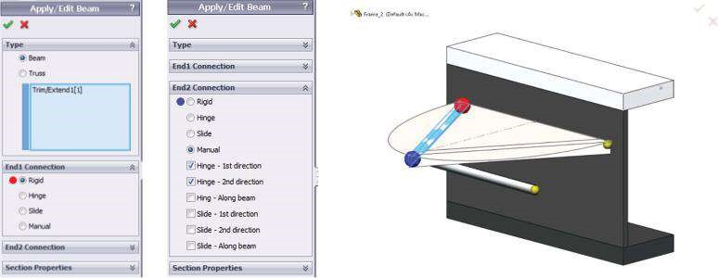

(b)

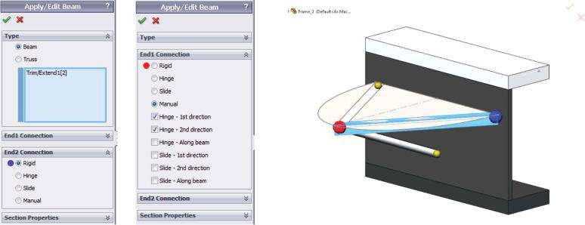

(c)

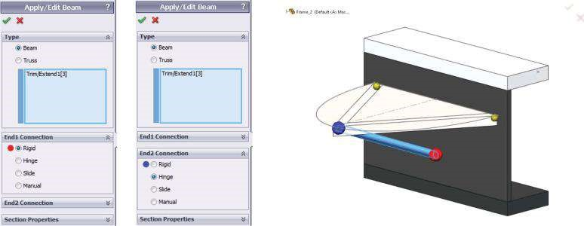

#### Figure 9.22

*Definition of the new restraints of all 1D components – scenarios 5 and 6. (a) Restraints of the first angle iron profile. (b) Restraints of the second angle iron profile. (c) Restraints of the pipe.*

In this section, we analysed a complex structure with 1D, 2D and 3D components. We focused our attention on setting different constraints and contacts. We discussed how to combine different types of FEs and the necessity of defining boundary conditions.

|  |
| --- |
| We exercised all previously discussed techniques in developing an FE model. We learned how   * To define different contacts, including global contact, component contact and local contact sets * To define a mixed mesh and to make all structural components work together and transfer loads and deformations among each other, etc. |

### 9.3 COMPARISON OF THE RESULTS OF THE SIXTH DESIGN SCENARIOS

A brief comparison of all the obtained results is given in the following.

#### 9.3.1 Definition of Stress Plots

When analysing an FE model with a mixed mesh, the **Stress Plot** property manager looks more complex. It combines the features of the property managers, which appear when a solid or shell structure is studied with the features of the ‘beam’ property manager.

In fact, the only more complicated and totally new sub-window is **Display** (Figure 9.23). The main point is that we have to select which type of stress to display. If we pick the **Solid and Shell** option, the software automatically limits the list of possible stress components () to normal stresses (SX, SY and SZ), shear stresses (TXY, TXZ and TYZ), principal stresses (P1, P2 and P3), von Mises stresses, etc., in which directions can be

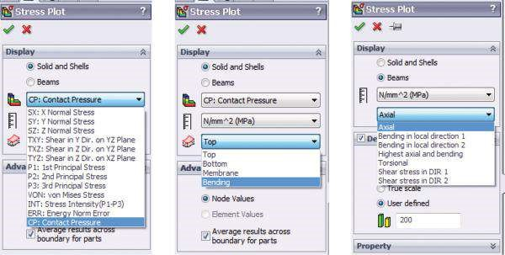

##### Figure 9.23

*Stress plot property manager of a complex structure.*

modified using appropriate reference geometry (). As far as the shell () is concerned, we can choose the among the Top (total stresses = bending + membrane at the top face), the Bottom (total stresses = bending + membrane at the bottom face), the Bending (bending stress component) or the Membrane (membrane stress component). When the software plots the stress components for beams and we choose among different options, it displays either normal (axial; bending in local direction 1; bending in local direction 2; highest axial and bending) or shear stresses (torsional; shear stress in Dir 1; shear stress in Dir 2).

Some of the solid and shell plots are shown in Figures 9.24 through 9.26).

The extreme values for all case studies of the plotted stresses are systematised in Table 9.1.

We see that as far as the stress–strain state of the solid body and the shell is concerned, the shell is the more vulnerable component, especially while the circle bottom of the shell body put above is projected (Study 2 results in Figures 9.24 through 9.26). The results for all studies of that group are similar, including Study 2, Study 4 and Study 6. However, the precise adjustment of the loads ensures the accuracy of the FE model and outlines clearly the vulnerable zones of the shell – at the middle and at its connection to the vertical plate.

Further, the extreme values of the beam stresses are systematised in Table 9.2. They are listed through

Results (right click) → List Beam Forces → List Beam forces property manager (check Forces) → Select in the table SI Units and check Show extreme values only → Close

The largest are the stresses due to **Bending Dir 2** for the angle profiles and due to **Bending Dir 1** for the pipe. We must remember that the yield strength of the used aluminium alloy is 27.57 MPa, which guarantees FoS close to 1 and above.

All these stress values correspond to the beam plots shown in Figure 9.27.

The most significant is the difference between the stress distribution of **Study 1** and **Study 6**. The extreme stress values are influenced by two factors:

* **Introduction of the pressure load** – uniform distribution across the entire shell versus the circle in the middle
* **The connection and the end definition on the beam** – rigid beam ends connected to the pink joint in **Study 1** versus hinge beam ends in **Study 6**.

The second factor influences more strongly the stress distribution along the beams than their extreme values.

The software lists the stress values at both ends of each beam:

Results (right click) → List Beam Forces → List Beam forces property manager (check Stresses) → Select in the table SI Units and check Show only beam end points → Close

The software displays the results for **End 1** (the red end) of each beam in red and the results for **End 2** in blue (Figure 9.28a). However, sometimes it is difficult to merge all beams’ ends in a common joint based on that signature, and the user must carefully consider the signature of the beam, particularly the start–end direction. Therefore, it is better to use the pink-green signature of the joints. The middle pink joint, for example, unites one red and two blue ends (Figure 9.28b).

The stress values, according to the pink-green joint signature, are given Table 9.3.

(b)

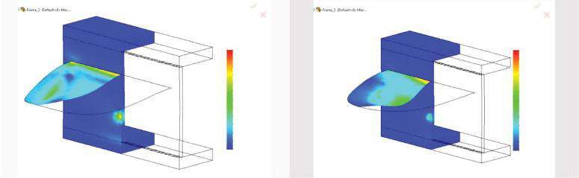

von Mises (N/mm/*2 (MPa))

von Mises (N/mm/*2 (MPa))

16.2

30.6

28.1

25.5

23.0

20.4

17.9

15.3

12.6

10.2

7.7

5.1

2.6

0.0

14.9

13.5

12.2

10.8

9.5

8.1

6.8

5.4

4.1

2.7

1.4

0.0

(c)

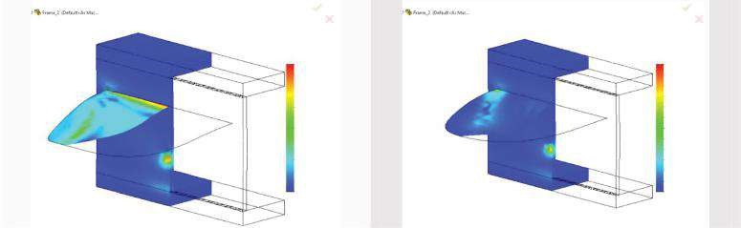

von Mises (N/mm/*2 (MPa))

von Mises (N/mm/*2 (MPa))

14.2

15.5

14.2

12.9

11.6

10.4

9.1

7.8

6.5

5.2

3.9

2.6

1.3

0.0

13.0

11.8

10.6

9.4

8.3

7.1

5.9

4.7

3.5

2.4

1.2

0.0

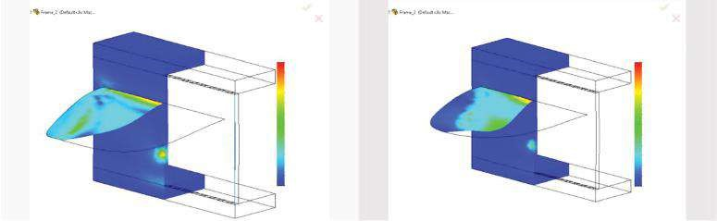

von Mises (N/mm/*2 (MPa))

von Mises (N/mm/*2 (MPa))

12.4

11.1

9.9

8.7

7.4

6.2

4.9

3.7

1.2

2.5

0.0

14.8

30.3

27.8

25.2

22.7

20.2

17.7

15.1

12.6

10.1

7.6

5.1

2.5

0.0

13.6

(d)

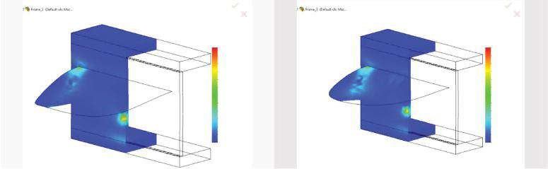

von Mises (N/mm/*2 (MPa))

von Mises (N/mm/*2 (MPa))

14.2

15.5

14.2

12.9

11.6

10.4

9.1

7.8

6.5

5.2

3.9

2.6

1.3

0.0

13.0

11.8

10.6

9.4

8.3

7.1

5.9

4.7

3.5

2.4

1.2

0.0

##### Figure 9.24

*Von Mises (VON) stresses inside the solid body and the shell (MPa). All figures on the left are for Study 1 and all figures on the right for Study 2. (a) Plots of von Mises stresses inside the solid body and on the top of the shell. (b) Plots of von Mises stresses inside the solid body and at the bottom of the shell. (c) Plots of von Mises stresses inside the solid body and bending stresses at the shell. (d) Plots of von Mises stresses inside the solid body and membrane stresses at the shell.*

(b)

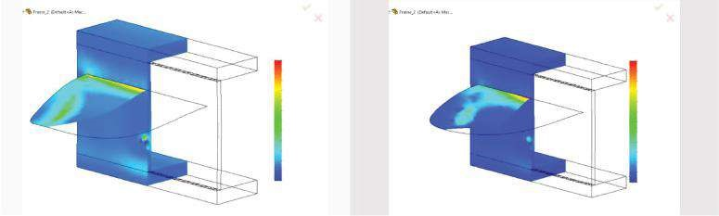

–1.9

–0.2

1.4

3.1

4.8

6.5

8.2

9.6

11.5

13.2

14.9

16.6

18.2

P1 (N/mm

2

(MPa))

P1 (N/mm

2

(MPa))

–1.8

1.3

4.3

7.3

10.3

13.3

16.3

19.3

22.3

25.3

28.3

31.3

34.3

(c)

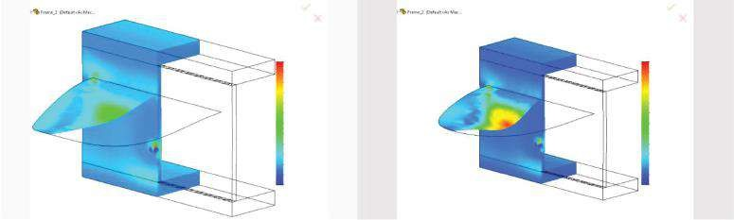

P1 (N/mm

2

(MPa))

12.5

11.4

10.2

9.0

7.7

6.5

5.3

4.1

2.9

1.7

0.5

–0.7

–1.9

–1.8

–0.2

1.4

3.0

4.5

6.1

7.7

9.2

10.8

12.4

13.9

15.5

17.1

P1 (N/mm

2

(MPa))

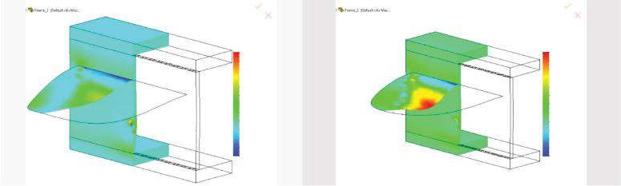

P1 (N/mm

2

(MPa))

P1 (N/mm

2

(MPa))

–9.7

–7.5

–5.3

–3.2

–1.0

1.2

3.3

5.5

7.7

9.8

12.0

14.2

16.3

–4.6

–3.2

–1.9

–0.5

0.9

2.3

3.6

5.0

6.4

7.8

9.1

10.5

11.9

(d)

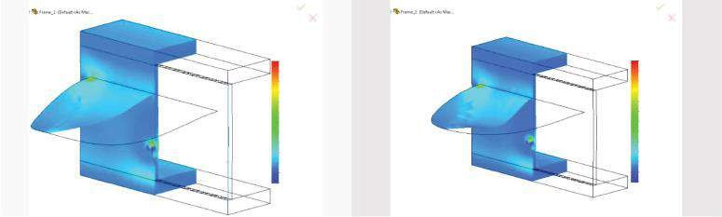

P1 (N/mm

2

(MPa))

P1 (N/mm

2

(MPa))

–1.9

–0.6

0.7

2.1

3.4

4.7

6.1

7.4

8.7

10.1

11.4

12.7

14.1

–1.8

–0.4

1.0

2.4

3.8

5.2

6.6

7.9

9.3

10.7

12.1

13.5

14.9

##### Fig u r e 9.25

*First principal (P1) stresses inside the solid body and the shell (MPa). All figures on the left are for Study 1 and all figures on the right for Study 2. (a) Plots of first principal stresses inside the solid body and on the top of the shell. (b) Plots of first principal stresses inside the solid body and at the bottom of the shell. (c) Plots of first principal stresses inside the solid body and bending stresses at the shell. (d) Plots of first principal stresses inside the solid body and membrane stresses at the shell.*

(b)

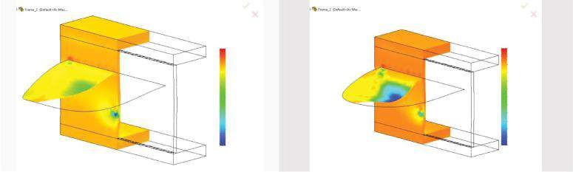

P3 (N/mm

2

(MPa))

P3 (N/mm

2

(MPa))

–14.3

–16.4

–14.8

–13.3

–11.7

–10.2

–8.6

–7.0

–5.5

–3.9

–2.4

–0.8

0.8

2.3

–12.9

–11.5

–10.0

–8.6

–7.2

–5.6

–4.3

–2.9

–1.5

–0.1

1.4

2.8

(c)

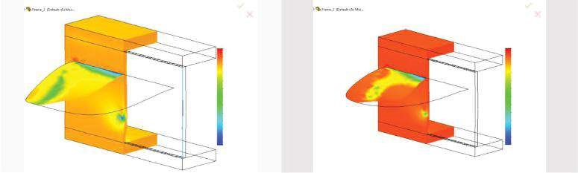

P3 (N/mm

2

(MPa))

2.8

1.3

–0.3

–1.8

–3.4

–4.9

–8.4

–9.0

–9.5

–11.1

–12.6

–14.1

–15.7

P3 (N/mm

2

(MPa))

–33.6

–30.6

–27.6

–24.6

–21.6

–18.6

–15.6

–12.6

–9.6

–6.7

–3.7

–0.7

2.3

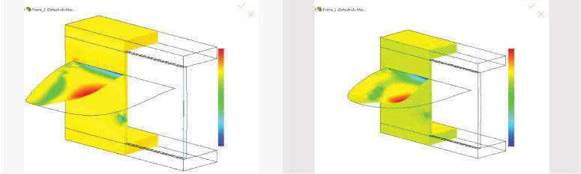

P3 (N/mm

2

(MPa))

P3 (N/mm

2

(MPa))

–16.5

–33.9

–29.8

–25.7

–21.6

–17.5

–13.4

–9.3

–5.2

–1.1

3.0

7.1

11.2

15.3

–14.7

–13.0

–11.2

–9.5

–7.7

–6.0

–4.2

–2.5

–0.7

1.0

2.8

4.5

(d)

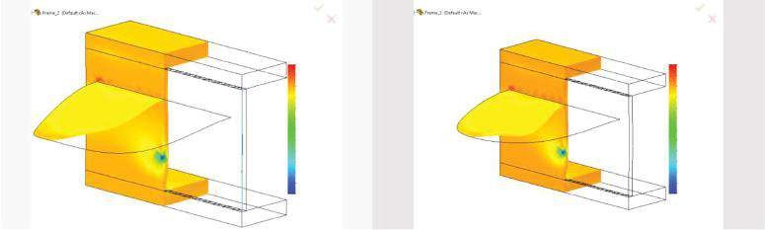

P3 (N/mm

2

(MPa))

P3 (N/mm

2

(MPa))

–13.2

–14.3

–12.9

–11.5

–10.0

–8.6

–7.2

–5.8

–4.3

–2.9

–1.5

–0.1

1.4

2.8

–11.9

–10.6

–9.3

–6.0

–6.7

–5.4

–4.2

–2.9

–1.6

–0.3

1.0

2.3

##### Figure 9.26

*Third principal (P3) stresses inside the solid body and the shell (MPa). All figures on the left are for Study 1 and all figures on the right for Study 2. (a) Plots of third principal stresses inside the solid body and on the top of the shell. (b) Plots of third principal stresses inside the solid body and at the bottom of the shell. (c) Plots of third principal stresses inside the solid body and bending stresses at the shell. (d) Plots of third principal stresses inside the solid body and membrane stresses at the shell.*

***Table 9.1***

#### Extreme Stress Values of Solid and Shell Structural Components

|  |  |  |  |  |  |  |  |
| --- | --- | --- | --- | --- | --- | --- | --- |
| **Study 1** | | | **Study 3** | **Study 5 Study 2** | | **Study 4** | **Study 6** |
| **von Mises Stresses (MPa)**  Top Node | | |  | 19,535 | |  |  |
|  | Stress | 14.17 | 14.52 | 14.51 29.95 | | 30.25 | 30.26 |
| Bottom | Node |  | 19,520 |  | | 19,535 |  |
|  | Stress | 16.21 | 16.52 | 16.56 30.63 | | 30.95 | 30.96 |
| Bending | Node |  |  | 19,535 | |  |  |
|  | Stress | 14.84 | 15.19 | 15.19 30.29 | | 30.60 | 30.61 |
| Membrane | Node |  | 19520 |  | | 19490 |  |
|  | Stress | 14.16 | 14.47 | 14.49 15.53 | | 16.02 | 16.01 |
| **First Principal Stresses (MPa)**  Top Node | | | 19,520 |  | | 19,490 |  |
| Stress 14.08 | | | 12.91 | 12.93 17.09 | | 17.62 | 17.62 |
| Bottom Node | | |  | 19,535 | |  |  |
| Stress 18.25 | | | 18.67 | 18.67 | 34.34 | 34.70 | 34.71 |
| Bending Node | | | 16,820 |  |  | 19,828 |  |
| Stress 11.87 | | | 12.14 | 12.14 | 16.32 | 16.45 | 16.45 |
| Membrane Node | | | 19,520 |  |  | 19,490 |  |
| Stress 14.07 | | | 14.37 | 14.40 | 14.87 | 15.34 | 15.33 |
| **Third Principal Stresses (MPa)**  Top Node | | | 19,532 |  |  | 19,535 |  |
| Stress −15.67 | | | −15.99 | −15.88 | −33.56 | −33.89 | −33.90 |
| Bottom Node | | | 16,204 |  |  | 19,828 |  |
| Stress −14.30 | | | −14.47 | −14.46 | −16.39 | −16.54 | −16.55 |
| Bending Node | | |  | 19,535 | |  |  |
| Stress −16.46 | | | −16.86 | −16.86 −33.95 | | −34.30 | −34.30 |
| Membrane Node | | | 16,204 |  | | 16,174 |  |
| Stress −14.30 | | | −14.47 | −14.46 −13.21 | | −12.61 | −12.62 |

We see the zeros in all beams at the pink joint for **Study 5** and **Study 6**. They are due to bending in both directions and the introduced hinges. The same is the explanation of the zero stresses for **Beam 3** (the pipe) in **Studies 3** and **4**.

##### 9.3.2 Definition of Plots of Inner Beam Forces

The next optional stage is plotting the diagrams of the inner beam forces. To start the procedure, the user can follow the path

Results (right click) → Define Beam Diagrams…

We have already discussed how the **Beam Diagrams** property manager (Figure 9.29) helps in drawing the beam diagrams. Beam diagrams are generated according to the local directions of each beam. We must choose the **Component** () among Axial

***Table 9.2***

#### Extreme Stress Values of Beam Structural Components

|  |  |  |  |  |  |  |
| --- | --- | --- | --- | --- | --- | --- |
|  | **Study 1** | **Study 3** | **Study 5** | **Study 2** | **Study 4** | **Study 6** |
| **Axial** Beam 1 | −2.831 | −2.907 | −2.909 | 3.633 | 3.848 | 3.847 |
| Beam 2 | 2.712 | 2.807 | 2.810 | 3.661 | 3.860 | 3.858 |
| Beam 3 | −3.611 | −3.601 | −3.598 | −3.126 | −3.106 | −3.106 |
| **Bending Dir 1** Beam 1 | 5.469 | 5.552 | 5.580 | 3.068 | 3.182 | 3.173 |
| Beam 2 | 6.119 | 6.208 | 6.230 | 4.091 | 4.232 | 4.229 |
| Beam 3 | 5.579 | 4.524 | 4.518 | 5.186 | 3.945 | 3.946 |
| **Bending Dir 2** Beam 1 | 16.391 | 16.755 | 16.782 | 15.508 | 16.062 | 16.057 |
| Beam 2 | 17.182 | 17.510 | 17.552 | 16.469 | 17.012 | 17.004 |
| Beam 3 | 2.780 | 3.012 | 3.01 | 5.168 | 2.430 | 2.430 |
| **Worst Case** Beam 1 | 24.691 | 25.214 | 25.271 | 21.646 | 22.429 | 22.415 |
| Beam 2 | 25.927 | 26.406 | 26.477 | 23.405 | 24.186 | 24.173 |
| Beam 3 | 9.425 | 9.036 | 9.027 | 8.771 | 7.739 | 7.740 |

Force, Shear Force in Dir 1, Shear Force in Dir 2, Moment in Dir 1, Moment in Dir 2 or Torque and the **Units** (). We can generate beam diagrams for all beams (by checking **All**) or for selected beams (by checking **Select** and picking the beams () in the **Graphics area**).

The beam diagrams are shown in Figures 9.30 and 9.31. The main difference between the diagrams of the two studies are at the common (the pink) joint. The extreme values of the inner forces for all diagrams are given in Table 9.4.

While the extreme values of the inner forces (stresses) are very important for the successful sizing of the beams, the values at both beam ends are significant when the connectors are designed. Even more, these values help the designers in calculating tapered beams. The inner force data for all beam ends are systematised in Table 9.5. The zeros correspond to the input hinges in Studies 3, 4, 5 and 6.

##### 9.3.3 Definition of Displacement Plots

We will view the displacement plots on the deformed shape (Figures 9.32 and 9.33) through the path

Results (right click) → Define Displacement Plot…

The extreme values of the nodal displacements, including nodal rotations, are given in Table 9.6. They help the designer to assess the deformations in the structure and to compare them to the limits in the regulations.

(a)

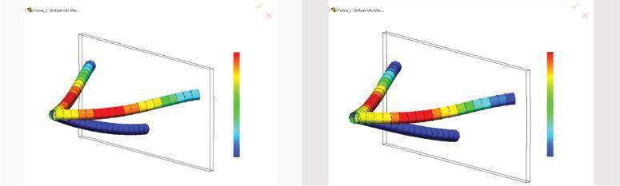

Axial P/A (N/mm

2

(MPa))

2.7

2.2

1.7

1.1

0.6

0.1

–0.4

–1.0

–1.5

–2.0

–2.6

–3.1

–3.6

–3.2

–2.6

–2.0

–1.4

–0.8

–0.3

0.3

0.8

1.5

2.1

2.7

3.3

3.9

Axial P/A (N/mm

2

(MPa))

(b)

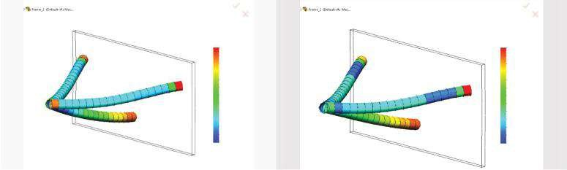

Bending Ms/Ss (N/mm

2

(MPa))

Bending Ms/Ss (N/mm

2

(MPa))

–1.2

–2.4

–1.7

–1.0

–0.3

0.4

1.1

1.8

2.6

3.3

4.0

4.7

5.4

6.1

–0.7

–0.3

0.2

0.6

1.1

1.5

2.0

2.4

2.9

3.3

3.6

4.2

(c)

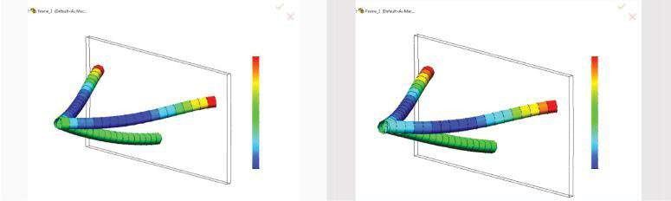

Bending Mt/St (N/mm

2

(MPa))

Bending Mt/St (N/mm

2

(MPa))

–7.9

–5.8

–3.7

–1.6

0.4

2.5

4.6

6.7

8.8

10.9

13.0

15.1

17.2

–11.8

–9.4

–7.0

–4.6

–2.2

0.2

2.6

5.0

7.4

9.6

12.2

14.5

17.0

(d)

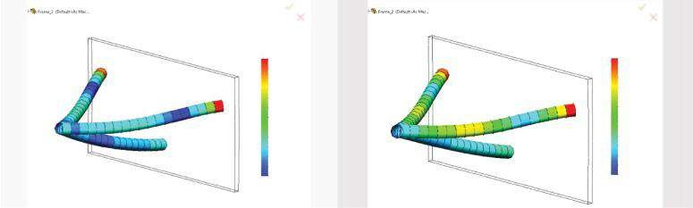

Highest axial and bending (N/mm

2

(MPa))

Highest axial and bending (N/mm

2

(MPa))

0.2

2.2

4.2

6.2

8.2

10.2

12.2

14.2

16.2

18.2

20.2

22.2

24.2

3.6

5.4

7.3

9.2

11.0

12.9

14.7

16.6

18.5

20.3

22.2

24.1

25.9

###### Fig u r e 9.27

*Plots of stresses inside the beams (MPa). All figures on the left are for Study 1 and all figures on the right for Study 2. (a) Plots of axial stress (P/A). (b) Plots of norm al stress as a result of bending in local direction 1 (Ms/Ss). (c) Plots of norm al stress as a result of bending in local direction 2 (Mt/ St). (d) Plots of total normal stress as a result of the highest axial and bending stress.*

(a)

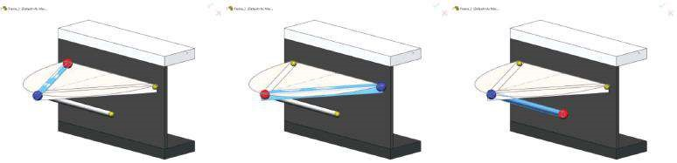

(b)

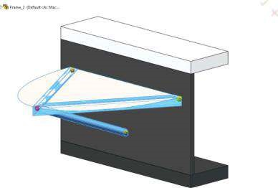

###### Figure 9.28

*Different ways to display beam ends. (a) Red-blue signature at the end of each beam element. (b) Pink-green signatures of all joints in the structure.*

While comparing the results, keep in mind that the vertical axis in this model is Y and the horizontal axes are X and Z.

##### 9.3.4 Definition of Deformation Plots

Additional information about the stress–strain state of the structure can be provided by

Results (right click) → Define Design Inside Plot …

This plot helps in finding the most vulnerable zones. The slider constantly increases the percentage of the applied loading, and thus, the software shows those areas that carry the loads most efficiently and that constantly enlarge during the process. The provided information is intended to be used to reduce the material and to optimise the model’s shape. The blue areas are loaded the most, whereas the translucent areas outline the model and the areas of the material, which can be discarded in a future optimisation. The pictures below show the structure state at 30% to 90% of the loading (Figure 9.34).

Regarding the plots, we can conclude that, if we need to make the structure steadier and suitable for exposing to higher loads, we better increase the thickness of the horizontal plate and re-design the connections between the shell and the vertical plate and between the pipe and the vertical plate than strengthen the

***Table 9.3***

#### Extreme Stress Values at the Beam Joints (Figure 9.28)

|  |  |  |  |  |  |
| --- | --- | --- | --- | --- | --- |
| **Study 1** | **Study 3** | **Study 5** | **Study 2** | **Study 4** | **Study 6** |
| **Axial – Pink Joint**  Beam 1 0.724 | −0.0857 | 0 | −0.0273 | 0.0524 | 0 |
| Beam 2 0.796 | 0.959 | 0.840 | 1.117 | 1.450 | 1.649 |
| Beam 3 −3.606 | −3.596 | −3.593 | −3.121 | −3.101 | −3.101 |
| **Axial – Green Joint**  Beam 1 −2.8314 | −2.907 | −2.909 | −3.070 | −3.184 | −3.185 |
| Beam 2 −2.627 | −2.6882 | −2.695 | −2.845 | −2.942 | −2.941 |
| Beam 3 −3.611 | −3.601 | −3.598 | −3.126 | −3.106 | −3.106 |
| **Bending Dir 1 – Pink Joint**  Beam 1 2.329 | −0.0454 | 0 | 0.0881 | 0.242 | 0 |
| Beam 2 5.262 | 3.526 | 0 | 0.584 | 0.664 | 0 |
| Beam 3 −2.442 | 0 | 0 | −2.283 | 0 | 0 |
| **Bending Dir 1 – Green Joint**  Beam 1 5.469 | 5.552 | 5.580 | 3.068 | 3.182 | 3.173 |
| Beam 2 6.119 | 6.208 | 6.230 | 4.092 | 4.232 | 4.229 |
| Beam 3 5.579 | 4.524 | 4.518 | 5.186 | 3.945 | 3.946 |
| **Bending Dir 2 – Pink Joint**  Beam 1 3.757 | 0.0775 | 0 | 0.151 | 0.413 | 0 |
| Beam 2 4.792 | 3.086 | 0 | 1.075 | −1.213 | 0 |
| Beam 3 2.780 | 0 | 0 | 5.168 | 0 | 0 |
| **Bending Dir 2 – Green Joint**  Beam 1 16.391 | 16.755 | 16.782 | 15.508 | 16.062 | 16.057 |
| Beam 2 17.181 | 17.51 | 17.552 | 16.469 | 17.012 | 17.004 |
| Beam 3 1.640 | 3.012 | 3.01 | 0.227 | 2.430 | 2.430 |
| **Worst Case – Pink Joint**  Beam 1 6.810 | 0.209 | 0 | 0.266 | 0.708 | 0 |
| Beam 2 10.851 | 7.571 | 0.840 | 2.776 | 3.327 | 1.649 |
| Beam 3 7.305 | 3.596 | 3.593 | 8.771 | 3.101 | 3.101 |
| **Worst Case – Green Joint**  Beam 1 24.691 | 25.214 | 25.271 | 21.646 | 22.429 | 22.415 |
| Beam 2 25.927 | 26.406 | 26.477 | 23.405 | 24.186 | 24.173 |
| Beam 3 9.425 | 9.036 | 9.027 | 8.318 | 7.739 | 7.740 |

beams. Another solution is to attach additional ribs or other strengthening devices to the plate.

The factor of safety plot shows another vulnerable zone – the connection of the angle profiles to the vertical plate (Figure 9.35). The FoS is minimal at that area and its values are

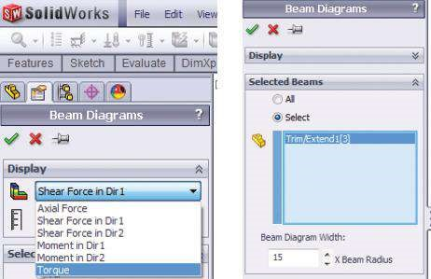

##### Figure 9.29

*Beam Diagrams property manager.*

Study 1—minFoS = 1.064 Study 2—minFoS = 1.178

Study 3—minFoS = 1.044 Study 4—minFoS = 1.140

Study 5—minFoS = 1.041 Study 6—minFoS = 1.141

We viewed and compared the results for a few studied examples.

We paid attention to the necessity of defining contacts between different structural members. This is a step towards learning how to perform static analysis of more complex structures and assemblies.

We proved that every structure can be optimised with regards to certain constructive requirements. We studied the impact of the applied connections on the stress and displacements across the structure and proved the modification of connectors to be one of the easiest ways to reduce the stresses in the most vulnerable areas.

We explained how to use the Design Inside plot as a guide to constructive optimisation resulting in material reduction and better shape for the input restraints.

|  |
| --- |
| We learned   * How different contact sets and connectors impact the results, and consequently how to improve the stress distribution by modification of the connectors * How to use the D esign Inside tool as a guide in performing a structural optimisation resulting in material reduction   Analysis of that complex structure is the step crossing the gap between the analyses of parts and structural analyses of complex structures designed as assembled models. |

(a)

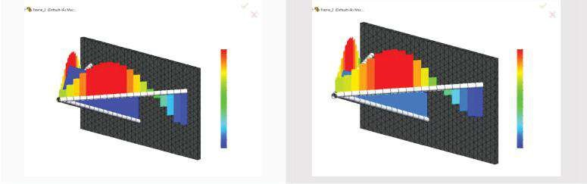

Axial Force (N)

Axial Force (N)

867

719

571

424

276

128

–19

–167

–314

–462

–610

–757

–905

–1.018

–830

–643

–455

–268

–80

108

295

483

670

858

1.046

1.233

(b)

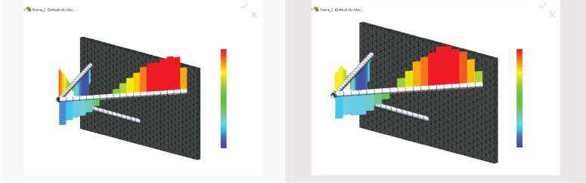

Shear Force in Dir1 (N)

Shear Force in Dir1 (N)

–178

–149

–119

–89

–59

–29

0

30

60

90

120

150

179

–217

–181

–145

–109

–73

–37

–1

35

71

107

143

180

216

(c)

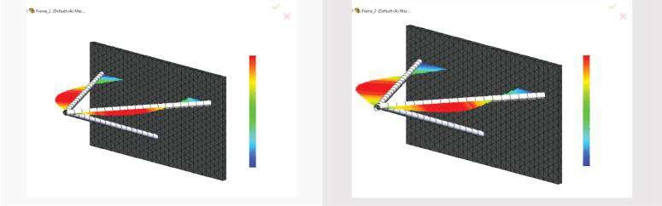

Moment in Dir2 (N-m)

Moment in Dir2 (N-m)

–16

–18

–13

–11

–9

–6

–4

–2

1

3

6

9

10

–20

–17

–14

–11

–8

–5

–2

1

4

7

10

13

16

##### Fig u r e 9.30

*Beam diagrams of the studied frame – part 1. All figures on the left are for Study 1 and all figures on the right for Study 2. (a) Diagram s of axial force (N). (b) Diagram s of shear force in direction 1 (N). (c) Diagram s of m om ent in direction 2 (N m).*

(a)

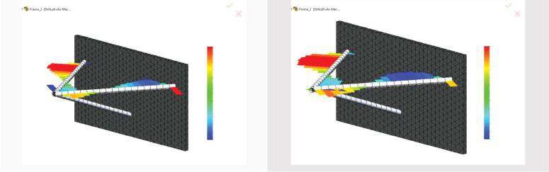

Shear Force in Dir2 (N)

Shear Force in Dir2 (N)

–78

–66

–53

–41

–26

–16

–4

9

21

33

46

58

71

–86

–72

–57

–43

–28

–14

0

15

29

44

58

73

87

(b)

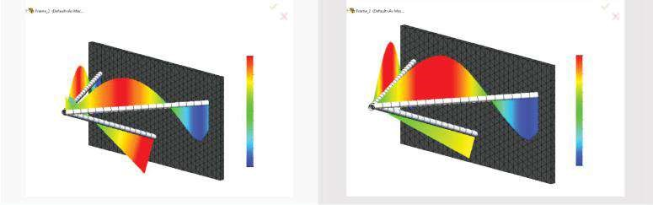

Moment in Dir1 (N-m)

Moment in Dir1 (N-m)

–8

–7

–5

–4

–3

–2

0

1

2

3

5

6

7

–10

–8

–6

–5

–3

–2

0

2

3

5

6

8

10

(c)

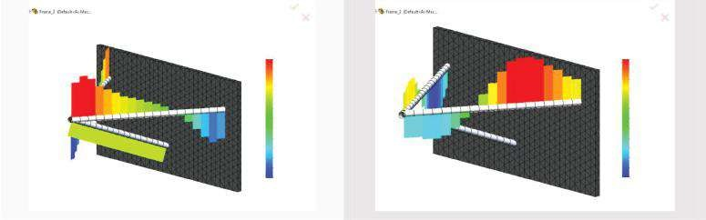

Torque (N-m)

Torque (N-m)

–4

–3

–3

–2

–1

–1

0

1

1

2

3

3

4

–6

–5

–4

–3

–2

–1

0

1

2

3

4

5

6

##### Fig u r e 9.31

*Beam diagrams of the studied frame – part 2. All figures on the left are for Study 1 and all figures on the right for Study 2. (a) Diagram s of shear force in direction 2 (N). (b) Diagram s of m om ent in direction 2 (N m). (c) Diagram s of torque (N m).*

***Table 9.4***

#### Extreme Values of Inner Forces for All Beams

|  |  |  |  |  |  |
| --- | --- | --- | --- | --- | --- |
| **Study 1** | **Study 3** | **Study 5** | **Study 2** | **Study 4** | **Study 6** |
| **Axial Force (N)**  Beam 1 905.02 | 929.19 | 929.88 | −1160.6 | −1229.8 | −1229.7 |
| Beam 2 −866.68 | −897.08 | −898.30 | −1170.8 | −1233.8 | −1233.1 |
| Beam 3 860.24 | 857.86 | 857.27 | 744.50 | 739.64 | 740.11 |
| **Shear Force in Direction 1 (N)**  Beam 1 178.50 181.94 | | 182.15 | 209.19 | 216.78 | 216.8 |
| Beam 2 179.49 182.39 | | 182.67 | 209.10 | 215.62 | 215.54 |
| Beam 3 −4.325 −8.974 | | −8.969 | −13.745 | −7.525 | −7.527 |
| **Bending Moment in Direction 2 (N m)**  Beam 1 17.707 18.130 | | 18.143 | 18.403 | 19.060 | 19.061 |
| Beam 2 −18.256 −18.628 | | −18.667 | −18.897 | −19.510 | −19.503 |
| Beam 3 −3.520 3.815 | | 3.812 | −6.538 | 3.076 | 3.077 |
| **Shear Force in Direction 2 (N)**  Beam 1 77.044 78.382 | | 78.901 | 109.32 | −86.963 | −86.969 |
| Beam 2 78.003 71.517 | | 71.625 | 83.639 | 86.078 | 86.049 |
| Beam 3 19.917 11.234 | | 11.22 | 18.426 | 9.792 | 9.800 |
| **Bending Moment in Direction 1 (N m)**  Beam 1 −7.798 −8.011 | | −8.009 | 9.258 | 9.588 | 9.592 |
| Beam 2 −7.33 | −7.506 | −7.520 | −9.157 | −9.550 | −9.545 |
| Beam 3 −7.065 | −5.729 | −5.722 | −6.547 | −4.994 | −4.998 |
| **Torque (N m)**  Beam 1 3.845 | 4.020 | 3.846 | 6.267 | 6.469 | 6.496 |
| Beam 2 −3.949 | −4.168 | −4.590 | −6.105 | −6.286 | −6.287 |
| Beam 3 −1.503 | 0 | 0 | −1.403 | 0 | 0 |

***Table 9.5***

#### Inner Forces at Beam Ends

|  |  |  |  |  |  |
| --- | --- | --- | --- | --- | --- |
| **Study 1**  **Axial – Pink Joint (N)** | **Study 3** | **Study 5** | **Study 2** | **Study 4** | **Study 6** |
| Beam 1 231.52 | −27.4 | 0 | 339.15 | 437.2 | 0 |
| Beam 2 −254.44 | −306.4 | −268.6 | −362.14 | −461.82 | −527.1 |
| Beam 3 −859.04  **Axial – Green Joint (N)** | −856.67 | −856.07 | −743.3 | −738.44 | −738.91 |
| Beam 1 905.02 | 929.19 | 929.88 | 981.18 | 1017.7 | 1017.9 |
| Beam 2 −839.77 | −859.25 | −861.4 | −909.5 | −940.31 | −939.96 |
| Beam 3 860.24  **Shear 1 – Pink Joint (N)** | 857.86 | 857.27 | 744.5 | 739.44 | 740.11 |
| Beam 1 145.76 | 11.935 | 10.068 | 126.23 | 112.43 | 1.118 |
| Beam 2 126.65 | 126.17 | 88.684 | 119.67 | 115.51 | 128.12 |
| Beam 3 1.337  **Shear 1 – Green Joint (N)** | −8.9738 | −8.969 | 10.757 | −7.525 | −7.527 |
| Beam 1 86.5 | 87.111 | 87.518 | 27.846 | 29.005 | 28.861 |
| Beam 2 120.51 | 121.53 | 121.76 | 68.762 | 71.029 | 70.984 |
| Beam 3 −4.325 | 5.986 | 5.981 | −13.745 | 4.537 | 4.539 |
| **Bending Dir 2 – Pink Joint (N m)** | |
| Beam 1 −3.214 0.0684 | | 0 | −1.589 | 1.300 | 0 |
| Beam 2 2.300 1.373 | | 0 | 0.965 | −1.097 | 0 |
| Beam 3 −3.520 0  **Bending Dir 2 – Green Joint (N m)** | | 0 | 0.290 | 0 | 0 |
| Beam 1 17.707 18.13 | | 18.143 | 18.403 | 19.06 | 19.061 |
| Beam 2 −18.256 −18.628 | | −18.667 | −18.897 | −19.51 | −19.503 |
| Beam 3 2.076 3.8145  **Shear 2 – Pink Joint (N)** | | 3.812 | −6.538 | 3.076 | 3.077 |
| Beam 1 −2.714 3.5929 | | −53.247 | −109.32 | −73.938 | 12.295 |
| Beam 2 78.003 35.533 | | −15.565 | −29.122 | −67.368 | −51.18 |
| Beam 3 −19.917 −11.234  **Shear 2 – Green Joint (N)** | | −11.22 | −18.416 | −9.792 | −9.800 |
| Beam 1 77.044 78.382 | | 78.901 | 40.759 | 42.34 | 42.192 |
| Beam 2 69.917 71.13 | | 71.499 | 50.499 | 52.319 | 52.285 |
| Beam 3 19.917 11.234  **Bending 1 – Pink Joint (N m)** | | 11.22 | 18.416 | 9.792 | 9.800 |
| Beam 1 0.1752 0 | | 0 | −2.815 | −0.0010 | 0 |
| Beam 2 −3.300 −2.3094 | | 0 | −0.272 | 0.0081 | 0 |
| Beam 3 −3.092 0 | | 0 | −2.845 | 0 | 0 |

(*continued*)

#### Table 9.5 (Continued) Inner Forces at Beam Ends

|  |  |  |  |  |  |
| --- | --- | --- | --- | --- | --- |
| **Study 1 Study 3** | | **Study 5** | **Study 2** | **Study 4** | **Study 6** |
| **Bending 1 – Green Joint (N m)**  Beam 1 5.532 5.7065 | | 5.689 | 8.059 | 8.343 | 8.351 |
| Beam 2 −5.279 | −5.4192 | −5.422 | −7.445 | −7.680 | −7.678 |
| Beam 3 −7.065 | −5.729 | −5.722 | −6.547 | −4.994 | −4.998 |
| **Torque – Pink Joint (N m)**  Beam 1 −3.74 | −0.3814 | −0.544 | 3.245 | 2.933 | 2.751 |
| Beam 2 −3.74 | −3.768 | −4.590 | 3.639 | 2.904 | 3.186 |
| Beam 3 1.503 | 0 | 0 | 1.403 | 0 | 0 |
| **Torque – Green Joint (N m)**  Beam 1 −2.9623 | −2.944 | −3.003 | 2.665 | 2.731 | 0.126 |
| Beam 2 −2.641 | −2.612 | −2.644 | 2.922 | 2.996 | 2.997 |
| Beam 3 −1.503 | 0 | 0 | −1.403 | 0 | 0 |

(a)

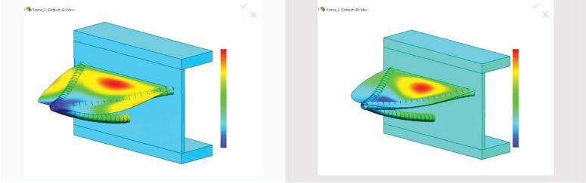

RX (deg)

RX (deg)

0.085

0.077

0.068

0.059

0.050

0.041

0.032

0.023

0.014

0.005

–0.004

–0.013

–0.022

–0.071

–0.050

–0.030

–0.009

0.012

0.032

0.053

0.073

0.094

0.114

0.135

0.155

0.176

(b)

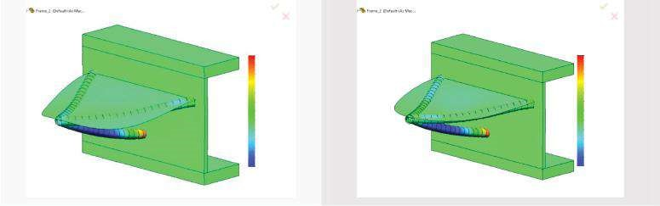

RY (deg)

RY (deg)

–0.018

–0.014

–0.010

–0.006

–0.003

0.001

0.005

0.009

0.012

0.016

0.020

0.024

0.027

–0.016

–0.013

–0.009

–0.006

–0.003

0.001

0.004

0.008

0.011

0.015

0.018

0.022

0.025

(c)

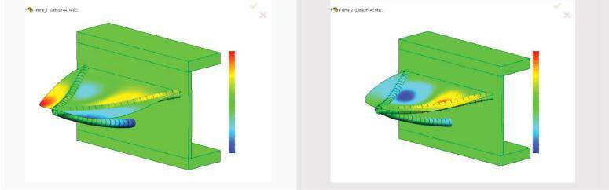

RZ (deg)

RZ (deg)

–0.063

–0.053

–0.044

–0.034

–0.024

–0.014

–0.005

0.005

0.015

0.025

0.035

0.044

0.054

–0.107

–0.089

–0.072

–0.054

–0.036

–0.016

0.000

0.018

0.035

0.053

0.071

0.089

0.107

##### Fig u r e 9.32

*Plots of nodal rotations (degrees). All figures on the left are for Study 1 and all figures on the right for Study 2. (a) Plots of the nodal rotations around axis X (RX). (b) Plots of the nodal rotations around axis Y (RY). (c) Plots of the nodal rotations around axis Z (RZ).*

(a)

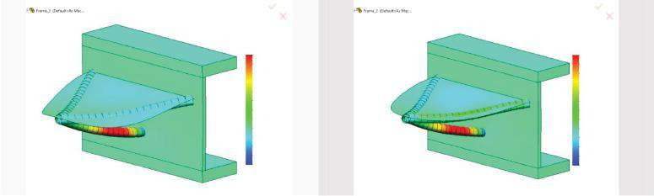

UX (mm)

UX (mm)

0.048

0.042

0.035

0.030

0.024

0.018

0.012

0.005

0.000

–0.006

–0.012

–0.018

–0.024

–0.023

–0.017

–0.011

–0.006

0.000

0.005

0.011

0.016

0.022

0.027

0.033

0.036

0.044

(b)

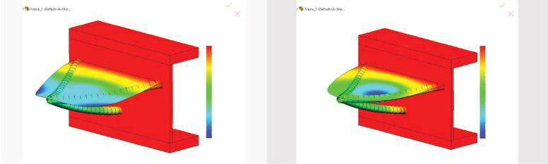

UY (mm)

UY (mm)

–0.320

–0.293

–0.266

–0.240

–0.213

–0.186

–0.159

–0.133

–0.106

–0.079

–0.052

–0.026

0.001

–0.410

–0.376

–0.342

–0.307

–0.273

–0.239

–0.205

–0.170

–0.136

–0.102

–0.068

–0.033

0.001

(c)

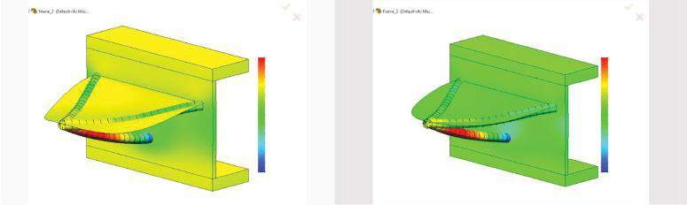

UZ (mm)

UZ (mm)

–0.039

–0.029

–0.025

–0.020

–0.016

–0.011

–0.005

–0.002

0.003

0.007

0.012

0.016

–0.034

–0.036

–0.031

–0.025

–0.020

–0.015

–0.010

–0.005

0.000

0.006

0.011

0.015

0.021

0.026

(d)

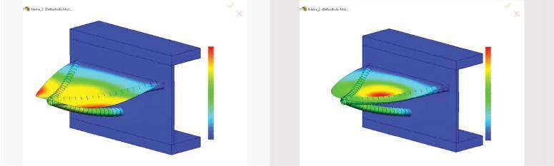

URES (mm)

URES (mm)

0.000

0.027

0.053

0.060

0.107

0.133

0.160

0.187

0.213

0.240

0.267

0.293

0.320

0.000

0.004

0.068

0.103

0.137

0.171

0.205

0.239

0.273

0.306

0.342

0.375

0.410

##### Fig u r e 9.33

*Plots of nodal displacements (mm). All figures on the left are for Study 1 and all figures on the right for Study 2. (a) Plots of the nodal displacem ents in direction X (UX). (b) Plots of the nodal displacem ents in direction Y (UY). (c) Plots of the nodal displacem ents in direction Z (UZ).*

*(d) Plots of the total nodal displacements (UREZ).*

***Table 9.6***

#### Extreme Values of Nodal Beam Displacements

|  |  |  |  |  |  |  |
| --- | --- | --- | --- | --- | --- | --- |
|  | **Study 1** | **Study 3** | **Study 5** | **Study 2** | **Study 4** | **Study 6** |
| **Algebraic Min** RX (°) | −0.02159 | −0.02675 | −0.02627 | −0.07071 | −0.07142 | −0.07142 |
| RY (°) | −0.01765 | −0.03750 | −0.03743 | −0.01641 | −0.03270 | −0.03271 |
| RZ (°) | −0.06305 | −0.06500 | −0.06496 | −0.10730 | −0.10811 | −0.10813 |
| UX (mm) | −0.02421 | −0.02483 | −0.02482 | −0.02551 | −0.02166 | −0.02166 |
| UY (mm) | −0.31980 | −0.32430 | −0.32590 | −0.41011 | −0.41962 | −0.41975 |
| UZ (mm) | −0.03853 | −0.03920 | −0.03918 | −0.03586 | −0.03516 | −0.03517 |
| **Algebraic Max**  RX (°) | 0.08578 | 0.08766 | 0.08756 | 0.17596 | 0.17894 | 0.17900 |
| RY (°) | 0.02731 | 0.02840 | 0.02839 | 0.02528 | 0.02477 | 0.02477 |
| RZ (°) | 0.05403 | 0.05371 | 0.05458 | 0.10679 | 0.10761 | 0.10769 |
| UX (mm) | 0.04756 | 0.06794 | 0.06800 | 0.04400 | 0.05963 | 0.05925 |
| UY (mm) | 0.00112 | 0.00122 | 0.00122 | 0.00082 | 0.00082 | 0.00082 |
| UZ (mm) | 0.00164 | 0.00579 | 0.00579 | 0.02642 | 0.00595 | 0.00598 |
| UREZ (mm) | 0.31981 | 0.32428 | 0.32595 | 0.41006 | 0.41963 | 0.41976 |

(a)

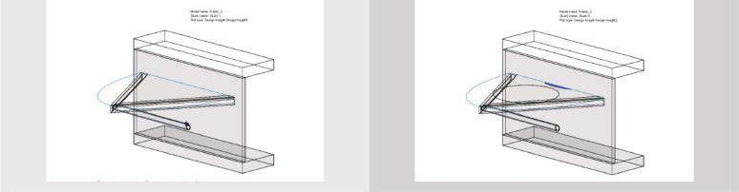

Model name: Frame_2

Study name: Study1

Plot ype: Design insight Design insight1

Model name: Frame_2

Study name: Study6

Plot ype: Design insight Design insight2

(b)

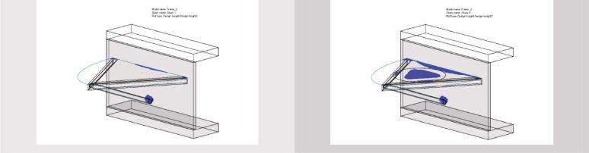

Model name: Frame_2

Study name: Study1

Plot ype: Design insight Design insight1

Model name: Frame_2

Study name: Study6

Plot ype: Design insight Design insight2

(c)

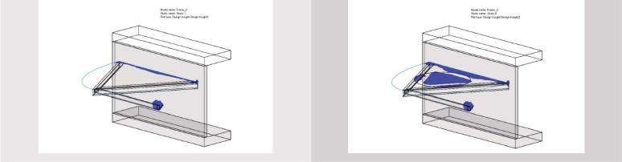

Model name: Frame_2

Study name: Study1

Plot ype: Design insight Design insight1

Model name: Frame_2

Study name: Study6

Plot ype: Design insight Design insight2

(d)

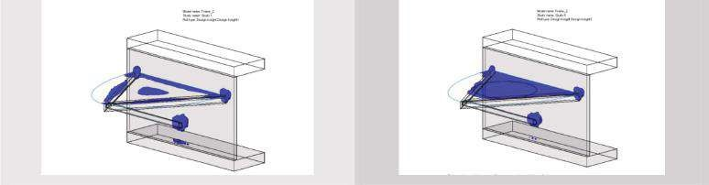

Model name: Frame_2

Study name: Study1

Plot ype: Design insight Design insight1

Model name: Frame_2

Study name: Study6

Plot ype: Design insight Design insight2

##### Figure 9.34

*Design inside plots at a different level of loading. All figures on the left are for Study 1 and all figures on the right for Study 2. (a) 30% loading. (b) 50% loading. (c) 70% loading. (d) 90% loading.*

10.00

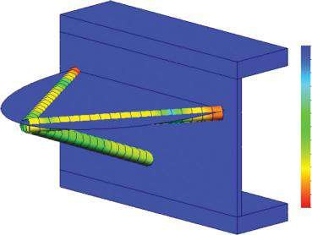

FOS

9.17

8.33

7.90

6.67

5.83

5.00

4.17

3.33

2.50

1.67

0.83

0.00

***Fig u r e 9.35***

*FoS plot for Study 1.*

#### Mechanical Engineering

“The contents seem to be quite logical and appropriate for this book. After explaining the theory, special examples with increasing complexity are worked out in detail.”

—Alois Steindl, Vienna University of Technology, Austria

“I loved the way the author guides the reader through intricate relationships in a very simple way, thus making of science of construction mathematical concepts, indeed very complex by their nature, as simple as solving a first degree equation!”

—Vincenzo Fine, Clyde Bergemann Materials Handling Ltd, Doncaster, UK ***Uses Finite Element Analysis (FEA) as Implemented in SolidWorks Simulation***

Outlining a path that readers can follow to ensure a static analysis that is both accurate and sound, **Introduction to Static Analysis Using SolidWorks Simulation** effectively applies one of the most widely used software packages for engineering design to the concepts of static analysis. This text utilizes a step-by-step approach to introduce the use of a finite element simulation within a computer-aided design (CAD) tool environment. It does not center on formulae and the theory of FEM; in fact, it contains essentially no theory on FEM other than practical guidelines. The book is self-contained and enables the reader to progress independently without an instructor. It is a valuable guide for students, educators, and practicing professionals who wish to forego commercial training programs but need to refresh or improve their knowledge of the subject.



***Classroom Tested with Figures, Examples, and Homework Problems***

The book contains more than 300 illustrations and extensive explanatory notes covering the features of the SolidWorks (SW) Simulation software. The author presents commonly used examples and techniques highlighting the close interaction between CAD modelling and FE analysis. She describes the stages and program demands used during static analysis, details different cases, and explores the impact of selected options on the final result. In addition, the book includes hands-on exercises, program commands, and a summary after each chapter.

**Introduction to Static Analysis Using SolidWorks Simulation** equips students, educators, and practicing professionals with an in-depth understanding of the features of SW Simulation applicable to static analysis (FEA/FEM).

K23105

**6000 Broken Sound Parkway, NW**

**Suite 300, Boca Raton, FL 33487** ISBN: 978-1-4822-3618-7

**711 Third Avenue**

**an informa business New York, NY 10017** 90000

**2 Park Square, Milton Park**

**www.crcpress.com Abingdon, Oxon OX14 4RN, UK**

9781482236187

##### w w w . c r c p r e s s . c o m